TO LET BY INFORMAL TENDER
3.3ac GRAZING LAND Adj. LONGFELLOW ROAD, CALDICOT MONMOUTHSHIRE, NP26 4LF

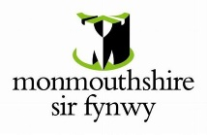


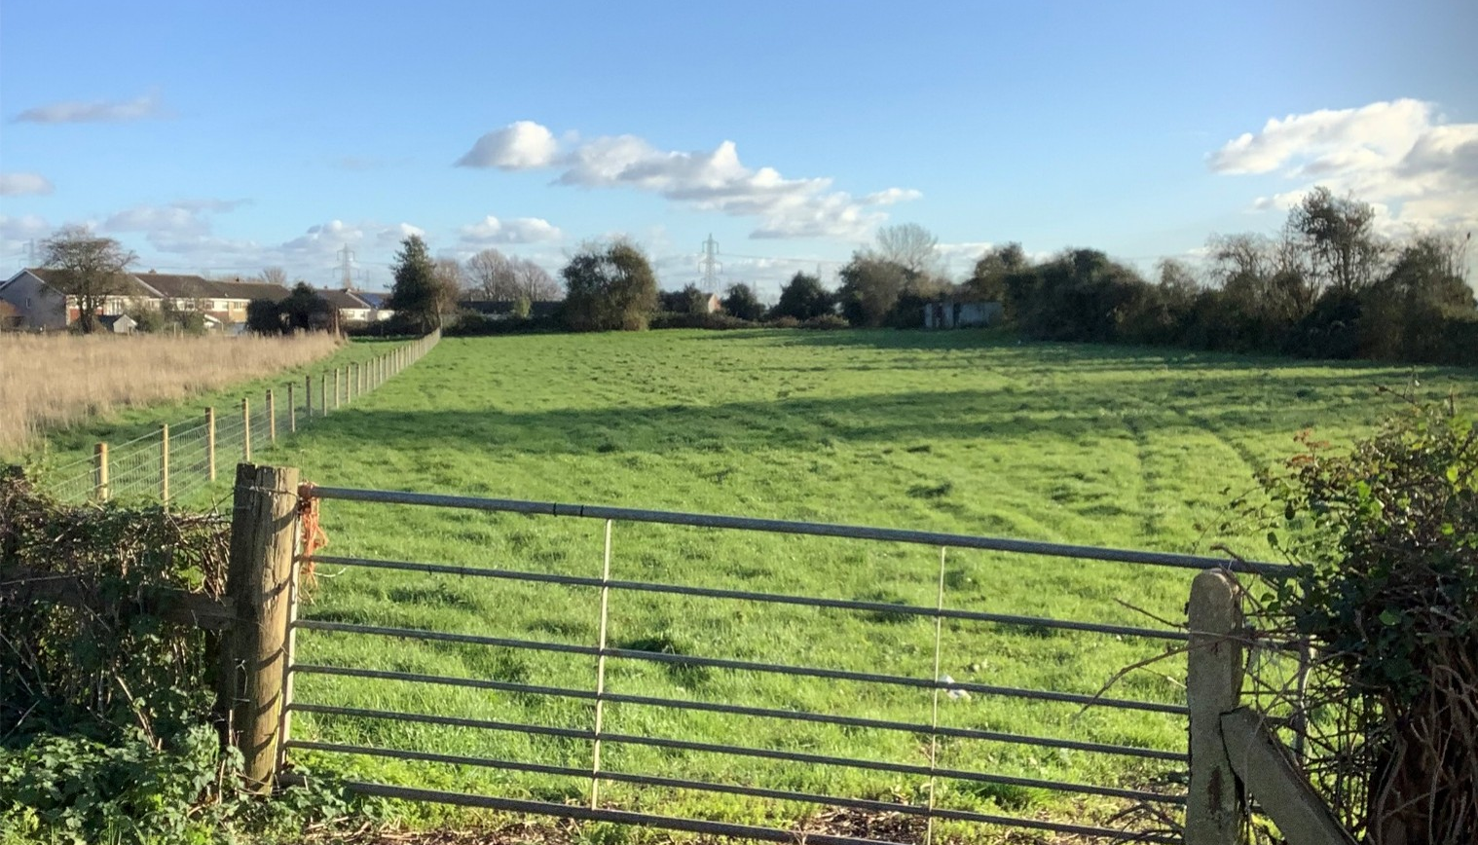


TO LET

Approximately 3.29 ac | To Let by Informal Tender | Situated between Rogiet & Caldicot

Permanent pasture | Grazing or mowing only | Roadside Access

Tender submission deadline: 12:00 (noon) Friday 16th October 2026

THE OPPORTUNITY
Monmouthshire County Council’s Asset Management Team invite offers via informal tender, for the opportunity to take on 3.3 acres of grazing land located on the outskirts of Caldicot town.

LOCATION
Situated on the edge of Caldicot as shown on the attached plan. Access is via a gateway from the B4245 (Rogiet Road).
DESCRIPTION
The land consists of approximately 3 acres of permanent grassland as shown on the attached plan.
PERMITTED USE
Grazing and mowing only.
WATER
Investigations indicate that there is no connected water supply at the site. The winning bidder will need to make their own arrangements for water if grazing animals are to be kept on the site.
ANNUAL LICENCE FEE
Negotiable.
Interested parties are invited to make offers on an informal tender basis. The Council reserves the right not to accept the highest or any offer.

METHOD OF DISPOSAL
It is proposed to let the land by way of a Grazing Licence agreement with an initial period of just under 12 months that will then continue for a periodic basis until terminated by either party.
Tender deadline Midday on Friday 16th October 2026.
The successful bidder will be responsible for maintenance of the land including fencing and boundaries.
LEGAL COSTS
Each party will bear their own legal and professional costs involved.
VIEWINGS
By appointment through Monmouthshire Council’s Estates Team.
Please contact:
EmilyHayes@monmouthshire.gov.uk
Estates@monmouthshire.gov.uk
Tel: 07516 513070

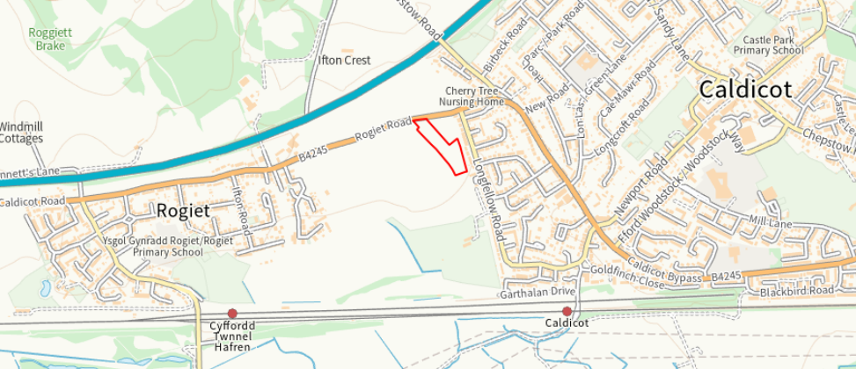

Monmouthshire County Council give notice that: These particulars are set out as a general outline only for the guidance of intending purchasers or lessees and do not constitute, nor constitute part of, an offer or contract. All descriptions, references to condition and necessary permission for use and occupation and other details are given in good faith and are themselves by inspection or otherwise as to the correctness of each of them. All dimensions are approximate. No persons in the employment of Monmouthshire County Council has any authority to make or give any representation or warranty whatsoever in relation to this property. All correspondence regarding this offer is subject to contract. In the event of inconsistency between these Particulars and Conditions of Sale, the latter shall prevail.

