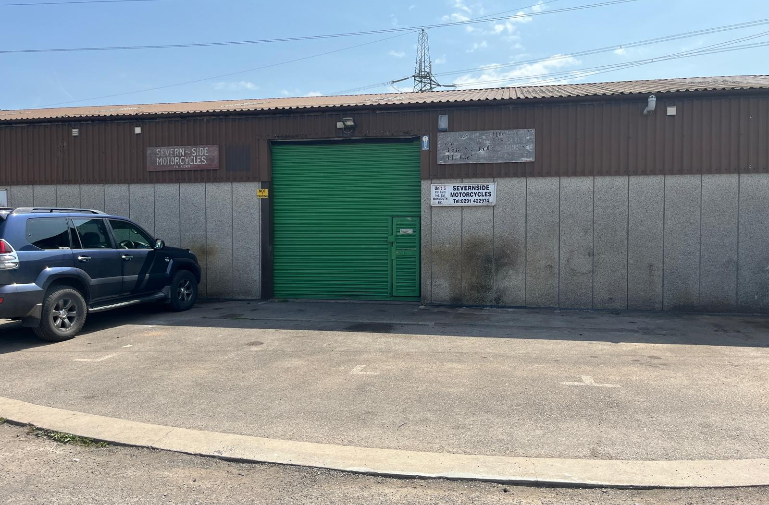
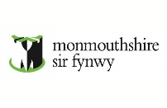
Contact
Emily Hayes MRICS
Simon Parfitt MRICS
T: 01633 644417
E: EmilyHayes@monmouthshire.gov.uk
E: SimonParfitt@monmouthshire.gov.uk

Industrial Unit to Let

Unit 5 Pill Farm Ind Est

Caldicot

NP26 5XE

1223 sq ft (113.6 sqm)
- Vacant industrial unit
- Excellent transport links to the M4 & M48
- On-site parking

LOCATION  The Property is located in the Portskewett area of south Monmouthshire and is close to the Severn Bridge Industrial Estate. The unit benefits from good transport links to the M48 motorway (Junction 2) and A48 trunk roads.  DESCRIPTION  Gross internal area (including a WC and warehouse of 1223 sq.ft (113 sqm). The unit benefits from a roller shutter door measuring 3.2m wide by 3.37m high. The unit has 3 phase mains electricity and water supply. Parking is available outside the unit.  ENERGY PERFORMANCE CERTIFICATE  EPC Rating – C  TENURE  The Property is available on a 5 year lease. There will be provisions in the lease for an estate service charge. | RENT  The opportunity to Let the unit will be via informal tender. Parties will be required to complete and submit a tender form, along with a business plan and how much they would be willing to offer. The tender forms will be provided in due course when a submission deadline is provided.  INSURANCE CHARGE  The new tenant will be required to provide a bank reference and a rental bond equivalent to 3 months rent.  BUSINESS RATES  Rateable value: £6,300  Small business relief may be available for qualifying tenants. Applicants are advised to make thei rown enquiries  VIEWINGS  By appointment through Monmouthshire Council’s Estates Team.  Contact: 01633 644417  SimonParfitt@monmouthshire.gov.uk  EmilyHayes@monmouthshire.gov.uk  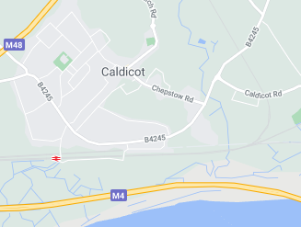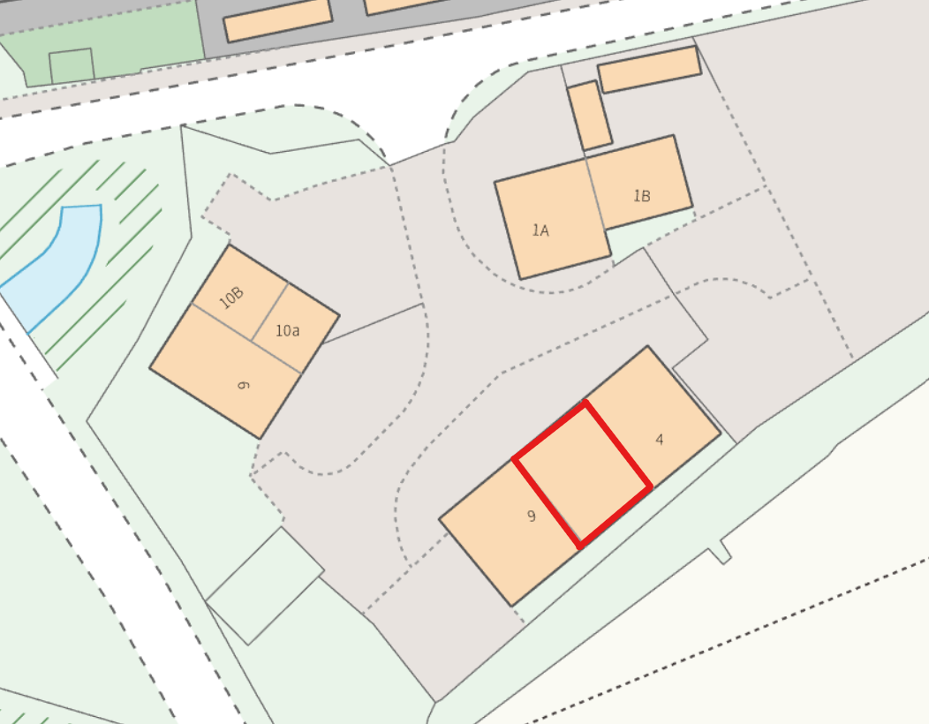


Misrepresentation Act:
Monmouthshire County Council give notice that:
These particular are set out as a general outline only for the guidance of intending purchasers or lessees and do not constitute, nor Constitute part of, an offer or contract.
All descriptions, references to condition and necessary permission for use and occupation and other details are given in good faith and are believed to be correct by any intending purchasers should not rely on them as either statements or representation of fact but must satisfy themselves by inspection or otherwise as to the correctness of each of them. All dimensions are approximate. No persons in the employment of Monmouthshire County Council has any authority to make or give any representation or warranty whatsoever in relation to this property. All correspondence regarding this offer is subject to contract. In the event of inconsistency between these Particulars and Conditions of Sale, the latter shall prevail.

