

Additional Learning Needs Policy

Monmouthshire’s Children, Learning, Skills and Economy Directorate

Additional Learning Needs Policy (January 2025)

This policy sets out Monmouthshire Local Authority’s approach and provision for learners with barriers to learning and additional learning needs (ALN).

Date of issue | September 2025
Updated
Review frequency | Every 3 years
Name of person responsible for maintaining this policy | Jacquelyn Elias
Contact details | JacquelynElias@monmouthshire.gov.uk

This document is available in English and Welsh.

Contents
Introduction 5
Definition and Scope 6
Monmouthshire’s ALN Service 6
Early Years 7
Designated Education Clinical Lead Officer 7
Promoting Inclusive Education 7
The Legal Framework: Responsibilities for Statutory Assessments and Plans 9
Barriers to Learning 9
Additional Learning Needs: Legal Definition 10
Identification and Assessment 10
Statutory Responsibilities of Maintained Schools 11
Statutory Responsibilities of the Local Authority 11
Admission to School or Nursery 12
ALN Transport 12
Request for a child or young person to be educated out of their chronological year group 12
Attendance and Exclusions 13
Children and Young People with Visual, Hearing or Multi-Sensory Impairments 14
Children and Young People with Complex Health Needs 14
Children Looked After (CLA) 14
ALN Statutory and Inclusion Panel 15
Specialist Provision 15
ALN Funding for Schools 16
Support for Children and Young People 17
Post-16 Provision 18
Quality Assurance of ALN Provision 18
Support Services for Schools, Children and Young People 20
Partnerships and Collaboration 20
Dispute Resolution 20
Complaints Procedure 21
Monitoring and Evaluation 21
Key Document Links 21
Appendices 21

Introduction
In Monmouthshire we believe that every child or young person has the right to receive an education that meets their individual needs and enables them to reach their full potential. As such, we are committed to providing inclusive, high-quality education for all children and young people, including those with barriers to learning and additional learning needs. This Additional Learning Needs (ALN) Policy outlines Monmouthshire’s approach to supporting children and young people with barriers to learning and additional learning needs, ensuring they receive the necessary support, resources, and opportunities to thrive academically, socially, and emotionally.

Monmouthshire local authority (LA) recognises that barriers to learning, and additional learning needs can encompass a wide range of challenges, including but not limited to, learning disabilities, neurodevelopmental needs, sensory impairments, and social, emotional, and mental health needs.

This policy is guided by our commitment to:

- Equality and Inclusion: Ensuring that all children and young people, regardless of their background or abilities, have equal access to education and opportunities for success.
- Person-Centred Approaches Recognising the unique needs of each child or young person and providing personalised support tailored to their specific requirements.
- Early Intervention: Identifying and addressing barriers to learning and additional learning needs at the earliest possible stage to prevent difficulties from escalating.
- Partnership Working: Collaborating with schools, parents/carers, and external agencies to provide comprehensive support and services for children and young people with barriers to learning and additional learning needs.
- Continuous Improvement: Regularly reviewing and evaluating our practices to ensure they are effective, responsive, and reflective of best practice.
- A bilingual system: Ensuring that specialist training, interventions, and resources are available in Welsh for children and young people in Welsh medium schools and settings.

Definition and Scope
This policy will refer to children and young people who are experiencing barriers to learning as well as additional learning needs as defined by the Additional Learning Needs (ALN) and Educational Tribunal Act, 2018 and associated Code. The LA’s responsibilities under the ALNET Act and Code applies to children from birth to 25 years. For the purposes of the Code and the Act, and this ALN Policy a ‘child’ is anyone not over compulsory school age and a ‘young person’ means a person over compulsory school age, but under the age of 25.

Monmouthshire’s ALN Service
The ALN Service is part of Monmouthshire’s wider Inclusion Service.

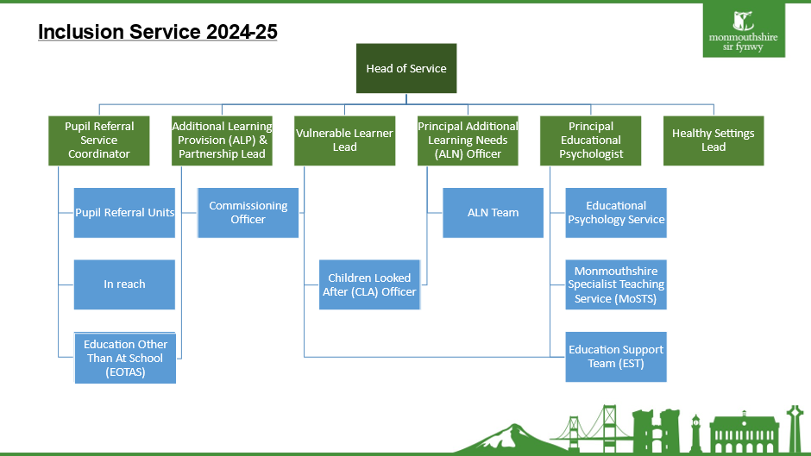

The ALN Service provides information and assistance to schools and parents/carers on all aspects of ALN provision. It also co-ordinates the local authority Inclusion Panel and Contingency Funding Panel (further details included below).

The ALN Service is responsible for undertaking statutory assessments for children and young people and maintaining LA Individual Development Plans (IDPs). Statutory Officers are responsible for writing LA IDPs and also provide advice and support to schools, children, and young people their families and carers.

The ALN section of Monmouthshire’s webpage (Additional Learning Needs - Monmouthshire) provides further information on ALN Service functions and the ALN team.

Early Years
Monmouthshire has an Early Years Additional Learning Needs Lead Officer (Early Years ALNLO) who has responsibility for co-ordinating the local authority’s functions under Part 2 of the Act in relation to children under compulsory school age who are not attending maintained schools. Contact details of the ALNLO and information on support for children under compulsory school age who may have barriers to learning or additional learning needs can be found via the following link Monmouthshire Early Years ALN Handbook.

Designated Education Clinical Lead Officer
The designated education clinical lead officer or DECLO is the person in the Aneurin Bevan University Health Board, who has responsibility for co-ordinating the Board’s functions in relation to children and young people with ALN. More information about the DECLO’s roles and responsibilities can be found in Chapter 9 of the ALN Code 2021.

Promoting Inclusive Education
An inclusive education system is one where every child or young person, regardless of their abilities or differences, feels valued, supported, and empowered to succeed. By working collaboratively with schools, families, healthcare professionals, and other stakeholders, we aim to continue to develop a culture of inclusion and support within schools and settings in Monmouthshire, where every child is valued for who they are and what they can achieve.

As indicated in the ALN Code (3.18, 3.19) meeting the needs of learners with ALN ought to be part of a whole school or setting’s approach to school improvement. Consequently, improvements in the teaching and learning of children and young people with barriers to learning or ALN cannot be isolated from improvements in the teaching and learning for children and young people across a school or setting as a whole.

This policy is designed to promote the inclusion of children with barriers to learning and additional learning needs in mainstream schools, wherever possible. We recognise that for many children, mainstream education provides the best opportunities for social integration, academic progress, and long-term success. Therefore, we are committed to ensuring that mainstream schools and settings have the training and resources to support the diverse needs of all learners.

To promote inclusion in all our schools and settings, we are committed to the following:
- Person-Centred Practice: Person-centred practice (PCP) puts the child or young person at the centre of decisions around their education. A person-centred approach will inform a one-page profile (OPP), which provides key information about the child or young person’s gifts and talents, what is important to them, and the best way to support them. We will work with schools and settings to ensure that person centred practice is used to inform discussions around statutory and non-statutory educational plans for children and young people with barriers to learning and ALN and that all children with barriers to learning or ALN have a one-page profile (OPP).
- Graduated Response: The importance of timely identification and of providing appropriate provision as soon as possible for a child or young person with barriers to learning or ALN cannot be overemphasised (ALN Code 3.13.). This may include differentiated learning, targeted interventions, use of assistive technologies, modified assessments, and peer support strategies to ensure that every child can access the curriculum and participate fully in learning activities. We will work with schools and settings to ensure they have identified a graduated response to barriers to learning and ALN, which provide timely access to interventions and support.
- Training and Support: Ongoing training and support will be provided for teachers and teaching assistants to develop their capacity to differentiate instruction, create inclusive learning environments, and meet the diverse needs of children and young people with barriers to learning and additional learning needs.
- Learner and Parent/Carer Participation: Central to a rights-based approach and to the ALNET Act, is the principle of participation – listening to children, their parents/carers and young people and taking their views meaningfully into account (ALN Code 3.5). The local authority will ensure that the views of children and young people and their families are actively sought in relation to ALN policy and practice and in the evaluation of ALN services. For more information see Appendix 1, MCC’s Participation Guidance.
- Equality and Accessibility: By prioritising equality and accessibility, schools can create a welcoming and supportive environment that supports all children and young people to thrive. Schools and settings have a legal obligation under the Equalities Act (2010) to provide equal opportunities for all children and young people, including those with disabilities and to ensure that they are not subjected to discrimination or harassment based on their disability. Schools and settings must strive to eliminate barriers to learning and ensure that every child and young person can fully participate in educational activities. This includes making reasonable adjustments for children and young people with disabilities, offering support for students from diverse cultural and linguistic backgrounds and promoting a culture of respect and acceptance among the school community.

The Legal Framework: Responsibilities for Statutory Assessments and Plans

Barriers to Learning
The ALN Code (Section 20.9) indicates that slow progress and low attainment do not necessarily mean that a child or young person has ALN and would not automatically lead to a decision that the learner has ALN. Equally, it ought not to be assumed that attainment in line with chronological age means that there is no ALN.
The ALN Code recognises that children and young people will inevitably progress at different rates so the fact that a child or young person is apparently underperforming by comparison with others of the same age is not, on its own, proof of ALN. Where progress is not adequate, it will be necessary for the school or setting to take some additional or different action to enable the learner to learn more effectively. Section 20.14 of the ALN Code states that;
‘The first response to inadequate progress would often be teaching targeted specifically at a learner’s areas of weakness. All education settings are expected to put in place differentiated teaching or other targeted interventions designed to secure better progress where appropriate, for all learners. Indeed, most children and young people will require a differentiated approach in some aspect of their education at some point. This is a fundamental element of high quality – but routine – teaching.’
Differentiated teaching does not, itself, constitute Additional Learning Provision (ALP) and just because a child or young person requires a differentiated approach does not mean that they have ALN. Monmouthshire LA is committed to ensuring that all schools and settings adopt a graduated response’, to ensure that the needs of learners experiencing barriers to learning are appropriately met (see Appendix 2 ALN Identification Flowchart for Schools).

Additional Learning Needs: Legal Definition
Section 2 of the ALNET Act, 2018 defines the term ‘additional learning needs’ (ALN), as,
(1) A person has additional learning needs if he or she has a learning difficulty or disability (whether the learning difficulty or disability arises from a medical condition or otherwise) which calls for additional learning provision.
(2) A child of compulsory school age or person over that age has a learning difficulty or disability if he or she— (a) has a significantly greater difficulty in learning than the majority of others of the same age, or (b) has a disability for the purposes of the Equality Act 2010 which prevents or hinders him or her from making use of facilities for education or training of a kind generally provided for others of the same age in mainstream maintained schools or mainstream institutions in the further education sector.
(3) A child under compulsory school age has a learning difficulty or disability if he or she is or would be if no additional learning provision were made, likely to be within subsection (2) when of compulsory school age.
(4) A person does not have a learning difficulty or disability solely because the language (or form of language) in which he or she is or will be taught is different from a language (or form of language) which is or has been used at home. (ALN Code 2.3)

Identification and Assessment
The ALN Code describes the duties on maintained schools, local authorities, and further education institutions (FEIs) to decide whether a child or young person has ALN, which requires additional learning provision (ALP). ALP encompasses additional or different educational or training provision, which goes beyond that generally made available. An Individual Development Plan (IDP) will be provided for a child or young person identified as having ALN requiring ALP; this statutory document will include a description of the child or young person’s needs, their one-page profile (OPP) and ALP deemed necessary to meet their needs. Once an IDP is issued, it should be reviewed on at least an annual basis. The ALN Identification Flowchart for Schools, is included as Appendix 2.

Statutory Responsibilities of Maintained Schools
Maintained schools are responsible for identifying whether a child or young person may have ALN and the subsequent decision as to whether the child or young person requires an IDP. This will include children attending nursery provision in a maintained school and young people attending post-16 provision in a maintained school. Schools have 35 days to complete an IDP assessment. The process schools have to follow should be available on the school website. The LA flow diagram for schools is included as Appendix 2.

Statutory Responsibilities of the Local Authority
The local authority (LA) is responsible for identifying whether a child or young person may have ALN and the subsequent decision as to whether requires an IDP for the following groups of children/ young people.
- Children attending non-maintained Nursery settings.
- Children or young people looked after (CLA).
- Children or young people attending Monmouthshire’s Specialist Resource Base Provision (SRBs).
- Children or young people attending out of county maintained special schools, independent schools or independent special post-16 institutions (ISPIs).
- Children or young people who are Electively Home Educated (EHE).
The LA has 12 weeks to complete an IDP Assessment.
The LA can, in certain circumstances, take responsibility for IDPs for children and young people attending maintained schools. Monmouthshire’s Principles Document is available via the website (www.monmouthshire.gov.uk/MCC-Principles-Document-2022) and describes the process that maintained schools would need to follow to request that the LA takes responsibility for a child or young person’s IDP.

Admission to School or Nursery
The School Admission Code (2013) gives parents /carers the right to express a preference for their child to be admitted to any school maintained by public funds. The following link, Applying for a school place - Monmouthshire provides detailed information on admission arrangements for children and young people who will be attending a maintained Nursery, Primary or Secondary school in Monmouthshire.
If a School or Nursery setting is oversubscribed, an oversubscription criteria will be applied. This indicates that a school must admit a child /young person to the school specified in their Individual Development Plan (IDP).
There is a separate process for parents/ carers who would like their child to be considered for a place in Monmouthshire Specialist Resource Base (SRB) provision, (see below). Parents/carers should note that until they have confirmation that their child has a place in a specialist provision, they need to continue to engage with admission arrangements as described in Monmouthshire’s School Admission’s Policy.

ALN Transport
Transport for children with ALN will only be funded by the LA:

- To take a child/ young person to their local school or nearest suitable school if he or she has major mobility problems, or
- If a child attends specialist provision (a special school or specialist resource base), that is not attached to their local school.

Transport will not be provided for children with additional learning needs if the child is attending a school due to parental preference, i.e. a school that is not considered by the LA to be the nearest suitable school.

Request for a child or young person to be educated out of their chronological year group
The local authority will consider requests to educate a child or young person out of their chronological year, on a case-by-case basis, taking into account the individual needs and circumstances of the child or young person. Schools should work closely with parents/carers and relevant educational professionals to assess the potential impact of educating a child / young person, out of their chronological year on their academic, social and emotional well-being. Monmouthshire’s ‘Placing Pupils Outside Their Chronological Year Group: Guidance’ is available.

Attendance and Exclusions
In addressing attendance and exclusions for children and young people with barriers to learning or additional learning needs, it is crucial that schools and settings adopt a holistic and inclusive approach that recognises and supports the unique requirements of each individual child or young person. Schools and settings should prioritise early intervention and support mechanisms to address attendance issues, working collaboratively with parents/carers and relevant professionals to identify and address any barriers that may be contributing to poor attendance.
Exclusions should only be considered as a last resort and when a school has exhausted all avenues to support the child or young person’s needs within the school setting. It is essential for all schools and settings to ensure that children and young people with barriers to learning and ALN are included, valued and supported by promoting a culture of understanding, acceptance and empowerment within the school community.
Monmouthshire’s Inclusion Service provides training and support for children and young people who are experiencing emotionally based school avoidance (EBSA) and training related to trauma informed practice. Information about and links to professional learning and training opportunities available to staff in schools and settings is regularly communicated to senior leaders and ALNCos. A range of information, resources and recorded training is also available via a training portal, which is located on the Monmouthshire internal SharePoint site and is accessible to all school staff or Monmouthshire professionals via this link (Inclusion Training Portal Pages (SharePoint).
Further information on attendance and engagement can be found in Welsh Government’s guidance on improving learner engagement and attendance, ‘Belonging, engaging and participating’ and in Monmouthshire’s Attendance and Engagement Policy.
The Welsh Government guidance on exclusions focuses on addressing the high rates of absenteeism that have persisted since the COVID-19 pandemic. Monmouthshire’s Exclusions Guidance for Schools (Key Document 1) provides further guidance for schools and settings.

Children and Young People with Visual, Hearing or Multi-Sensory Impairments
The local authority has a statutory duty to establish and maintain a register of those in their area who are sight (VI) or hearing impaired (HI) or have a combination of both (Multi-Sensory Impairment - MSI), such that it has a significant effect on their day-to-day lives (ALN Code section 2.27). The regional Sensory and Communication Service (SENCOM) provide Monmouthshire LA with information on children and young people with HI, VI, and MSI. This information is cross-referenced with school PLASC data to ensure that information included the register is accurate. The register is maintained by the ALN Service and updated bi-annually.

Children and Young People with Complex Health Needs
Welsh Government provides guidance for children and young people with complex health care needs in its guidance document. This guidance emphasises the importance of collaboration between health and education professionals as well as the involvement of parents and carers, to develop individual health care plans (IHCP).

Monmouthshire’s Education Other than at School (EOTAS) Policy (Appendix 3) provides information regarding the referral process for children and young people who may require EOTAS due to short-term illnesses/injuries or longer-term complex health or mental health needs.

Children Looked After (CLA)
Monmouthshire local authority has statutory responsibility to maintain IDPs for all children and young people for whom Monmouthshire is the Corporate Parent. This means that whether a child or young person looked after by Monmouthshire lives in the county or in another local authority in Wales, the responsibility for writing and maintaining the IDP remains with Monmouthshire. The local authority has a Statutory Officer with specific responsibilities for CLA, who works across both the ALN Statutory and Vulnerable Learners Services to ensure a consistent and cohesive approach.

If a looked after child or young person has an IDP, it will also include the child or young person’s Personal Education Plan (PEP). The ALN Code makes it clear that both statutory documents should be reviewed at the same time.

If a school is concerned that a Monmouthshire child who is looked after has additional learning needs, they need to follow a graduated response and if following a period of intervention and review, concerns remain, the school ALNCo should make the local authority aware of this and provide information to the LA Panel, where consideration will be given to whether a statutory assessment is appropriate. Chapter 14 of the ALN Code provides detailed information on the duties, maintained schools have in relation to children and young people who are looked after and who have ALN.

ALN Statutory and Inclusion Panel
All decisions relating to commencing a local authority IDP assessment or agreeing to a local authority IDP being written, are taken at the ALN Statutory Panel. The ALN Statutory Panel is part of a wider Inclusion Panel, which takes place every three weeks. The function of the Inclusion Panel and terms of reference are included in Key Document 2.

Specialist Provision
Monmouthshire local authority does not have a discrete special school catering for children and young people with significant and complex ALN. Since local government reorganisation in 1996, Monmouthshire developed a model of specialist provision, which places special education at the heart of identified mainstream schools. This model ensures that children and young people remain as close to their communities as possible and have meaningful inclusion opportunities with their mainstream peers, whilst also benefitting from specialist teaching and resources.
Two primary Specialist Resource Bases (SRB), two secondary SRBs and one 3-19 through school provide additional learning provision (ALP) for children and young people with highly complex learning and neurodevelopmental needs. Lead Teachers from the SRBs and officers from the local authority Inclusion Service, work collaboratively through a Specialist Provision and Outreach Team (SPOT) network to ensure that there is equity of provision and consistent practice across Monmouthshire’s specialist settings. See Appendix 4 Specialist Resource Base Policy and Handbook.

A Panel approach is taken to all admission to the SRBs. Learners will have an IDP, and their attainment will be significantly below that of their age-appropriate peers, despite significant differentiation and intervention.
The following website link will provide more information on specialist provision in Monmouthshire, Specialist Resource Bases - Monmouthshire.

ALN Funding for Schools
Following a full consultation with headteachers and agreement by Council, ALN Funding has been delegated to schools since 1st April 2022.

The agreed funding formula bases 70% of the allocation of ALN funding on the numbers of pupils on roll of the school with 30% of the funding allocated to children or young people with IDPs or to pupils with highly complex medical needs as evidenced by their Individual Health Care Plan.

In addition to ALN delegated funding, schools are expected to use 5% of their Age Weighted Pupil Unit (AWPU) funding to support children who have barriers to learning or ALN in their school.

A Contingency Fund has been reserved to support exceptional and unanticipated ALN needs. A Contingency Panel meets on a half termly basis to consider requests from schools for additional funding. Further details of the Contingency Funding Panel criteria are included in Key Document 3.

Support for Children and Young People
Monmouthshire LA recognises the importance and value of trusting relationships with key adults for children and young people, particularly for those with attachment and trauma related difficulties. The LA supports the ‘team around the child’ approach which provides a child with a small group of adults, who can provide support for a child as necessary, throughout a school day. Our approach aims to develop independence, resilience and friendships in a modelled, scaffolded and supported way.

The LA does not endorse using ‘one-to-one support’ terminology in IDPs or one-page profiles. The reason for this is that identifying direct support from a named adult can make children feel separated from their peers and can make them feel stigmatised or singled out. Additionally, some children may get very attached or dependent on their named adult, usually a teaching assistant (TA), which can have a negative impact on a child should the TA be absent, leave their post or be allocated to another pupil. Over-dependence on one TA can also be a significant barrier to a child becoming independent and resilient in the school setting.

For some children, a risk assessment may identify times during a school day when individual support may be necessary e.g. individual supervision during lunchtime due to risk of choking. Where a risk assessment identifies the need for individual support, this should be reviewed regularly and a ‘step-back’ approach taken, where progress has been made.

The local authority aims to support schools to develop resilient, independent, successful and engaged (RISE) learners. We believe this is essential to support progress as children and young people move through education and beyond. We recognise that the approach we take to developing this will be individualised and person centred based on pupil need.

Schools can access whole staff RISE training, which focuses on the role of adults working with children and young people to teach, model and support the rehearsal and practice of the skills needed to access and make progress in core aspects of learning.

Post-16 Provision
Young people with an identified ALN and attending SRB provision can remain in their setting until they are 19 years old. The local authority remains responsible for maintaining their IDP until they leave school or if they transition to an independent special post-16 institution (ISPIs), until they leave that setting.
Under the ALNET Act and Code, young people with ALN transferring to Further Education Institutions (FEIs) for post-16 education, will usually have their IDPs transferred to the FEI, who would then maintain the IDP in line with guidance set out in the ALN Code. For young people with ALN transferring to an ISPIs, the local authority will continue to maintain the IDP. Further information is included in MCC’s ALN Post 16 Strategy (Appendix 5).

Quality Assurance of Additional Learning Provision (ALP)
Chapter 7 of the ALN Code indicates that local authorities must keep under review the arrangements made both by the authority, and by the governing bodies of the maintained schools in its area, for children and young people who have ALN. Keeping ALP and other arrangements under review, is a key part of local strategic planning and decision making. It will enable local authorities to assess current and likely future needs and secure sufficient provision and services to meet those needs.

The duty involves the local authority considering, at a strategic level, what provision there is to meet needs; whether that provision is sufficient and if insufficient in any respects, considering what to do to remedy the matter; and consulting as the authority considers appropriate during that process.

As part of the review process the ALN Code indicates that a local authority should also review data and evidence on the effectiveness of current provision in meeting children and young people’s needs and improving the outcomes they achieve.

Monmouthshire local authority has developed a robust quality assurance (QA) system for both specialist and mainstream provision (see figure 2 below).

Figure 2 Quality Assurance System for ALN

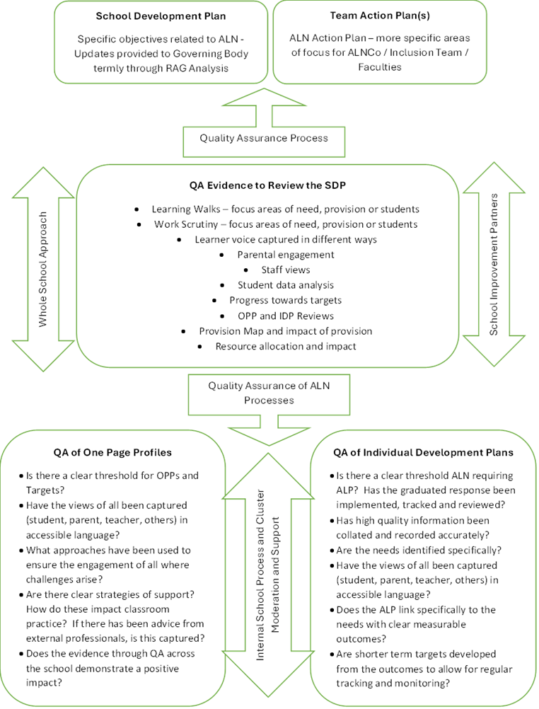

Further information on Monmouthshire’s quality assurance system and review cycle can be found in Appendix 6.

Support Services for Schools, Children and Young People
Schools and Settings in Monmouthshire have access to a number of services and specialist teams who support schools, children and young people and their families. Follow the links below for more information on each service or team.

- Educational Psychology Service (EPS) - Monmouthshire
- Monmouthshire Specialist Teaching Service (MoSTS)
- Outreach, Autism Support and Inclusion Service (OASIS) (Appendix 7)
- Education Support Team (EST) - Monmouthshire
- Monmouthshire Autism in Schools and Settings

Partnerships and Collaboration
Monmouthshire LA works with partners with the region and nationally to develop training, resources and provision for schools and settings, and for children and young people with barriers to learning and ALN. Follow the links below for more information on these organisations.

- SENCOM - Sensory & Communication Support Service
- CALDS - Child and Adolescent Learning Disability Service
- AET- Autism Education Trust

Dispute Resolution
Wherever possible every effort should be made to resolve any disputes relating to ALN identification and provision at the earliest opportunity (see Appendix 8).

Where disagreements cannot be resolved, parents/ carers and young people can lodge an appeal with the Education Tribunal for Wales (ETW). The ETW deals with disputes to do with Individual development plans (IDP) and claims of disability discrimination. Their website provides detailed guidance on both these areas for appeal - Welcome to the Education Tribunal for Wales.

SNAP Cymru is the regional independent parent partnership service provider (see website Home - Snap Cymru).

Complaints Procedure
Parents /carers or young people wishing to make a complaint about matters relating to ALN that have been managed by a school, should follow the school’s complaints procedure.
Parents /carers or young people wishing to make a complaint about matters relating to ALN that have been managed by the local authority should follow the local authority complaints procedure - Complaints, Comments, Feedback and Compliment - Monmouthshire.

A copy of Monmouthshire’s Complaints and Compliments Policy is available via their website (link here - Whole Authority Complaints and Compliments Policy, 2016).

Monitoring and Evaluation
This ALN Policy will be monitored and evaluated on an annual basis to ensure its effectiveness and to identify areas for improvement.

Key Document Links
- Monmouthshire’s Exclusion Guidance for Schools - MCC Exclusions Guidance to Schools.pdf
- Inclusion Panel Terms of Reference
- Contingency Funding Information
Some of the Key Document rely on internal Monmouthshire links. If these do not work for you, or you would like a copy of any of these documents (in Welsh or English) please email ALN@monmouthshire.gov.uk.

Appendices
- Monmouthshire’s Participation Guidance
- ALN Identification Flowchart for Schools
- Monmouthshire’s EOTAS Policy
- Specialist Resource Base Policy and Handbook
- Monmouthshire’s ALN Post 16 Strategy
- Quality Assurance System and Review Cycle
- Information about Outreach and Education Support Team
- Dispute Resolution

Additional Learning Needs and Education Tribunal (Wales) Act 2018 (legislation.gov.uk)
The Additional Learning Needs Code for Wales (Welsh Gov, 2021)
The Additional Learning Needs Code for Wales (Welsh Gov, 2021)
Equality Act 2010 Guidance (Gov.Uk)
School Admissions Code (Welsh Gov, 2013)
Belonging, engaging and participating: Guidance on improving learner engagement and attendance (Welsh Gov, 2023)
Exclusion from schools and pupil referral units (Welsh Gov, 2024)
Pupil level annual school census (PLASC) | GOV.WALES
Supporting Learners with Healthcare Needs (Welsh Gov, 2017)

