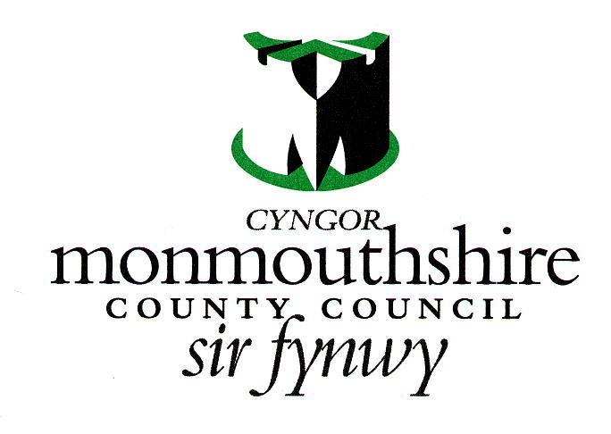

MONMOUTHSHIRE COUNTY COUNCIL
MEMORIAL TREE APPLICATION FORM

Applicant and tree details:

Applicant name:
Address and postcode:

Contact Tel number:
Contact Email address:
Cemetery name:
Grave plot number or full name of deceased to be remembered on the memorial plaque:

Details of wording, images or motifs on the memorial plaque:

MCC will only permit dwarf varieties of trees and preference is given to ornamental or fruit trees.

Variety of tree (species and common name)

Please note:
The Council reserves the right to refuse an application based upon (but not limited to) the variety of tree, the requested location, and the memorial plaque inscription.

Deciding factors will include available space, proximity to other memorials, graves, and paths.

Permission will be granted following a successful application and the Applicant agreeing to the process, the terms and conditions and payment being made. Payment is for the planting of the tree (fee to be advised at time of application).

The Applicant is responsible for purchasing the agreed tree, as per the application, and arranging its delivery to the cemetery at a date and time agreed with the Cemetery Service.

Terms and conditions
Only the tree that has been agreed upon will be permissible. If the tree differs in any way, then it will be refused and its planting in the cemetery will not be permitted.

Once the tree is planted it becomes the property of Monmouthshire County Council.

As such:
MCC will maintain/pruning the tree as is necessary and as it sees fit (without prior notification to the Applicant), to keep the tree in a healthy condition, keep it at appropriate height and span for its location and to prevent it from hindering access.

MCC will remove the tree should it become unsafe or too large for its location. MCC holds no responsibility, under such circumstances to replace the tree or to replant it elsewhere in the cemetery.

Under circumstances where the tree is to be removed, MCC will make all reasonable endeavours to contact the Applicant prior to its removal. However, if there is an immediate safety issue this may not be possible.

Any additional adornments on and around the tree, other than the agreed memorial plaque, are not permissible and will be removed by the Council.

The land upon which the tree is planted remains the property of the Council.

The Applicant acknowledges and agrees that the Council may revoke this permission at its absolute discretion at any time and shall reserve its right to revoke the permission in the event that the applicant breaches any of the terms and conditions.

I, the Applicant (as per below) agree to adhere to the terms and conditions above
Applicant Signature:
Date:

Please return the completed form to, cemeteries@monmouthshire.gov.uk or to the address at the bottom of the form.

