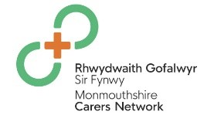 MONMOUTHSHIRE CARERS NETWORK
SIGN UP TO RECEIVE THE CARERS NEWSLETTER
Are you over 18 and provide unpaid care for someone such as a relative or friend who lives in Monmouthshire?
Would you like to receive information and access to support that can help you in your caring role?
Why not sign up to be part of the Monmouthshire Carers Network.
- You'll receive a biannual Carers Newsletter with a range of local and national unpaid carers information.
- Access to free events and activities so you can have time away from your caring role and the opportunity to meet other unpaid carers.
- Access to apply for 25% discount at MonLife Leisure Centres.
To sign up, please return the form below either by email, post or scan the QR code for Microsoft Forms.
Email: Carers@Monmouthshire.gov.uk
Post: Monmouthshire County Council, Carers Team, County Hall, Rhadyr, Usk, Monmouthshire, NP15 1GA.
Name: | Date of Birth:
Please indicate if you want to receive correspondence via email or post?
Email: Post:
Please provide email address:
Home address:

Telephone Number:
Name and Address of the Person you care for.

Signed: Date:

If you have directly referred yourself, or you are not known to the Carers Team, you may receive a call from our Carers Team to see if there is any support you may need in your caring role.

