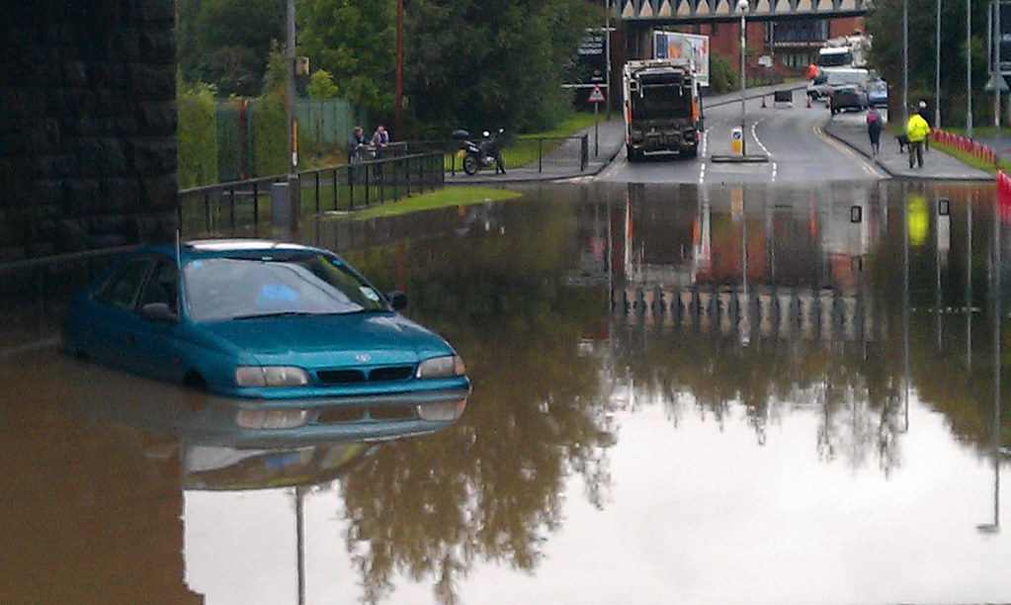
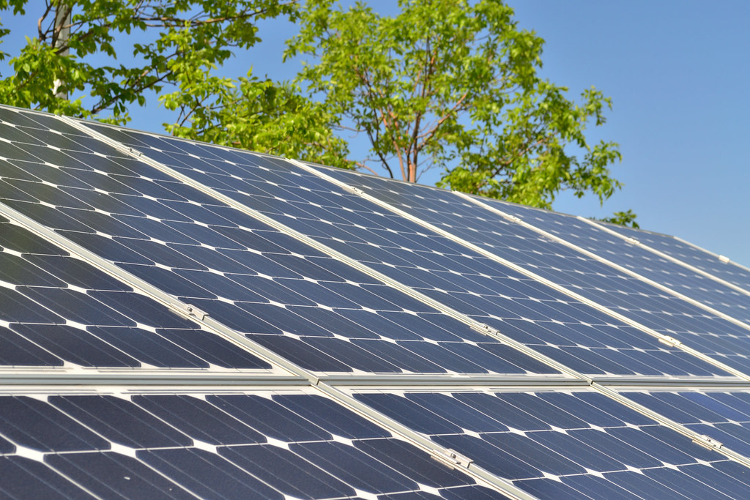
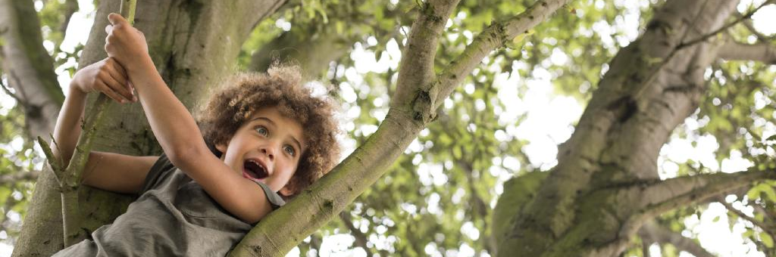
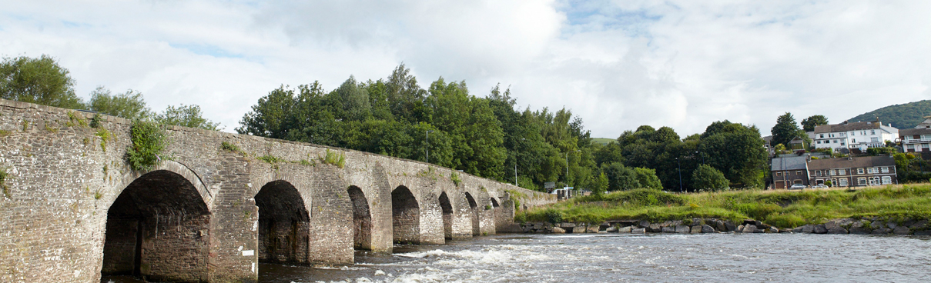
Monmouthshire County Council
Climate and Nature Emergency Strategy
May 2024

Title | Climate and Nature Emergency Strategy
Purpose | This strategy outlines the council’s response to the climate emergency declared in May 2019, the Motion for Rivers and Ocean declared in March 2022 and the nature emergency
Owner | Monmouthshire County Council
Approved by | Cabinet
Date | 15th May 2024
Version Number | 3.0
Status | Agreed and adopted
Review Frequency | Annual
Next review date | May 2025
Consultation | N/A

Contents

Foreword 4
Background 6
Setting the scene 7
Climate Change and carbon emissions 7
Nature recovery 9
Rivers and ocean 10
How are we responding? 12
Climate Adaptation 15
The benefits of action 16
Playing your part 16
Monitoring progress 17
Annex 1 - The Council’s Carbon Emissions – How they are calculated and reported 18

Foreword

How we reduce our contributions to climate change, manage the impacts of climate change and reverse the decline in species and habitats is one of the major challenges facing society today. At Monmouthshire County Council, we recognise that we have a critical role to play by looking at our organisation, estate and assets and how we manage them to reduce carbon and improve biodiversity. But perhaps even more significantly we have a hugely important role to play in working with other organisations, community groups, business and others to help everyone who visits, lives or works in Monmouthshire to reduce their environmental impact too.
Our Community and Corporate Plan sets out our purpose “to become a zero-carbon county, supporting well-being, health and dignity for everyone at every stage of life”. One of the objectives which will deliver this purpose is to work towards a Green Place for people to live and work, with reduced carbon emissions, and making a positive contribution to addressing the climate and nature emergency.
In 2019 councillors in Monmouthshire were unanimous in declaring a climate emergency. Since that date, the Council has published a climate emergency action plan, and then updated it and increased the focus on the nature emergency. In 2022 we declared a Motion for the Rivers and Ocean, and are working with multiple partners to try and improve water quality in our rivers.
This strategy aims to tie together the focus on all of these areas of work, and forms a high level strategy under which 4 action plans sit, which address Council Emissions, Nature Recovery, Rivers and Ocean and Communities and Climate.
We recognise that we cannot address the climate and nature emergencies alone. All of the action plans require us to work with public bodies, partners, businesses, community groups and individuals.
We recognise the outstanding beauty of Monmouthshire. As custodians of this stunning place we need to encourage residents and visitors to enjoy it, protect it and conserve it. The natural world in all its guises is the backdrop to our tourism and visitor economy. We will work with others to promote access to our special places whilst protecting the environment, support nature recovery, reduce our carbon emissions, reduce the risk of flooding and promote the circular economy.
But even if we do all these things, we will still see the impacts of climate change such as warmer, wetter winters, hotter, drier summers and more extreme weather events. We need to ensure that our county is resilient to these impacts and that people, society and nature are able to adapt to a changing climate.
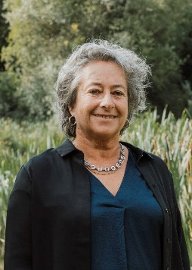
These are all big challenges, that we are undertaking at a time of great financial pressure on the council against a backdrop of the cost of living crisis. It will not be easy, but we are committed to working with others to do all that we can to address the climate and nature emergencies for the wellbeing of present and future generations.

Cllr Catrin Maby,
Cabinet Member for Climate Change and the Environment

Background

In May 2019 Monmouthshire County Council declared a Climate Emergency, with unanimous support from Councillors across all parties. This set out a clear policy commitment for the council to:
- strive to reduce its own carbon emissions to net zero in line with the Welsh Government target of 2030;
- encourage and support residents and businesses to take their own actions to reduce their carbon emissions;
- Work with partners across the county and other councils and organisations to help develop and implement best practice methods in limiting global warming to less than 1.5 °C.
In October 2019 an action plan and strategy was adopted which set out how we planned to do this. The Action Plan was refreshed in 2021 to better reflect our commitment to tackling the nature emergency, and in 2024 has been completely reviewed to reflect the priorities of Monmouthshire’s Community and Corporate Plan. Since 2019, there has been a greater focus on how tackling the nature emergency is an intrinsic part of how we address the climate emergency. In addition, we have declared a Motion for the Rivers and Ocean which sets out how we will work in partnership to play our part in reducing river pollution and protecting the ocean. The Council’s Climate and Nature Emergency Steering group has helped to develop this new integrated approach. This new overarching strategy is underpinned by 4 different work streams with action plans, as set out below, which between them incorporate how we will address both the Climate and Nature Emergencies:
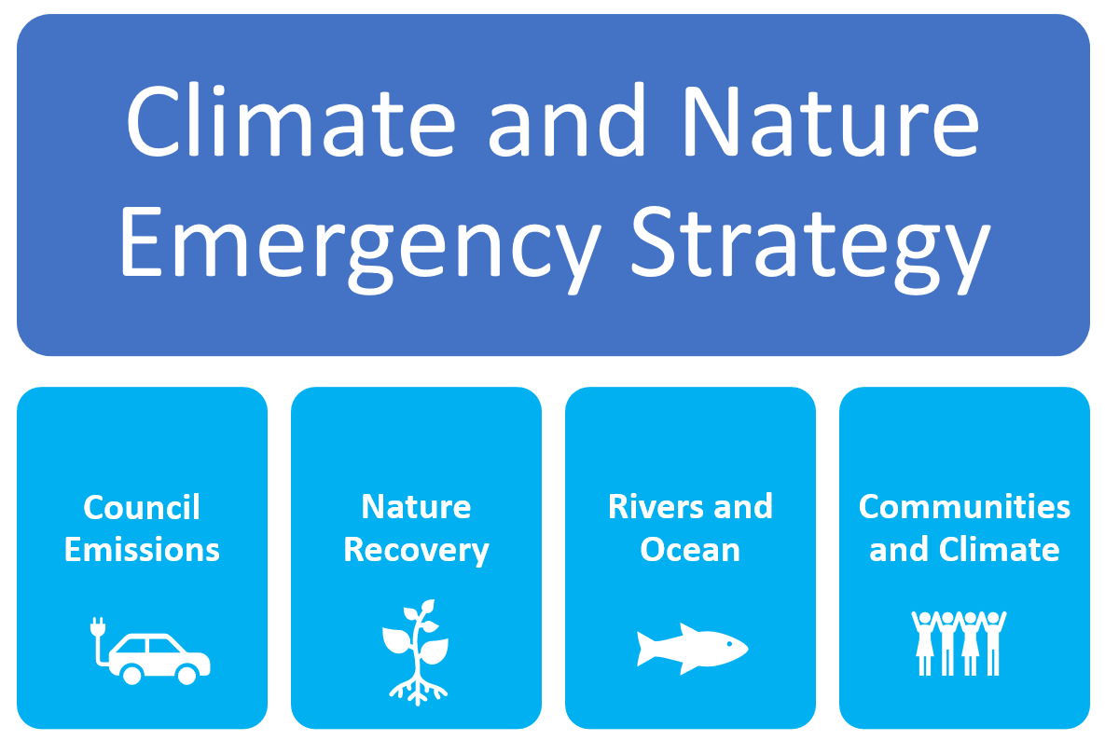
This strategy is an important contribution to the council’s purpose which is: “a zero carbon county, supporting well-being, health and dignity for everyone at every stage of life”.

Setting the scene

Climate Change and carbon emissions

We cannot fail to have seen the plethora of reports and evidence that are pointing to a changing climate. The UK 3rd Climate Change Risk Assessment published in 2021 states that the average annual UK temperature is 1.2 degrees warmer than in the pre-industrial period, the likelihood of experiencing hot summers like 2018 have doubled, and since 1900 sea level around the UK has risen by 16cm and is set to continue. The impacts of these changes are numerous, affecting the natural environment, infrastructure, health, communities, the built environment, business, industry and international relations.
Our climate is changing as a result of man-made greenhouse gas emissions, and in particular carbon dioxide. So what is Monmouthshire’s contribution to carbon emissions? Since 2005 net carbon emissions across the county as a whole have reduced by 32% from 924 kilotonnes to 625 kilotonnes of CO2 equivalent per year in 2021 while our population has increased by around 5% over the same period. The graph below shows this trajectory, with a slight drop in 2020 as a result of the Covid pandemic. The downward trajectory mirrors a similar trend across the UK as a result of things like an increase in the use of cleaner energy.

Source: UK Local Authority and Regional Greenhouse gas emissions national statistics 2005 to 2021
What are the main sources of carbon emissions in Monmouthshire? The pie chart below shows the breakdown of where Monmouthshire’s emissions are from. Just under half of emissions come from transport (which includes all road transport and diesel rail) and around a quarter from domestic properties. This reflects the rural nature of the county with more journeys being made by car, as well as major trunk roads carrying private cars and commercial vehicles running through the county, together with relatively old and energy inefficient housing stock. This data indicates where we will need to take action if the county is to play its part in reducing global emissions.

Source: UK Local Authority and Regional Greenhouse gas emissions national statistics 2005 to 2021

In 2021, Monmouthshire’s per capita CO2e emissions were 6.7 tonnes CO2e, higher than the UK average of 4.8 tonnes, but lower than the Welsh average of 7.3 tonnes (which is heavily skewed by the steelworks emissions in Neath Port Talbot).
The Council does not control or have a direct influence on all the things that need to change to reduce emissions in the county. You can see from the pie chart that the public sector only accounts for 2% of Monmouthshire’s emissions. This is why it is important that as well as working hard to reduce our own emissions, Monmouthshire County Council will also work closely with the Public Service Board, local businesses and community groups to reduce emissions.
The Council itself was responsible for 44,248 tonnes of CO2e emissions in 2022/23, which is steadily decreasing year on year, as the following graph shows. Emissions in 2022/23 were 17.8% lower than the 2019/20 baseline. The graph also shows that a significant proportion of the Council’s emissions are from the supply chain – in other words from goods and services which we procure. Annex 1 gives more details about how the council’s carbon emissions are measured and reported.
1124 tonnes of CO2 were avoided through renewable energy generation, from solar panels on Council buildings and from the Council’s solar farm at Oak Grove Farm in Crick.
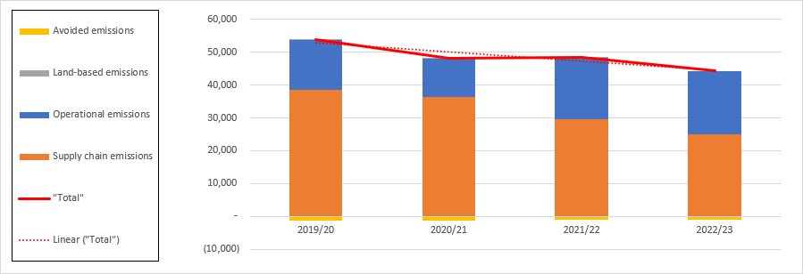
Monmouthshire County Council Tonnes of CO2e per year

Source: Monmouthshire County Council return to Welsh Government for 2022/23

Nature recovery

It is important that the climate emergency and the nature emergency are considered hand in hand, since the two are so interlinked. Climate change is having a significant impact on habitats and species, and is one of many pressures on our natural world. At the same time, our green infrastructure has a crucial role to play in helping to mitigate the impacts of climate change, reduce flooding, build resilience and sequester (or lock away) carbon. A degraded natural environment will be less able to offer these benefits, as well as other important services we refer to as ecosystem services, such as providing food and timber, health and wellbeing benefits, tourism, pollination and many more.
We are facing a biodiversity crisis, globally, nationally and locally. Within the UK 38% of species in decline, with one in six species threatened with extinction.
Latest data from the State of Nature 2023 report for Wales shows that since monitoring of 380 Welsh species began in 1994, the numbers of those species has declined on average by 20%, and 42% of Wales’ plant species are found in fewer places than before. The need for nature recovery in our local area is also clear with 34% of the 100 species considered in the Greater Gwent State of Nature report showing a decline in their numbers . Only 12% of the species that were studied showed stable populations.
The State of Natural Resources Report 2020 (SoNaRR) reported that all ecosystems in Wales had only low to moderate resilience. Climate change, pollution, invasive non-native species, habitat loss and deterioration, over-exploitation, pests, and disease were all given as significant pressures and demands affecting the resilience of ecosystems.
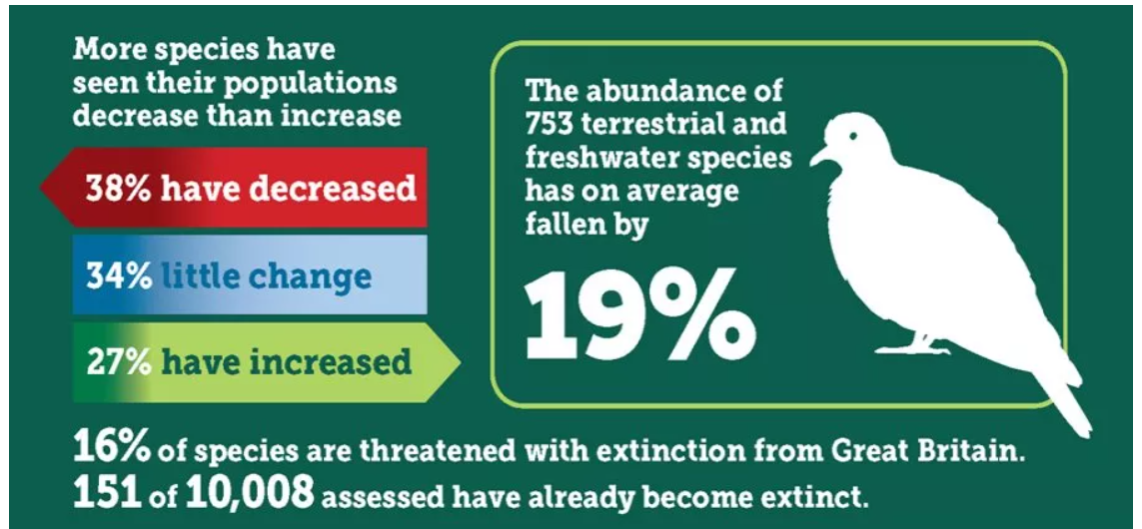
Source: State of Nature 2023 https://stateofnature.org.uk/infographics/ data for the UK

Rivers and ocean

The health of our rivers, waterways and ocean is a particular area of concern which led to the adoption of an action plan following the Council’s Motion for the Rivers and Ocean.
Phosphate targets for the Usk are being failed at a rate of 88% and the Wye at 68%. Algal blooms smother other life in the rivers having a direct impact on the species that they provide habitat for. The health of our rivers is also affected by litter, in particular plastics which can be seen on riverbanks. Studies have also found increasing levels of microplastics in fish and other species.
The health of our ocean is inextricably linked with our climate and with human health, wellbeing and prosperity. A healthy ocean is fundamental in regulating the global climate system and is an essential ally in our fight against climate change. The ocean absorbs more than 90% of the excess heat in the climate system as well as absorbing around 20% of annual carbon dioxide (CO₂) emissions generated by human activity. The following diagram illustrates how much carbon is sequestered and carbon storage potential in Welsh seas.

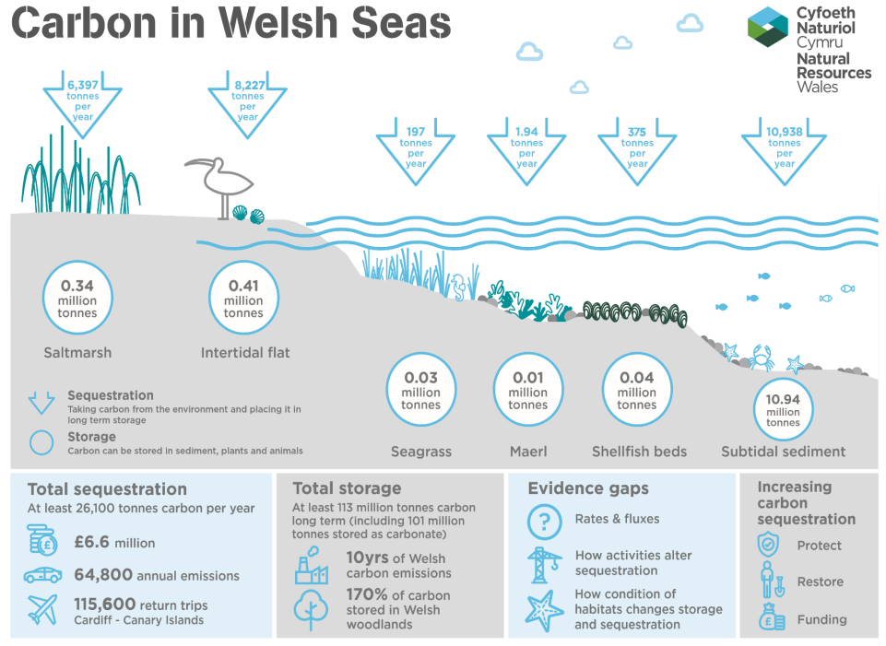
Source: SoNaRR 2020 SoNaRR2020 Ecosystem: Marine (naturalresources.wales)

An ocean in crisis, and likewise rivers in crisis are not only bad news for our climate, but also for our fishing industry, aquaculture industry, tourism industry and for the health, wellbeing and prosperity of our coastal and river communities. Delivering the pledges set out in the Motion for the Rivers and Ocean could yield new jobs and opportunities, more resilient coastal and riverside economies, and happier, heathier people; as well as a cleaner, healthier and more productive natural environment. Healthy oceans and rivers are essential allies in our fight against climate change.

How are we responding?

Climate change, the nature emergency and the condition of our rivers and ocean are all inextricably linked. This is why the Council’s response to these has been drawn together into this one overarching strategy. Under the strategy sit four different objectives, each with an action plan. Some of the actions within the 4 plans will link with the other plans, since climate, nature and rivers and ocean cannot be considered in isolation and all have links with each other.


Council Emissions

Purpose: Strive to reduce the council’s carbon emissions to net zero by 2030

This sets out how the council plans to reduce its own carbon emissions to meet the Welsh Government target of a net zero public sector by 2030 public sector. This is the commitment we made in our Climate Emergency declaration in 2019. The actions in this plan focus on the themes set out in the Welsh Government Decarbonisation Route Map of: Buildings, Mobility and Transport, Procurement and Land Use.

Objectives:
1 Strategic – Support the collection of data and resource management
2 Buildings – Reduce and remove the carbon emissions from our built environment
3 Transport – Reduce and remove the carbon emissions from operational, business and commuting emissions
4 Procurement– Reduce in-direct emissions from the supply chain
5 Land Use– Reduce emissions from land use polices and how the Council uses its land


Nature Recovery

Purpose: Maintain and enhance biodiversity and ecosystems resilience through the Council’s operations and working in partnership with communities

This action plan incorporates actions taken from the refreshed Biodiversity and Ecosystem Resilience Forward Plan, the Nature Recovery Action Plan and the Green Infrastructure Strategy. Actions include how the Council will maintain and enhance biodiversity when carrying out its own operations, as well as working with communities to help them restore and protect nature. Also included are landscape scale actions which are delivered in partnership.

Objectives:
1 Embed biodiversity throughout decision making at all levels
2 Provide nature-based opportunities to raise awareness, support health and well-being and encourage action for nature
3 Undertake land management for biodiversity and promote ecosystem resilience
4 Influence land management to improve ecosystem resilience
5 Tackle key pressures on species and habitats
6 Support landscape scale projects and partnerships to maximise delivery
7 Use improved evidence, understanding and monitoring to inform action
8 Monitor the effectiveness of the plan and review


Rivers and Ocean

Purpose: Work towards clean, healthy and productive rivers and ocean

Actions focus on ways to improve the quality of our rivers and ocean. Some of these actions the Council is the main lead on, but many of the actions rely on working in close partnership with neighbouring authorities and partners like Natural Resources Wales and Welsh Water.

Objectives:
1 Reduce sewage, phosphate and other chemical pollution in our rivers
2 Reduce plastic and other litter pollution in rivers and coast areas
3 Protect natural habitats along our rivers, estuaries and coast
4 Minimise the impacts of flooding on communities by mitigation and adaptation (rivers and coastal areas)
5 Raise awareness of the importance of our rivers and coasts


Communities and Climate

Purpose: Work with communities, partners and business to reduce carbon emissions

Since only 2% of Monmouthshire’s carbon emissions come from the public sector, it is really important that the Council works closely with communities, residents, partners and businesses to help them reduce emissions. This action plan sets out what the Council is doing to reduce wider emissions from across the county, not those which we are directly responsible for ourselves. This includes actions to help reduce emissions for example through active travel, waste and recycling and education.

Objectives:
1 Reduce energy use and increase renewable energy across the county
2 Reduce waste and what we buy by encouraging people to reduce, re-use and recycle more
3 Encourage active travel, public transport and low emission vehicles
4 Help people understand climate change and what they can do to make a difference
5 Prepare and adapt for the impact of climate change

Climate Adaptation

Even if we were to stop all carbon emissions today, we will still have to face the impacts of climate change that are already happening. Over the next few decades we are facing significant levels of climate change regardless of any action to reduce our emissions now. The 3rd Climate Change Risk Assessment for Wales published in 2021 forecasts hotter, drier summers, warmer, wetter winters and more extreme weather events. The Risk Assessment considered 61 different risks and opportunities from climate change, and in Wales 26 of these risks have increased in urgency in the 5 years since the previous Risk Assessment in 2016.
In particular risks include:
- The impacts of climate change on the natural environment, including terrestrial, freshwater, coastal and marine species, forests and agriculture.
- An increase in the range, quantities and consequences of pests, pathogens and invasive species.
- More frequent and severe flooding and coastal erosion, causing damage to our infrastructure services, homes, communities and business
- The impact of extreme temperatures, high winds and lightning on the transport network.
- The impact of increasing high temperatures on people’s health and wellbeing.
- Disruption to the delivery of health and social care services from extreme weather.
- Damage to our cultural heritage assets as a result of temperature, precipitation, groundwater and landscape changes.
- Impacts internationally that may affect the UK, such as risks to food availability, safety and security, risks to international law and governance from climate.
It is crucial that the Council gives careful thought to how it will respond to these risks. Rather than have a separate action plan for climate adaptation, adaptation is embedded into each of the four action plans, since they all need to identify climate risks, measures to mitigate those risks and opportunities to help nature and people to adapt.
Council services have begun thinking about what the potential risks to their services are, in order to start planning how to adapt to these risks. The Local Development Plan has a key role to play in making sure that our communities are sustainable and resilient to the impacts of climate change.
With an increase in winter rainfall and rising sea levels, flooding is likely to increase, and this will be a particular concern in parts of Monmouthshire. Much of the work to co-ordinate emergency responses is organised through the Gwent Local Resilience Forum (LRF). We will continue to work with partners on the LRF to make sure that we are prepared for severe weather events.

The benefits of action

It is important that addressing the climate and nature emergencies is done in a just and equitable way that does not widen inequalities. Those who contribute the least to climate change are often those who suffer the impacts of climate change the most, both globally and here within the UK. Solutions need to be developed that benefit everyone, not just those who can afford expensive new technologies. The aim of this strategy is that as well as reducing carbon emissions and helping to slow climate change, there will be other co-benefits that will benefit communities, business, visitors and everyone who lives and works in Monmouthshire. These include things like:
- Lower energy bills for residents and businesses
- Better air quality and the resulting health benefits
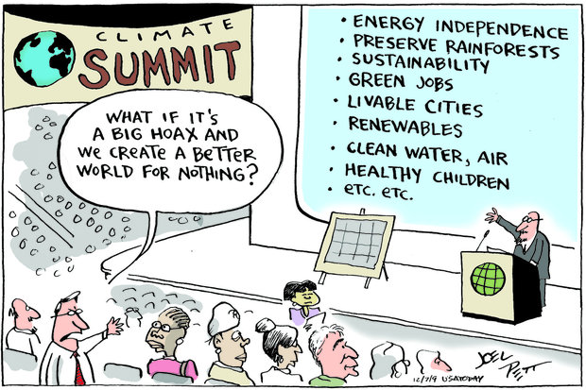
- Improved health and less congestion through use of active travel like walking and cycling
- Less damage to the local environment from drought, floods and fire
- Increased demand for green technologies and the resulting potential for job growth in these sectors
- Better habitat management, increased biodiversity and creation of green space
- Improved mental and physical health when people connect more with the natural environment
- More globally responsible citizens
- Benefits for tourism through maintaining an attractive, clean, green environment

Playing your part

The Climate Emergency Action Plan cannot be delivered by the Council alone. We need other partners to join us in helping to reduce carbon emissions across the county. To that end, we will be working with Public Service Board partners over coming months. Much decarbonisation work is also done at a regional scale, with close working with Cardiff Capital Region, and some of our actions will contribute to their Energy Vision and Strategy.
We hugely value the enthusiasm, energy and expertise of the residents of Monmouthshire who have such a lot to contribute, and we continue to collaborate with our communities and other partners to work together on our action plan. For example, Monmouthshire Community Climate Champions is a network of community organisations, town and community councils, council staff and elected members who are all working on practical projects to help reduce carbon emissions and build sustainable and resilient communities. The group has met quarterly since 2008 to share ideas and information and develop projects to reduce our impact on climate change.
There are things that every resident, visitor or worker in Monmouthshire can do to play their part in reducing carbon emissions and helping to slow down climate change. We are all part of the problem, but can all be part of the solution too. The Communities and Climate Action Plan sets out some of the steps that we can all take as individuals to help reduce our contribution to climate change.

Monitoring progress

It is important that we know whether the actions we will be taking to address the climate and nature emergencies are making a difference. Some things are easier to measure than others. We can measure how much carbon some of the actions will save, for example based on the Council’s energy or fuel bills. However, carbon savings from some of the actions in the wider community are much harder to measure, but we can at least make sure that we are doing what we have said we will do. Likewise, we can measure how many trees have been planted, or how many hectares of grassland have been managed for pollinators, but it can be very hard to quantify the impact that this has.
Each of the 4 action plans has a lead officer, responsible for driving progress and collating and reporting on progress. The actions are delivered by Service Area Officers/ Managers and coordinated by the Chief Officer – Communities and Place. This enables strategy ownership and delivery across all services. Progress will be reported regularly to councillors through the Climate and Nature Emergency Steering Group. The action plans contained within this strategy will be updated and reported on annually but the actions will be continuous, as we look globally for examples of leading edge practice that can help us accelerate our progress. Progress will be monitored by Performance and Overview Scrutiny, followed by the Cabinet member reporting to Cabinet on progress.

Annex 1 - The Councils Carbon Emissions – How they are calculated and reported
- Reporting Methodology
Welsh Government (WG) have an ambition for the public sector to be collectively net zero by 2030. This will require MCC to cut both our direct emissions from energy and our built estate and the indirect emissions arising from service delivery and procurement activities. To monitor progress against this target, Welsh Government have required the Welsh Public Sector to submit annual carbon emission returns since 19/20 . The reporting model is divided into three emission scopes as follows.
Scope 1 - are direct emissions from operations that are owned or controlled by the Council.
Scope 2 – indirect emissions from purchased electricity, heating and cooling.
Scope 3 - indirect emissions that occur in the value chain of the Council, e.g. purchased goods & services, business travel and employee commuting.

Welsh Government have developed a reporting template for recording public sector emissions which is illustrated in the table below:
Section | Category | Sources
Estate | Buildings | Generation of electricity, heat or steam  Generation, transmission & distribution of purchased electricity.  Generation, transmission & distribution of purchased heat or steam.  Fuel & energy related upstream activities.  Upstream leased assets (where not included elsewhere in the public sector)  Downstream leased assets
 | Land based emissions & Sequestration | Sequestration from owned estate
 | Waste generated in operations | Waste generated in operations.  Municipal waste collected
Transport | Fleet & other mobile equipment | Transportation of employees / goods in company-controlled vehicles.  Fuel and energy related upstream activities
 | Business Travel | Public Transport  Service Travel  Private car for business (grey fleet)
Supply Chain | Procurement | Purchased Services  Purchased Goods
Employees | Employee commuting | Employee commuting  Employee homeworking
Source : Welsh Public Sector Net Zero Reporting Guide Version 3

- Council Emissions
Public Sector organisations are required to submit annual returns each September that record the emissions generated in the preceding financial year. Monmouthshire’s return for the financial year 22/23 is detailed in the table below.
Buildings Fleets & Other Assets
Units of kgCO₂e
Categories | Direct – Scope 1 | Indirect – Scope 2 | Indirect – Scope 3 | Total
Buildings | 3,407,253 | 1,310,966 | 1,079,249 | 5,797,468
Streetlighting |  | 205,381 | 72,400 | 277,781
Fleet & equipment | 2,799,061 |  | 668,500 | 3,467,561
Total | 6,206,315 | 1,516,347 | 1,820.149 | 9,542,810

The WG template applies a standardised formula to inputted energy consumption data to calculate direct and indirect emissions. Whilst the Council purchases through a green tariff (100% renewable) we are still required to record the data assuming standard grid energy which does distort the electricity emissions factor. The green tariff can be factored into the renewable’s aspect of the template. In 22/23 we purchased 7,826,198 kWh of energy and generated 4,783,567kwh of renewable energy, 4,217,524kwh of which was exported to the grid.
Fuel and equipment emissions are calculated based on the purchased fuel data (1,006,176 litres of petrol, diesel and LPG for operational fleet and 93,268 litres of LPG, gas oil and diesel for equipment).
Business Travel
Units of kgCO₂e
Categories | Direct – Scope 1 | Indirect – Scope 2 | Indirect – Scope 3 | Total
Business Travel | 6,465 |  | 336,620 | 343,085
Commuting |  |  | 3,713,585 | 3,713,585
Homeworking |  |  | 700,832 | 700,832
Total | 6,465 |  | 4,751,038 | 4,757,503

In the above table, the business travel emissions are calculated using business mileage claims and emissions are determined by the vehicle size, fuel type and miles travelled. In 22/23, business mileage amounted to 1,045,008 miles of which 24,014 miles was travelled in vehicles hired by MCC, 1,460,354 miles was undertaken in private cars (5,325 in electric cars, 18,432 in hybrid) and 10,640 on public transport. Commuting data is calculated based on kilometres travelled and this has been calculated using home and work base locations, number of working days and agile working days (this is based on a staff survey in 22/23).
Homeworking emissions was introduced in 22/23 and is based on an estimate of the number of full-time equivalent staff and the average homeworking percentage. The emissions are generated from the assumed electricity and heating consumption when working from home.
Waste
Units of kgCO₂e
Categories | Direct – Scope 1 | Indirect – Scope 2 | Indirect – Scope 3 | Total
Organisational Waste |  |  |  | No data available
Municipal Waste |  |  | 226,320 | 226,320
Total |  |  | 226,320 | 226,320
No data for organisational waste was available at the time of the submission, hence why no emissions are recorded against this category. Municipal waste includes recycling tonnage, albeit the emission factor is substantially lower for recycling (9.122/kgCO2e/unit) than landfill (436.007/kgCO2e/unit).
Supply chain – Tier 1 & Tier 2 combined
Units of kgCO₂e
Categories | Direct – Scope 1 | Indirect – Scope 2 | Indirect – Scope 3 | Total
Agriculture, forest & fishing |  |  | 250,673.2 | 250,673.2
Mining & quarrying |  |  | 101,644.97 | 101,644.97
Manufacturing |  |  | 5,781,879.90 | 5,781,879.90
Water supply, sewerage, waste management & remediation |  |  | 4,764,308.87 | 4,764,308.87
Construction |  |  | 7,687,025.34 | 7,687,025.34
Transportation & Storage |  |  | 4,090,752.93 | 4,090,752.93
Accommodation & food service activities |  |  | 141,483.85 | 141,483.85
Information and communication |  |  | 337,483.12 | 337,483.12
Financial & insurance activities |  |  | 78,562.22 | 78,562.22
Professional, scientific and technical activities |  |  | 2,514,949.7 | 2,514,949.7
Administrative & support service activities |  |  | 592,572.84 | 592,572.84
Education |  |  | 294,606.12 | 294,606.12
Human health & social work activities |  |  | 3,107,143.55 | 3,107,143.55
Arts, entertainment & recreation |  |  | 20,668.57 | 20,668.57
Other service activities |  |  | 25,649.20 | 25.649.20
Total |  |  | 29,780,404 | 29,780,404

Supply chain emissions are generated through spend data and are indicative estimates of the resulting emissions. This method will not factor in any efforts to reduce supply chain emissions as an average factor is applied to each product group. In the 22/23 accounting year we spent circa £32million on construction related activities, £9,458,000 on manufactured goods and £30,565,758 on human health and social work activities.
The above data evidence the challenges faced by the public sector to decarbonise their activities by 2030. Between 19/20 and 22/23, Monmouthshire has achieved a 17.8% reduction in its emissions, largely due to a reduction in supply chain spend. In 22/23 the total reported emissions were 44,248,418 kgCO₂e. Below is a table that shows the reported emissions between 19/20 and 22/23.

Whilst there has been an overall decrease in carbon emissions, operational emissions increased between 21/22 and 22/23. This can be attributed to the increase in the staff base (96) and the inclusion of an additional reporting category for emissions arising from home working.
We are in the process of developing costed decarbonisation plans for our built estate and fleet transition which will provide data to support decision making around the use of assets and financial investment. The Council Emissions Action Plan sets out the core activities necessary to support our net zero journey and associated indicators to measure progress.

https://www.ukclimaterisk.org/
https://www.ukclimaterisk.org/publications/summary-for-wales-ccra3-ia/#section-1-about-this-document
https://assets.publishing.service.gov.uk/media/64a67b3a4dd8b3000f7fa546/2005-21-uk-local-authority-ghg-emissions-update-060723.xlsx (accessed 2/1/24)
https://statswales.gov.wales/Catalogue/Population-and-Migration/Population/Estimates/Local-Authority/populationestimates-by-localauthority-age
https://www.gov.uk/government/statistics/uk-local-authority-and-regional-greenhouse-gas-emissions-national-statistics-2005-to-2021
https://www.cbd.int/2011-2020/about/biodiversity
State of Nature 2023 https://stateofnature.org.uk/infographics/
https://stateofnature.org.uk/countries/wales/
Jones S M, Karran A, Bosanquet S, Barter G, Garrett H and Hancocks L. 2021. Greater Gwent State of Nature. Produced by the Resilient Greater Gwent Partnership
https://naturalresources.wales/media/695923/sonarr2020-executive-summary.pdf
https://www.monmouthshire.gov.uk/planning/water-quality/#:~:text=Any%20proposed%20development%20within%20the,contribution%20to%20the%20water%20body.
Global reconstruction of historical ocean heat storage and transport (pnas.org)
WMO The State of Greenhouse Gases in the Atmosphere Based on Global Observations through 2018
https://www.gov.wales/sites/default/files/publications/2021-07/a-route-map-for-decarbonisation-across-the-welsh-public-sector.pdf
https://www.ukclimaterisk.org/wp-content/uploads/2021/06/CCRA-Evidence-Report-Wales-Summary-Final.pdf

