
Community Cohesion
Small Grant Application 2024-25
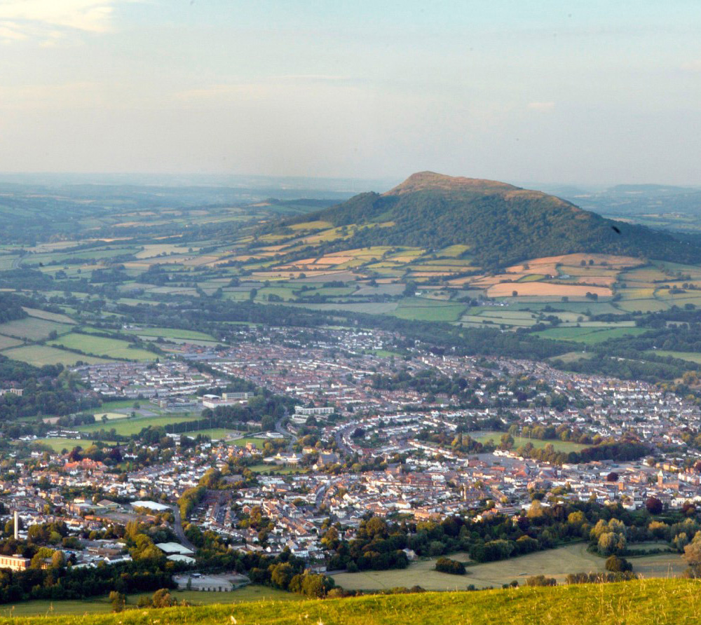

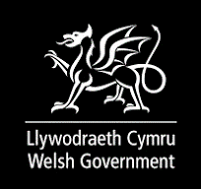


Community Cohesion Fund

Grant Application

1st of May 2024 to 31st March 2025

Closing Date for all applications: 19th of July 2024

Please read the below guidance notes carefully, in particular the Eligibility section before submitting an application.

Introduction:

What is Community Cohesion? A cohesive community is an area where those from different backgrounds share positive relationships, feel safe in the neighbourhood, and have a sense of mutual respect and shared values. Within a cohesive society:

- there is a common vision and sense of belonging by all communities.
- the diversity of people’s backgrounds and circumstances is appreciated and valued.
- similar life opportunities are available to all; and
- strong and positive relationships exist and continue to be developed in the workplace, in schools and in the wider community.

We would like to invite community groups and third sector organisations to apply for funding of between £500 and £1500.
The funding available can be used to build cohesive and resilient communities, including to highlight and celebrate the diversity of communities across Monmouthshire.
Applications are welcomed for events, activities, and capacity building within Monmouthshire focussing on bringing communities together and we are encouraging collaborative work.

Funding must be spent by the end of March 2025. Bids must not exceed £1500.
How to apply for the grant funding:
To apply for this funding, you must submit an application form to Partnerships@monmouthshire.gov.uk by Friday 19th of July 2024. The Council will award grants up to a maximum of £1500.

How are applications assessed and monitored by the Council?
All applications received will be assessed by a panel that will decide whether they are successful, based upon the information in your application form.
The Council will monitor these projects and may ask you for case studies, which may mean that we visit you or ask for information about what your project has achieved. We may also ask for copies of invoices or receipts that show what you have spent the grant money on. We will report to the Welsh Government on Project outcomes.
Timescale: Projects will need to be finalised by March 2025
This funding will be administered by the Monmouthshire Council Community Cohesion Team.
Any queries regarding the grant can be sent to the Community Cohesion Team Partnerships@monmouthshire.gov.uk

Completed application forms should be sent via email by Friday 19th of July 2024.

Eligibility (Please read carefully to avoid disappointment)

Each application will be assessed, and final decisions made by panel (see below for guidance notes).

To be eligible to apply, the applicant must be a constituted and established voluntary organisation or community group and have a bank or building society account in the name of the organisation or have a host organisation willing to accept the funds on their behalf (payments will not be made to individuals).

Relevant insurances must be in place under the organisation’s constitution.

To adhere to statutory and regulatory conditions and embrace the essence of constituted community organisations, value for money and partnership working, applications from individuals who are not aligned within a constituted group will not be accepted.
In addition, please note the grant will not cover the below and similar costs:

- Usual salary costs of staff
- Costs of work to maintain property.
- Costs of hire of property / use of premises usually paid for under the organisations normal working practice.
- No one day events
- No ticketed events

Application Objectives:

Applications must meet at least one of the following objectives:

- Deliver events and activities that specifically bring together people from different communities to foster a wider sense of community and belonging. Proposals should consider how activities support integration, tackle loneliness and isolation, identify commonality through shared interests and experiences, and celebrate the culture and heritage of the area.

- We encourage collaborative projects and joint events that bring people from different backgrounds / communities together to foster a wider sense of community and belonging.

- Deliver activities that support ethnic minority communities to address community tensions and build community cohesion. This includes Gypsy, Roma, and Traveller communities; Refugees and Asylum Seekers; and action to tackle Antisemitism and Islamophobia.

Applications must demonstrate reasonable costs for activity / value for money, and any expenditure must be substantiated in respect of all costs.

Examples of events or campaigns may include bringing people from different backgrounds together, promoting cultural diversity, cooking sessions, community music, arts-based projects, sports related activities, dance, education, specific campaigns, and awareness raising (e.g. Hate Crime victim support)

Some Annual Equality / Community Cohesion Calendar Dates
- National Hate Crime Awareness Week October
- Black History 365.
- Holocaust Memorial Day,
- Windrush Day
- Refugee Week
- LGBT History Month
- International Women’s Day
- Learning Disability Week
- Interfaith Week
- International Day of Disabled People
- International Day Against Homophobia, Transphobia and Biphobia
- Human Rights Day – 10 December
- Winter Great Get Together Mid-January
- Summer Great Get Together (last weekend in June)

What happens next:
You will be notified of the outcome of your application by email.

Successful Applicants:
Regular progress updates and a final report containing evaluation, testimonials, photographs etc will be required.


Please complete all parts of the application details below:

1. | Name of community group/organisation:  Charity No:
2. | Full address of community group/organisation, including post code:
3. | Name of key contact:
4. | Email address:
5. | Telephone Number:
6. | What event/activity/literature/capacity are you planning? (In no more than five hundred words)

7. | How will your event /activity /literature/capacity meet one or more of the objectives stated above? (In no more than three hundred words)
8. | How will you promote your funded event/activity?
9. | Where and when will your planned activities take place?
10. | Total Project Cost (please include quotations for any items):

11. | Amount requested from this.  funding:  Please provide a breakdown of purchases (staff or continuing premises costs are ineligible)
12. | Have you applied to any other funding bodies for funding towards this event/activity?

The Payment:

The awarded amount of funding will be paid as a one-off payment.

All successful applications will be required to monitor activity funded and return a Project Completion Form including all receipts and invoices before release of the funding.
Name (Print clearly) ………………………………………….. Position ……………………………….

Signature:………………………………………………… Date: …………………………………..

Please send your completed application form via email to no later than Friday 28th of June 2024

For office use only:

Date application received by Regional CC Team …………………………………………...

Date of panel meeting
…………………………………………………………………………………..

Date of decision to applicant
……………………………………………………………………………

