Monmouthshire County Council Socially Responsible Procurement Strategy 2023-2028

Foreword

The Council faces a number of key challenges including our response to the impact of the Covid-19 pandemic on our communities and businesses, climate emergency and managing ongoing budgetary constraints at a time of increasing demand for services.
The Council’s Community and Corporate Plan wants Monmouthshire to be an ambitious, fair and sustainable place where people care about each other, where more of its money is spent locally and ethically, whilst minimising the long-term impact of its activities and increasing local value creation and focusing on whole life costs.
We will continue to use the full size and scale of the Council to tackle inequality and poverty and addressing the climate and nature crises. This will mean maximising the social impact of our spend, accelerating the move to net zero.
To this end we are committed to the delivery of community benefits, including employment and apprenticeship opportunities, and the promotion of “Fair Working Practices”.
It is crucial that this strategy is viewed as a corporate strategy that all Council Officers and Elected Members must engage with to deliver.
It is recognised that these changes will need to be supported by a programme of learning and development, not only to build capacity for both Council Officers and Elected Members but also for existing and future suppliers and contractors.


Cllr Mary Ann Brocklesby – Leader

What Matters to Monmouthshire

The ambition for the Council and county of Monmouthshire is to be a zero carbon county, supporting well-being, health and dignity for everyone at every stage of life. Each year we spend nearly £100 million buying goods, services and works from suppliers to help us deliver on this ambition. It is vital that we have a procurement strategy and supporting delivery plan that is completely aligned with our aspirations.
Our financial position is challenging and must use every penny we have wisely. However, procurement also plays a vital role in achieving societal benefits through enabling the delivery of progressive policies like decarbonisation, achieving social value, securing fair work and delivering community benefits that can play a significant role in bringing about a more fairer society.
Our Socially Responsible Procurement Strategy 2023-28 will enable us to buy goods, services and works that are sustainable, ethically produced, local wherever possible, and in line with our priorities and commitment to be an equitable organisation.
Our purpose requires clear high-level objectives that are measurable. Monmouthshire will be:
- A Fair place to live where the effects of inequality and poverty have been reduced;
- A Green place to live and work, with reduced carbon emissions, and making a positive contribution to addressing the climate and nature emergency;
- A Thriving and ambitious place, where there are vibrant town centres, where businesses can grow and develop;
- A Safe place to live where people have a home and community where they feel secure;
- A Connected place where people feel part of a community and are valued;
- A Learning place where everybody has the opportunity to reach their potential.
Our Community and Corporate Plan sets out in more detail the steps we will take to deliver these commitments. Our approach to procurement has a vital role to play through more responsible and sustainable purchasing decisions; encouraging suppliers to adopt fairer working practices; increasing community benefits and making contracts more accessible to micro and small local suppliers.
Our approach to procurement will achieve financial value but equally, if not more importantly. It will also achieve equitable community benefits and social value for current and future generations.

Located in south east Wales, Monmouthshire occupies a strategic position between the major centres in south Wales and the south west of England and the Midlands. The county covers an area of approximately 880 square kilometres, with an estimated population of 95,164. The six main settlements are Abergavenny, Caldicot, Chepstow, Magor, Monmouth and Usk / Raglan, and although it is a predominantly rural area, 53% of the population live within wards which are defined as being urban areas.

Why Procurement Matters
'Procurement’ is the process by which the Council manages the acquisition of all its Goods, Services and Works, in a way that achieves value for money on a whole life basis in terms of generating benefits not only to the Council, but also to society and the economy, whilst minimising damage to the environment. It includes the identification of need, consideration of options, the actual procurement process and the subsequent management and review of the contracts.”

The Council delivers its services through a mixed economy - directly through its own workforce, and through public, private and third sector organisations.
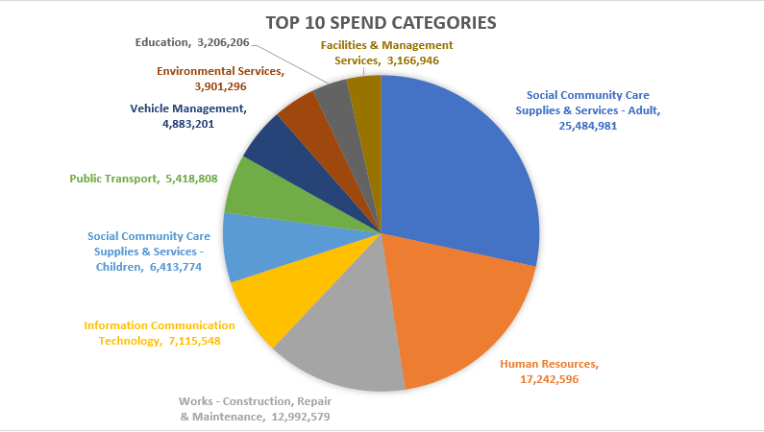
As a result, the Council spends over £98 million a year procuring a diverse range of goods, services and works from over 2,800 suppliers and contractors. The graphs below shows key areas where we spend our money.
Our Community and Corporate Plan recognises the importance of procurement and contains a number of priorities that informed the Key Objectives within this Strategy, namely:
- Reducing the carbon emissions generated from the Council’s activities with a particular focus on our supply chains
- Ensuring our procurement process contribute to greater consideration of equality and diversity
- Promoting localism and ensuring that growth is sustainable and inclusive
- Delivering Community Benefits and Social Value to help support individuals and communities
- Championing fair work, equality, diversity and inclusion across our entire supply chains
- Exploring new and innovation ways of delivering Council priorities and services especially in social care, housing and the local economy.

This procurement strategy will therefore be vital in making sure our budgets are used effectively to deliver our priorities and reduce our carbon footprint while delivering equitable community benefits and social value.

Informing Our Strategy

Public Contract Regulations and Procurement Reform
The procurement of goods, services and works by the public sector is governed by the Public Contract Regulations 2015 (PCRs 2015) which are grounded in the principles of free movement of goods, freedom of establishment and freedom to provide services. These principles are under pinned by values of equal treatment, non-discrimination, mutual recognition, proportionality and transparency.
In response to the UK leaving the EU the UK Government issued a Green Paper: Transforming Public Procurement (published December 2020) and in May 2022 introduced the Procurement Bill 2022-23 to Parliament. The Bill, yet to be enacted, introduces a new public procurement regime which will revoke the Public Contracts Regulations 2015. The new regime is unlikely to take effect until late 2023. The main features of the Bill will be its focus on value for money, the public good, transparency, integrity, efficiency, fair treatment of suppliers and non-discrimination.

In addition to the Council’s Community and Corporate Plan, there are increasing legislative and policy requirements that inform and influence the way in which the Council manages its procurement activity which have been taken into account when developing this Strategy. This section highlights some of the key overarching legislative and policy requirements and priorities with further information contained within this Strategy.
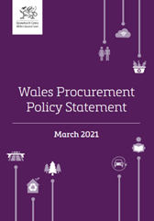
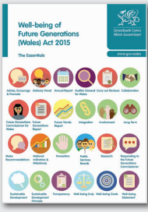

The Wellbeing of Future Generations (Wales) Act 2015
The Wellbeing of Future Generations Act focuses on improving the economic, social, environmental and cultural well-being of Wales. The aim of the Act is to help create a Wales that we all want to live in, now and in the future. Procurement is one of the seven corporate areas for change in the Act’s statutory guidance.

The Wales Procurement Policy Statement (WPPS)
The third WPPS published in March 2021 sets out the ten principles the Welsh Government expects the Welsh public sector to follow for procuring well-being for Wales based on the Well-being of Future Generations (Wales) Act Goals and key Welsh Government policies. The Social Partnership & Public Procurement Bill will strengthen the requirement for public sector organisations to adhere to the WPPS.

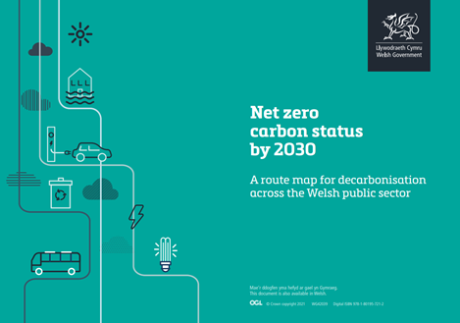

Social Partnership and Public Procurement (Wales) Bill
The Bill, expected to be enacted towards the end of 2023, will require the Council to carry out procurement in a socially responsible way by taking action, in accordance with the sustainable development principle, aimed at contributing to the achievement of— (a) the well-being goals listed in section 4 of the Well-being of Future Generations (Wales) Act 2015, and (b) the fair work goal (within the meaning given by section 4), referred to for the purposes of this Part as the “socially responsible procurement goals.”
In 2021 the Welsh Government published the Net Zero carbon status 2030 route map which states
‘By 2030, choosing zero carbon will be routine culturally embedded and self-regulating across the Welsh public sector.’

Delivering value throughout the Procurement Cycle
There is an increasing expectation on the role procurement can play in tackling some of the greatest challenges facing our Communities and the Planet as a whole.
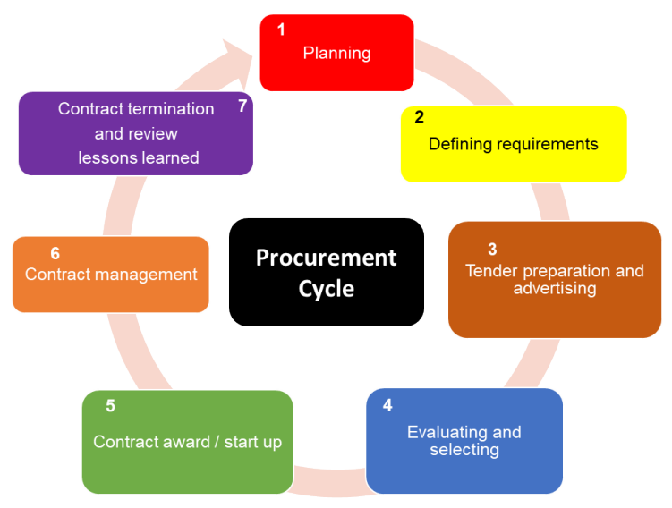
To achieve this, it is crucial that value is considered at each stage of the procurement cycle which means that all staff involved in specifying, sourcing, awarding and managing contracts have a key role to play. It is particularly important that adequate attention and time is invested in the planning and contract management stages.

.

Examples of the way in which value can generated / delivered through the procurement cycle include but not limited to:
- Encouraging innovative solutions from the market by focusing on outcomes rather than inputs and outputs
- Developing specifications that require lower carbon materials or construction methods and reduce cost
- Encouraging suppliers to adopt fair working practices and policies that promote equality, diversity and inclusion.
- Structuring tender processes and documents to improve accessibility to smaller and third sector businesses
- Considering the whole life cost of decisions made
- Including contractual clauses can ensure that fair work commitments are achieved
- Securing community benefit and social value commitments that are equitable from contractors to support delivery of wider Council priorities
- Managing contracts effectively to ensure that requirements and added value commitments are delivered

Key Procurement Objectives
To ensure our Strategy addresses the priorities already outlined above, the following Procurement Objectives have been identified.

- Contributing to reducing the Council’s carbon emissions to Net Zero by 2030.
- Making procurement spend more accessible to local small businesses and the third sector.
- Improving Fair Work, Equity and Safeguarding practices adopted by suppliers.
- Increasing equitable community benefits and social value delivered by suppliers.
- Securing value for money and managing demand.
- Ensuring legal compliance and robust and transparent governance.
- Promoting innovative and best practice solutions.

The next section of this strategy expands on these procurement objectives providing a brief overview of the current position, setting out the key aims, identifying the key themes of what we will do and how we will measure achievement. The detailed actions are contained within the accompanying Socially Responsible Procurement Strategy Delivery Plan.

Contributing to reducing the Council’s carbon emissions to Net Zero by 2030 | 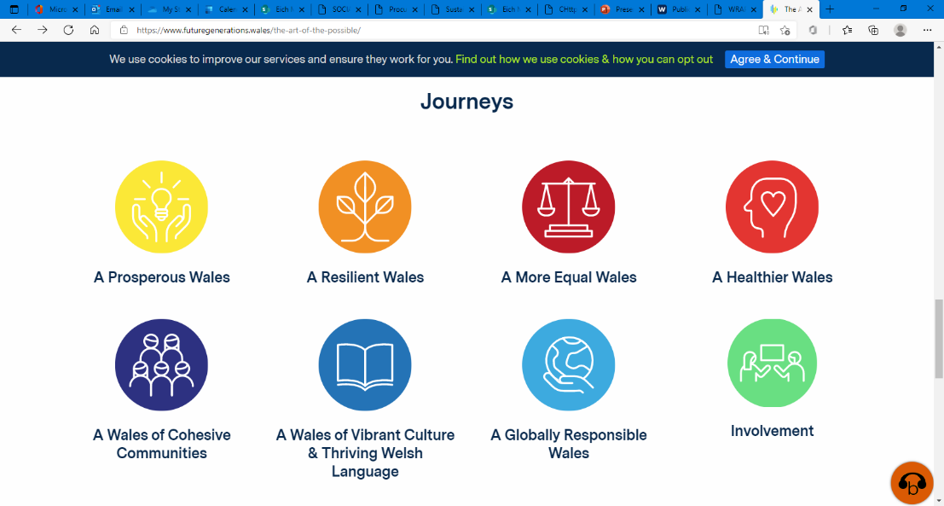  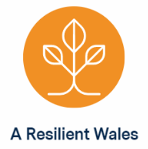  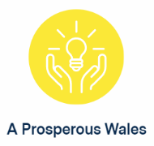  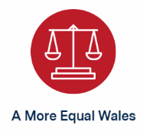

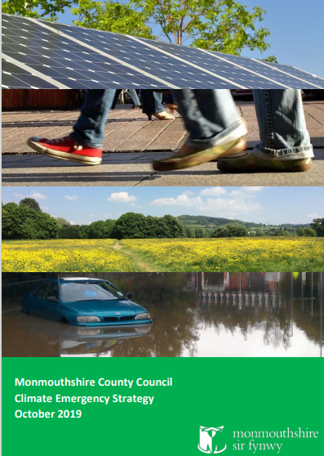
Through its Climate Emergency Strategy and Action Plan the Council has committed to be a Net Zero Council by 2030. The Community and Corporate Plan demonstrates the Council’s intention to establish Monmouthshire as a “Green place to live” where resources will be collectively focused on reducing carbon emissions and making a positive contribution to addressing the climate and nature emergency.
Using the Welsh Government’s Carbon Reporting Framework more than 71% of our carbon footprint comes from the indirect emissions arising from the supplies, services and works the Council buys to support the delivery of Council services.
Although procurement has a role in supporting the reduction of Scope 1 and 2 emissions over which we have a level of direct influence (for example, emissions arising from our own estate / internal operations - employee commuting / business travel) this Strategy focuses on reducing the Scope 3 procurement emissions arising through our supply chain.
Therefore, any reduction in our carbon footprint will need to be delivered through service areas rethinking and challenging what they buy and how it is delivered.
The challenge presented by Scope 3 emissions is that while they arise from the organisations demand for goods, services or works, they occur in supply chain activities that the Council does not directly own or control.

However, our contractual relationships present opportunities to drive emissions reduction through our procurement processes (procurement strategies – how we approach the market; how we specify requirements; evaluate tenders and set KPIs) and ensure the anticipated outcomes are delivered through our contract management relationships by working with our supply chain partners and going further by incentivising innovation / continuous improvement over the period of the contract.

Contributing to reducing the Council’s carbon emissions to Net Zero by 2030

Aim (where we want to be)
- The Council understands the carbon impact of the supplies, services and works it buys and takes active steps to reduce their carbon footprint
- The Council uses the procurement cycle to routinely take advantage of opportunities to reduce carbon impact

We will do this by (how we will get there)
- Understanding the carbon footprint of the Council’s purchased goods, services and works to ensure our carbon reduction activity is targeted where it can have the biggest impact
- Working with our elected members, staff, partners and contractors to ensure that carbon reduction is fully considered throughout the procurement cycle
- Collaborating with, and learning from organisations across the public, private and third sector

We will demonstrate delivery by
- Reporting on procurement’s contribution to carbon reduction through the Council’s Climate Emergency Strategy and Action Plan.

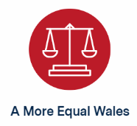  Making procurement spend more accessible  to local small businesses and third sector | 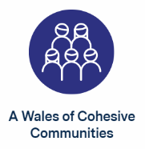

Monmouthshire County Council recognises the economic, social, environmental and cultural value that can be generated by spending money with local businesses, in particular small and micro enterprises, sole traders and the third sector.
In 2022 the County of Monmouthshire has 4,575 registered businesses with 4,190 identified as micro businesses (0-9 employees), 320 small (10-49 employees) 50 medium (50-249 employees and 15 large (250 plus employees).
The Council demonstrates its intent to support and grow the Foundational Economy and keeping more of our spend local, by committing (via the priority area of “A Green Place to Live” within the Community and Corporate Plan) to increase the percentage of local produce that is used in Council services such as school meals and social care. The Council’s Procurement function will as part of its enabling role help to facilitate support within these sectors.
When considering the support for local suppliers the Council recognises that, dependent on the particular requirement, local can be Monmouthshire, Gwent, English Border Counties, Cardiff Capital Region or Wales, where the procurement is socially responsible, offers value for money and can support our foundational economy aims. Therefore, the Council measures ‘local’ spend for Monmouthshire, Gwent, the wider Cardiff Capital Region, Wales and our bordering Councils.
The third sector includes community groups, voluntary organisations, faith and equalities groups, charities, social enterprises, co-operatives, community interest companies, mutuals and housing associations.
The Welsh Procurement Policy Note (WPPN) 07/21 highlights and builds on the principles within 'Opening Doors: The charter for SME-friendly procurement'. The WPPN sets out what the Welsh Public Sector and SMEs can do to ensure that an SME-friendly procurement process is adopted and implemented.
For the financial year 2022/23 our ‘Local’ spend was:
- Monmouthshire 18.67%
- Wider gwent 25.72%
- Wider cardiff capital region 31.92 %
- border counties 7.37%

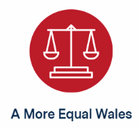  Making procurement spend more accessible  to local small businesses and third sector | 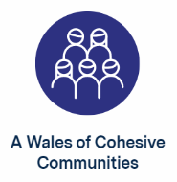

Aim (where we want to be)
- Small businesses and third sector organisations
  - have timely visibility of and access to opportunities to bid for Council contracts
  - find it easier to bid for opportunities to work with the Council
  - to better understand the make-up of our supply chains and where opportunities may exist to include supply further down the supply chain

We will do this by (how we will get there)
- Increasing the availability, visibility and timeliness of opportunities for small businesses and the third sector to supply the Council
- Making it easier for small businesses and the third sector to do business with the Council
- Working with partners to develop the capability and capacity of small businesses and the third sector to secure public sector contracts
- Work with partners to gather and share market intelligence around local suppliers

We will demonstrate delivery by
- Increasing the proportion of our spend that is local and equitable.
- Increasing the number of local businesses and third sector organisations accessing and bidding for Council opportunities.
- Increasing the number of local businesses and third sector organisations successfully bidding for Council opportunities

Improving Fair Work, Equity and Safeguarding practices

adopted by suppliers

Our Community and Corporate Plan aims at improving equality and diversity for all who live, work and earn in Monmouthshire. We will work with our partners and supply chains to:
- Promote greater equity and diversity in the tendering and issuing of contracts and
- Promote ethical working practices throughout our supply chains
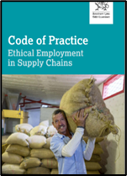
In January 2020 the Council signed-up to the Code of Practice Ethical Employment in Supply Chains which seeks to tackle modern slavery, human rights abuses, blacklisting, false self-employment, unfair use of umbrella schemes and zero hours contracts.
In 2023 the Social Partnership and Public Procurement Bill is expected to become law. The stated purpose of the Bill is to create a framework to enhance the well-being of the people of Wales by improving public services through social partnership working, promoting fair work and socially responsible public procurement, including through the establishment of a Social Partnership Council. Elements of the Code of Practice: Ethical Employment in Supply Chains are likely to be made mandatory and embedded within statutory guidance.
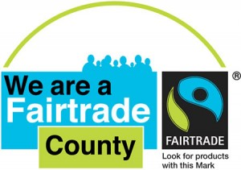
As a Fair Trade council, Monmouthshire is committed to:
- Promoting fair trade across the council and county
- Where available, using fair trade products in its work including serving fair trade teas and coffees in meetings and at events
- Organising joint events with its four town fair trade groups to promote fair trade in the wider community
Safeguarding vulnerable people is one of the Councils main corporate priorities, public procurement has an essential role to play in ensuring all relevant safeguarding checks have been embedded within the tender process and that safeguarding policies, procedures and training are integral for the duration of the contract.

Improving Fair Work, Equity and Safeguarding practices

adopted by suppliers

Aim (where we want to be)
- Procurement is used to influence and increase positive fair work and socially responsible outcomes which benefit the County by addressing poverty, inequality and diversity
- The Council and its suppliers and contractors actively safeguard and promote the rights of children, young people and vulnerable adults

We will do this by (how we will get there)
- Ensuring that tenderers and contractors are aware on the Council’s commitment to working with organisations that will support the Council to meet equality, fair work and safeguarding duties
- Using our tendering process to ensure that our suppliers are committed to supporting the Council to deliver its equality, fair work and safeguarding duties
- Working with our suppliers to ensure that they promote fair work practices and safeguarding within their organisation and supply chain

We will demonstrate delivery by
- Monitoring and evaluation of gender equality and diversity to encourage suppliers to improve their performance
- Delivering against the Social Partnership and Public Procurement Act and the principles of the Code of Practice: Ethical Employment in Supply Chains

Increasing community benefits and  social value delivered by suppliers | 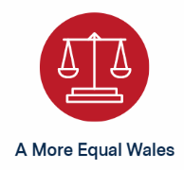 |  | 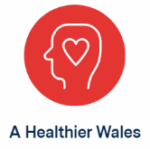
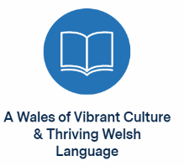
The Council’s Community and Corporate Plan provides a focus and commitment that the Council works effectively for and with communities while giving the best value for money. As an integral part of this commitment, we will look to ensure that the Socially Responsible Procurement Strategy and Delivery Plan drives effective outcomes that support the priorities of our Council, which include the delivery of meaningful Community Benefits and Social Value.
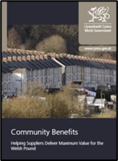
Community Benefits and Social Value are designed to achieve equitable economic, social, environmental and cultural added value outcomes when tendering for works, services or supplies.
Community Benefits will typically focus on:
- Training and recruitment of disadvantaged groups and economically inactive people
- Supply chain initiatives and Working with the 3rd Sector
- Educational initiatives
- Community and Cultural initiatives
- Environmental initiatives
The Council has regularly included the Welsh Government Community Benefits requirements into major construction and maintenance contracts over the past 10 years.
However, despite some successes Community Benefits is not embedded across all areas of Council spend and does not yet benefit all communities and interest groups and managing and reporting on delivery has proved to be difficult.
The Council recognises this is an area it needs to improve on to provide opportunities to tackle the inequality and poverty gap and provide much needed support to our communities and individuals.
To this end, the Council is committed to communities and interest groups having a say in how community benefits are identified and established.
The approach to community benefits in Wales is currently being reviewed by Welsh Government and Monmouthshire is playing an active and collaborative role to developing a common approach across the Welsh Public Sector.

Increasing community benefits and

social value delivered by suppliers

Aim (where we want to be)
- Community benefits and social value opportunities are maximised and aligned to support the priorities of the Council and the individuals and communities it serves
- Community benefits and social value is routinely incorporated in tenders across all spend categories
- Community benefits and social value commitments are equitably delivered and the benefit to the individual and / or community is evidenced

We will do this by (how we will get there)
- Adopting a consistent approach to securing and managing delivery of community benefits and social value commitments which is understood by the Council and its contractors
- Co-ordinating the community benefits and social value approach by working with Council services, our communities, partners and contractors to inform our priorities and facilitate their delivery
- Reporting on achievements, learning from failures and promoting success

We will demonstrate delivery by
- Increasing the number of tenders that ask for community benefits and social value commitments
- Increasing the volume and value of community benefits and social value committed to and delivered through Council contracts
- Track the type, and range of communities and/or interest groups benefitting from community benefits and/or social value delivered through our contracts

Securing value for money and managing demand

Annually the Council spends in excess of £98 million on the acquisition of goods, services and works.
The Community and Corporate Plan and this Strategy have been produced against the backdrop of economic uncertainty. We face rising energy costs, inflation and escalating borrowing costs alongside increased demand pressures in areas such as children's services, adult social care, homelessness, additional learning needs and home to school transport.
The Council recognises that our procurement strategy will be vital in making sure our budgets are used effectively to deliver our priorities. It is therefore our commitment to use the Council’s spend to deliver within budget, whilst enabling and promoting additional value for money considerations such as social value, community benefits,- equity and a reduction of carbon across our supply chains.
One way in which the Council is able to demonstrate Value for Money is by awarding contracts through open competition. The Council has in place a robust set of procedure rules that govern the processes that need to be followed when looking to buy in goods, works and services from external suppliers.
Economy: minimising the cost of resources used or required (inputs) – spending less
Efficiency: the relationship between the output from goods or services and the resources to produce them – spending well; Effectiveness: the relationship between the intended and actual results of public spending (outcomes) – spending wisely
Equity: the extent to which services are available to and reach all people that they are intended to – spending fairly
We are in the process of redeveloping and resourcing a Council-wide Contract Forward Plan and Contract Register which will provide far greater oversight of our existing contracts and the ability to better plan delivery of contract renewals and new requirements. These will be regularly published on the Council’s website from August 2023.
Over the years procurement has evolved from focusing only on achieving cost savings to becoming a key enabler for delivering positive economic, social, environmental and cultural growth. Such a focus now requires additional skills and tools. Learning and development across all interested parties will be a key driver to the effective implementation and delivery of this strategy.
Where appropriate the Council seeks to collaborate with the wider Public Sector in Wales both in terms of use of and delivery of collaborative contracting arrangements. To this end Monmouthshire play an active role in supporting the WLGA National Procurement Network in the delivery of this programme.
As we manage the impact of BREXIT and COVID and other significant events which are impacting on our supply chains now and in the medium-term, price and availability issues are likely to be a challenge over the duration of this strategy.

Securing value for money and managing demand

Aim (where we want to be)
- The Council can clearly demonstrate it is achieving value for money from its third-party spend through all stages of the procurement lifecycle including planning, award and management of contracts.
- The Council routinely evidences that it considers quality and whole life cost in respect of financial and wider environmental, social, economic and cultural considerations, in particular carbon reduction and equitable community benefits.

We will do this by (how we will get there)
- Reviewing and challenging what we spend our money on and identifying opportunities to deliver efficiencies
- Demonstrating value for money and considering the whole life cost of the decisions we make [including consideration of social value and equitable community benefits, fair work and equality, and move towards being net zero]
- Managing contract delivery and the impact of price and market pressures

We will demonstrate delivery by
- Reporting on our contract register and spend under management
- Reporting of procurement’s contribution to savings targets through effective procurement
- Reporting on the equality, diversity and inclusion aspects of procurement
- Managing our Contract Forward Plan and publishing it on quarterly basis

Ensuring legal compliance and robust and transparent governance

The way in which the Council undertakes its procurement activity is subject to both UK and WG legislation, and the Council’s own Constitution.
The UK Public Contract Regulations 2015 place express legal requirements in terms of how the Council undertakes the award of contracts over defined financial thresholds. The intent of these Regulations was to create an open, transparent and equitable EU market. Following the UK exit from EU, the UK and Welsh Government have been undertaking a review of procurement legislation which is planned to come into force in 2023. Although the exact detail is still being developed it is clear there will be a requirement for greater transparency of procurement activity.
The new procurement legislation will in Wales be further strengthened through the Social Partnership and Public Procurement (Wales) Bill which is also planned to come into force in 2023. Procurement and Legal Services will work closely together to develop any changes to the Council’s approach to procurement that may be required to comply with the proposed legislation.
In addition to the legislative requirements procurement activity in the Council is also subject to the Council’s Constitution, in particular the Scheme of Delegations and Contract Procedure Rules.
The Constitution requirements are in place to ensure transparent governance through clearly defined decision-making requirements, accountability to and to ensure probity and minimise the risk of fraud.
The Council also has a number of key processes, systems and documentation requirements which are in place to ensure proportionate but adequate controls.

Ensuring legal compliance and robust and transparent governance

Aim (where we want to be)
- All procurement staff and Council officers involved in procurement processes have full awareness of the impact of the regulations and contract procedure rules which apply to procurement activity.
- The Council complies with relevant legislation and that the governance and risk management arrangements of the Council are proportionate and followed.

We will do this by (how we will get there)
- Regularly reviewing and updating procurement documentation, processes, systems and controls to ensure they reflect legislative changes
- Providing education and training to Council officers involved in the procurement process
- Ensuring we have adequate arrangements in place to manage performance and providing oversight and assurance to the Council’s leadership team

We will demonstrate delivery by
- Publishing an annual Procurement Report.

Promoting innovative and best practice solutions

The Council has always delivered services within budget while maintaining a prudent level of financial reserves. We’ve done this by being as efficient as possible, pursuing innovative approaches and acting with a commercial mindset.
Demands on us have grown which means we will need to adjust our practice and do things differently. We have a good track record of innovation, but these challenges are on a scale we have not seen before.
Therefore, the Council recognises that many of the challenges we face will not be addressed by maintaining the status quo and there is a need to challenge ourselves and our markets to deliver new products and ways of working which can help us to:
- Reduce carbon
- Increase Community Benefits and Social Value delivery
- Deliver better and more equitable outcomes, for example by targeting community benefits at certain groups who may be under-represented in some areas of the economy or society
- Maintain or reduce cost
- Improve services
This means we need to plan better, challenge what we have always done, engage markets early, seek good practice from across the public, third and private sector and use the procurement process as a means to drive the market to offer solutions which address specific problems, challenges and outcomes.
Although procurement can be viewed by some as stifling innovation, the reality is that there are a number of ways in which the procurement process itself, if correctly followed, can drive improvement from those within the Council by challenging the status quo. Further, bidders can be given the scope to submit new innovative ways of working. For these benefits to be achieved however, it requires a change in the prevailing preference to fix solutions based on what has gone before and for better and timely planning.
The public sector across Wales also recognises it could do more to share good practice and to develop new, innovative solutions. To this end Welsh Government has agreed funding to establish a Procurement Centre of Excellence.

Promoting innovative and best practice solutions

Aim (where we want to be)
- Opportunities are regularly sought for innovative solutions for products, services or works required by the Council and the market is challenged to offer improved solutions.
- The procurement process is used to drive and encourage innovation where it can reduce the cost and / or improve the effectiveness of Council services and deliver wider priorities in particular decarbonisation.

We will do this by (how we will get there)
- Challenging existing procurement arrangements and delivery models and seeking relevant examples of market innovations and best practice.
- Encouraging outcome / problem-based procurement approaches to stimulate creative and innovative solutions and engaging early with markets.
- Collaborating with Welsh Government, the Welsh Local Government Association (WLGA), Cardiff Capital Region and other public, private and third sector partners to drive innovation and greater value and share good practice and develop insight.

We will demonstrate delivery by
- Reporting and developing case studies to highlight best practice.
- Identifying and reporting on procurement contributions to new ways of delivering improved services and products

Key Enablers

The Council has identified five key enablers that will be critical to the delivery of this Strategy:

People
- Continue to invest in our People to ensure that the Procurement Team has the right mix of skills, knowledge and expertise.
- Ensure staff across the Council have the procurement skills, knowledge and tools to work effectively and independently.

Process
- Simplify and standardise our core processes and ensure our controls ensure compliance.
- Ensure that standard templates are in place for key procurement and contracting documentation and that these are regularly reviewed.

Technology
- Invest in the use of technology and e-procurement to underpin and simplify our core processes for both staff and suppliers.

Information
- Provide staff with accurate timely spend data to inform procurement decisions and identify savings opportunities without compromising on our social value and community benefit commitments
- Produce an annual procurement performance report.
- Support Directorates to optimise their spend in the achievement of their strategic objectives.

Culture
- Develop a culture that is innovative and challenges traditional delivery to improve what we do and drive change.
- Ensure that staff understand and appreciate the rules and policies of the Council.
- Ensure that there is positive engagement with staff across the Council to support and encourage the delivery of innovative solutions within the agreed Council rules and wider legislation.
- Work collaboratively to secure better solutions and share learning

Managing Procurement

In August 2021 the Council entered into a collaborative arrangement with Cardiff Council to support the management and delivery of procurement activity across the Council. The service is responsible for:
- Development and delivery of procurement strategy and policy,
- Provision of spend analytics and performance oversight and assurance and
- Supporting Directorates in the delivery of the Contract Forward Plan
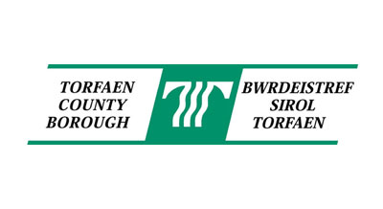
Responsibility for specifying requirements and contract management remains with the relevant service.
In addition to managing procurement for Cardiff Council and Monmouthshire County Council the service is also responsible for managing the procurement function for Torfaen County Borough Council and the Vale of Glamorgan Council and the delivery of three regional collaborative frameworks for South East Wales – SEWSCAP (Buildings Construction), SEWH (Civils Construction) and SEWTAPS (Technical Professional Services).

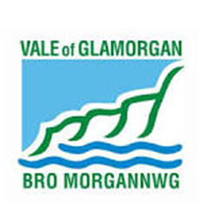

Monitoring, Reviewing and Reporting
A detailed Delivery Plan will set out the actions that the Council will take to deliver this Socially Responsible Procurement Strategy.
This Delivery Plan will be updated on an annual basis and will be used to manage and report on progress on an annual basis to the Council’s Strategic Leadership Team. The Council will publish a Procurement Annual Report at the end of each financial year. The report will include:
- A progress report on the implementation of the Socially Responsible Procurement Strategy Delivery Plan.
- A summary of the contracts awarded above PCRs 2015 Thresholds.
- Details of a review into the extent to which Council contracts contributed to improving well-being in Monmouthshire.
- A statement of the how the Council intends to further improve the delivery of economic, social, environmental and cultural well-being.
- A summary of the procurement the Council expects to carry out in the next two financial years.

