People & Governance HR

GENDER PAY GAP REPORT 2023


Gender Pay Gap Report 2020/2021

Contents

Introduction | 3
What do we have to report? | 3
Workforce profile | 4
Bonus pay | 5
Quartile pay bands | 5
Conclusions | 6
Factors affecting the gender pay gap | 6
What do we do to support equality in the workplace? | 6

Introduction
The Gender Pay Gap Information Regulations require all employers with 250 or more employees to report their Gender Pay Gap annually, publishing on a national Government website as well as the organisations website. The Gender Pay Gap Information Regulations apply to employers in the public and private sector.
In addition to these new regulations, employers in the public sector are subject to a specific public sector equality duty in respect of their functions - The Equality Act 2010 (Specific Duties and Public Authorities) Regulations 2017.
The regulations apply to all employers with 250 or more employees on the "snapshot" date. The "snapshot" date for the public sector is 31 March each year. Therefore, the Council is required to publish its gender pay gap for each year on the Monmouthshire County Council website and on the Government website (GOV.UK), no later than 31 March of the following year. Therefore, for the “snapshot” date of 31 March 2022, the findings must be published no later than 31 March 2023.
The purpose of Gender Pay Gap reporting is to achieve greater gender equality across the UK and increase pay transparency. The gender pay gap is an analysis of gender distribution across the workforce.
Monmouthshire County Council is committed to the principle of equal pay for all employees by ensuring that it meets the requirements of the Equality Act. To achieve this the Council introduced Single Status and uses the Greater London Provincial Council (GLPC) job evaluation scheme to assess the value of all National Joint Council (NJC) jobs across the organisation, which provides evidence in support of the banding of each job within our grading structure. Salaries are paid according to band and incremental annual progression within the band occurs irrespective of an employee's gender.

What do we have to report?
The regulations require employers to publish the following information:
- The mean gender pay gap;
- The median gender pay gap;
- The mean bonus pay gap;
- The median bonus pay gap;
- The relative proportions of male and female employees in each quartile pay band.

Workforce Profile
As of the ‘snapshot date’ of 31 March 2022, the Council’s workforce profile for the purposes of this report was as follows:
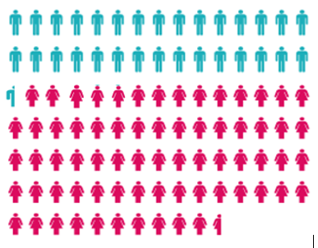.
Male 30.05% Female 69.95%

The Full Time and Part Time Gender Ratios:
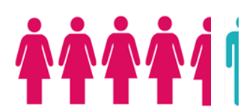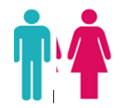

Part Time 4.49:0.22 Full Time 1.03:0.97

Mean Gender Pay Gap
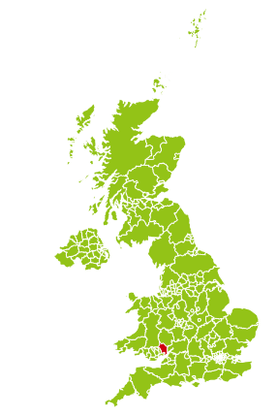



6.51%

The mean gender pay gap is the difference between the average hourly earnings of men and women.

£14.60 £0.95 £13.65

Median Gender Pay Gap

3.95%
The median pay gap is the difference between the
mid points in the ranges of hourly earnings of men and women.
£12.42 £0.49 £11.93

Bonus Pay
Monmouthshire County Council has not operated any bonus schemes since 2009 - upon the introduction of Single Status. Bonus Pay Gap 0%

Quartile Pay Bands
Lower Pay Quartile  £18,328.00 - £21,261.00 | Lower Middle Pay Quartile  £21,261.00 - £23,479.00
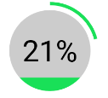

Upper Middle Pay Quartile  £23,479.00 - £28,226.00 | Upper Quartile  £28,226.00 - £121,754.00

Conclusions
The Mean Gender Pay Gap for all workers as at 31 March 2022 was 6.51%, a difference of £0.95 per hour.
The Median Gender Pay Gap for all workers as at 31 March 2022 was 3.95%, a difference of £0.49 per hour.
The Mean Bonus Pay Gap is nil
The Median Bonus Pay Gap is nil
Quartile analysis shows, that in the lower pay quartile there has been a decrease in the percentage of males from 31.53% to 24.79%, however there is a relatively stable proportion of female to male as you would expect based on the overall proportion of workers being 30.05% male to 69.95% female. The proportion of males to females increases in the upper quartiles.

Factors affecting the Gender Pay Gap
The pay gap is strongly affected by the make-up of the Council’s workforce and its distribution.
The majority of the Council’s employees are in the lower grades, this means that the overall pay gap is distorted, reflecting workforce composition rather than pay inequalities. This is particularly evident across social care, cleaning and catering service areas which have a large female workforce who in general terms work more part time hours, as opposed to roles dominated by males in areas such as Highways, Waste and Grounds as an example, who tend to work full time hours. Therefore, the Gender Pay Gap is as much a societal gap as a pure pay gap.
The Council has a very stable workforce and for 2021/2022 had an employee turnover rate at 12.41%. The UK average employee turnover across all industries is 15% per year.

What do we do to support equality in the workplace?
Monmouthshire County Council is committed to equality in the workplace having already taken several measures to ensure that it is a fair and equitable employer:
- Ensuring equal pay for work of equal value using job evaluation (Greater London Provincial Council – GLPC).
- Monmouthshire County Council’s grading structure has 13 grades with 5 increments in ten of the grades, 3 increments in two of the grades and 4 increments in one of the grades. Grades span across SCP 1- 51 with associated salaries from £20,258 (SCP 1) to £58,086 (SCP 51).
More information about the GLPC job evaluation scheme and the grades can be found in the Council’s Single Status Collective Agreement.

- The minimum spinal column point (SCP 1) with effect from 1 April 2022 is £10.50 per hour.

- Promoting and supporting a number of flexible working practices for employees within the organisation, irrespective of gender. These include job share, part time working and term time working. The Equality, Diversity and Inclusion Policy, Family Leave Policy and Recruitment & Selection Policy set out positive statements and actions to 1) support wellbeing and to enable employees to balance work and home/family commitments, and 2) encourage opportunity for all employees to access a range of family friendly arrangements and 3) provide a fair, transparent & equitable framework by which employees are appointed into job roles. Our policies & working practices therefore aim to positively support access & opportunity to a wide range of career choices, training opportunities and career progression, irrespective of gender.
The Council is therefore confident that its gender pay gap does not stem from paying male and female employees differently for the same or equivalent work. Rather its gender pay gap is the result of the roles in which male and females work within the Council and the salaries that these roles attract.

