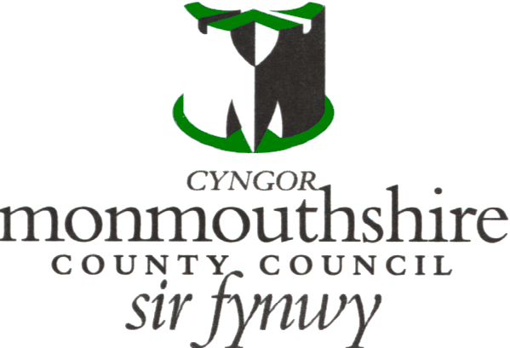

MONMOUTHSHIRE COUNTY COUNCIL
CHILDREN AND YOUNG PEOPLES DIRECTORATE

EMPLOYMENT OF CHILDREN IN PUBLIC ENTERTAINMENT

CHAPERONE LICENCE APPLICATION FORM

Please complete in block capitals
(Mr/Mrs/Miss/Ms) SURNAME: ………………………………….. FORENAMES: …………………….……………

ADDRESS:.……..……………………………………………………………………………………………….…..…….
…………………………..………………………………………………………………………..…………………….……
………………………………………………………………………………POSTCODE .……….……………………...
HOME TEL NUMBER: ……………………………………………………………………………………………………
MOBILE NUMBER:………………………………………………………..................................................................
OCCUPATION …………………………………………………… DATE OF BIRTH ………………………………..
EMAIL: …………………………………………………………………………………………………………………….

Experience & Qualifications:

Have you previously applied to become a Chaperone? If yes, please provide the name of the Local Authority that applications were made to.

Do you have any relevant qualifications applicable to working with children e.g. teacher, teaching assistant, nursery worker, youth worker etc?

Please state your experience in the care, control and supervision of children:

Do you have a First Aid Qualification?

Do you have a Full UK Driving Licence?

NB: If you use your own vehicle to transport children you must ensure that you have appropriate business use insurance and that you comply with all the relevant legislation.

Health Information:

Do you have any health and/or physical conditions that might restrict your ability to act as a Chaperone?

If yes, please give details:

Disclosure & Barring Service Checks:

Due to the nature of the work you are seeking approval for, we require you to have an Enhanced DBS Certificate through Monmouthshire County Council. We only accept current Enhanced DBS Certificates issued by other organisations if you are registered to the DBS Update Service.

If you are registered to the DBS Update Service, please provide the following information:

Certificate Number:…………………………………………………………………………….

Update Service ID Number:…………………………………………………………………..

If you require an Enhanced DBS through Monmouthshire County Council, please complete the following:

Applicant’s official first name:
(Do not shorten or use nick names)
Applicant’s official surname:

Applicant’s email address:
(where DBS link will be sent)
Is this a volunteer role? |  | YES/NO
Does this position involve working with children or adults at the applicant’s home address? |  | YES/NO

Once the above information has been provided, you will receive an email with a link to the online DBS application form.

Have you ever been known to Social Services?

If yes, please give details:

References

Please provide two references (not family members) who have known you for more than 2 years and are prepared to answer an enquiry as to your suitability to carry out the duties of a Chaperone. One of these should be a recent employer.

1. Name  Address:  Postcode:  Telephone Number :  Email:  Context in which known: | 2. Name  Address:  Postcode:  Telephone Number:  Email:  Context in which known:

Declaration:

I hereby clarify that the above particulars are correct

Date:…………………………………….. Signature:…………………………………………………………………….

Please provide two passport sized photographs and return with the completed application form to the address below:

Rachael Worrad/Annalisa Williams
Education Welfare Service,
Monmouthshire County Council,
County Hall,
The Radyr,
Usk,
Monmouthshire,
NP15 1GA.

Tel: Rachael – 07866005202
Annalisa - 07977015454
Email: rachelworrad@monmouthshire.gov.uk
annalisawilliams@monmouthshire.gov.uk

Official use only:

Documents | Date | Carried out by | Approved
Application form received
Photographs received
References checked:
(1)
(2)
Enhanced DBS certificate received:

Chaperone Training attended

