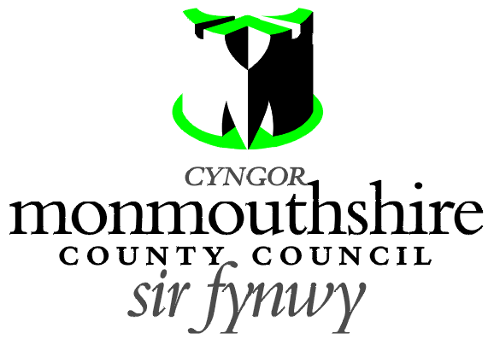

MOUNTON ROAD AND VAUXHALL ROAD
(CHEPSTOW COMMUNITY)
SECTION 90A HIGHWAYS ACT 1980

Monmouthshire County Council propose to provide vertical traffic calming features (Speed Cushions) on Mounton Road and Vauxhall Road in Chepstow.

A Plan indicating the location of the proposed Speed cushions may be examined online at http://www.monmouthshire.gov.uk/public-consultation-traffic.
The proposed Speed Cushions’ dimensions are 1.65 m width, 2.0 m length with a vertical height of 75 mm.

Speed cushions are proposed on Mounton Road at 25 m, 103 m, 151 m, 227 m, 277 m, 324 m, 359 m, 399 m, 464 m, 502 m and 562 m from its junction with the A466.
Speed cushions are proposed on Vauxhall Road at 42 m, 150 m and 213 m from it’s junction with Hardwick Hill (A48).


Any person desiring to object to this proposal can do so by visiting http://www.monmouthshire.gov.uk/public-consultation-traffic or scanning the QR code below, where the public consultation response form can be accessed. Alternatively a statement in writing of their objections specifying the grounds on which they are made to Traffic section, Monmouthshire County Council, County Hall, Usk NP15 1GA. Any representations should be received not later than 17:00 on Thursday 28th April 2022. Monmouthshire County Council will consider objections and representations received in response to this Notice. They may be disseminated widely for these purposes and made available to the public.

Date: 31st March 2022

Mark Hand
Head of Placemaking, Housing, Highways, Flooding and Planning, Monmouthshire County Council
PO Box 106 Caldicot Monmouthshire NP26 9AN

