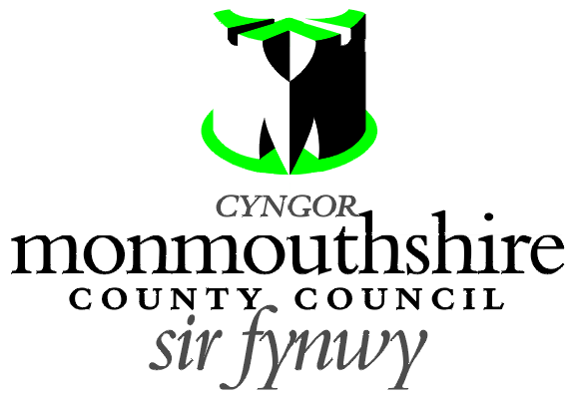

Dear Resident,

Please find enclosed the Notice of Proposal and a plan for a new zebra crossing located on Star Road, Goytre, near to your property. Please find the plan detailing this enclosed. You will note that the newly proposed zebra crossing is to be located slightly further east than where there are Belisha Beacons currently installed.

The reason for this proposal is to address an identified safety risk caused by pedestrians, particularly school children, not having a designated pedestrian crossing near to the blind bend.

By introducing the crossing, pedestrians will have a designated crossing point which will be visible to motorists either side of the bend, greatly increasing pedestrian safety.


Any person desiring to object to this proposal can do so by visiting http://www.monmouthshire.gov.uk/public-consultation-traffic or scanning the QR code below and selecting “How to comment on a proposed TRO”, where the public consultation response form can be accessed. Alternatively a statement in writing of their objections specifying the grounds on which they are made to Traffic section, Monmouthshire County Council, County Hall, Usk NP15 1GA. Any representations should be received not later than 17:00 on Wednesday 23rd March 2022. Monmouthshire County Council will consider objections and representations received in response to this Notice. They may be disseminated widely for these purposed and made available to the public.

Kind regards,

Monmouthshire County Council - Traffic

