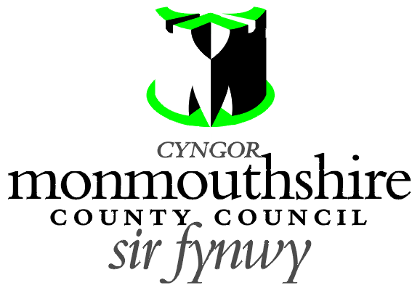

ZEBRA CROSSING
STAR ROAD, GOYTRE

Monmouthshire County Council propose to provide a new Zebra controlled crossing facility on Star Road, Goytre. The zebra crossing is proposed to be located 15 metres east of its junction with School Lane.

A Plan indicating the location of the proposed zebra crossing may be examined online at http://www.monmouthshire.gov.uk/public-consultation-traffic.


Any person desiring to object to this proposal can do so by visiting http://www.monmouthshire.gov.uk/public-consultation-traffic or scanning the QR code below and selecting “How to comment on a proposed TRO”, where the public consultation response form can be accessed. Alternatively a statement in writing of their objections specifying the grounds on which they are made to Traffic section, Monmouthshire County Council, County Hall, Usk NP15 1GA. Any representations should be received not later than 17:00 on Wednesday 23rd March 2022. Monmouthshire County Council will consider objections and representations received in response to this Notice. They may be disseminated widely for these purposed and made available to the public.

Date: 2nd March 2022

Frances O’Brien
Chief Officer
Enterprise Directorate

