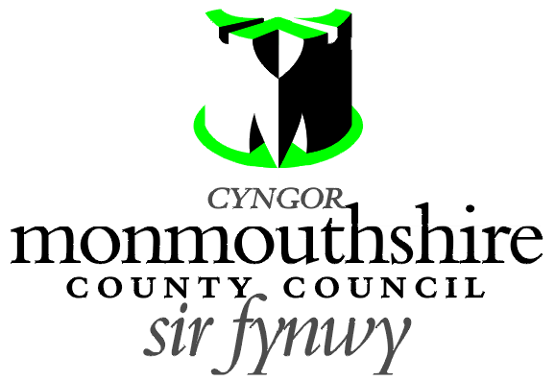

ZEBRA CROSSING
STAR ROAD, GOYTRE

Monmouthshire County Council propose to provide a new Zebra controlled crossing facility on Star Road, Goytre. The zebra crossing is proposed to be located 15 metres east of its junction with School Lane.

A Plan indicating the location of the proposed zebra crossing may be examined online at http://www.monmouthshire.gov.uk/public-consultation-traffic.


Any person desiring to object to this proposal can do so by visiting http://www.monmouthshire.gov.uk/public-consultation-traffic or scanning the QR code below and selecting “How to comment on a proposed TRO”, where the public consultation response form can be accessed. Alternatively a statement in writing of their objections specifying the grounds on which they are made to Traffic section, Monmouthshire County Council, County Hall, Usk NP15 1GA. Any representations should be received not later than 17:00 on Wednesday 23rd March 2022. Monmouthshire County Council will consider objections and representations received in response to this Notice. They may be disseminated widely for these purposed and made available to the public.

Date: 2nd March 2022

Frances O’Brien
Chief Officer
Enterprise Directorate

CREOSFAN SEBRA
HEOL SEREN, GOETRE

Mae Cyngor Sir Fynwy’n cynnig darparu cyfleuster croesfan sebra newydd ar Heol Seren, Goetre. Cynigir lleoli’r groesfan sebra 15 metr i’r dwyrain o’i chyffordd â Lôn yr Ysgol.

Gellir archwilio Cynllun sy’n dangos lleoliad y groesfan sebra arfaethedig
ar-lein - http://www.monmouthshire.gov.uk/public-consultation-traffic.

Mae unrhyw berson sydd am wrthwynebu’r cynnig hwn yn medru gwneud hynny drwy fynd i http://www.monmouthshire.gov.uk/public-consultation-traffic neu drwy sganio’r cod QR isod a dewis “Sut i wneud sylw ar GRhT arfaethedig”, lle y mae modd llenwi ffurflen er mwyn ymateb i’r ymgynghoriad cyhoeddus. Fel arall, mae modd cyflwyno datganiad ysgrifenedig yn nodi sail eu gwrthwynebiad i’r Adran Draffig, Cyngor Sir Fynwy, Neuadd y Sir, Brynbuga NP15 1GA. Dylid cyflwyno unrhyw sylwadau erbyn 17:00 ar ddydd Mercher, 23ain Mawrth 2022. Bydd Cyngor Sir Fynwy yn ystyried unrhyw wrthwynebiadau a sylwadau a dderbynnir sy’n ymwneud gyda’r Hysbysiad hwn. Efallai y byddant yn cael eu rhannu’n ehangach at y dibenion a nodwyd ac ar gael i’r cyhoedd.

Dyddiad: 2ail Mawrth 2022

Frances O’Brien
Prif Swyddog
Cyfarwyddwr Menter

