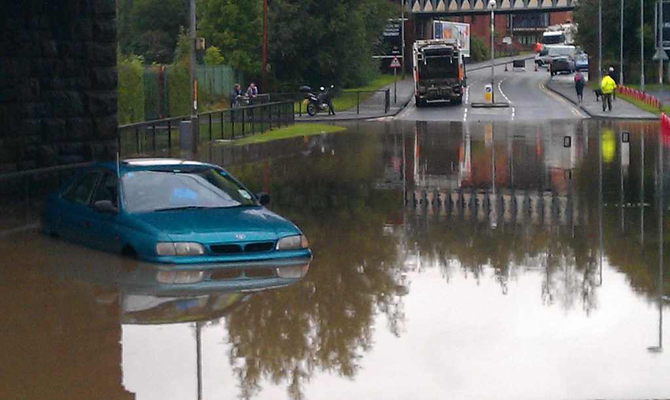
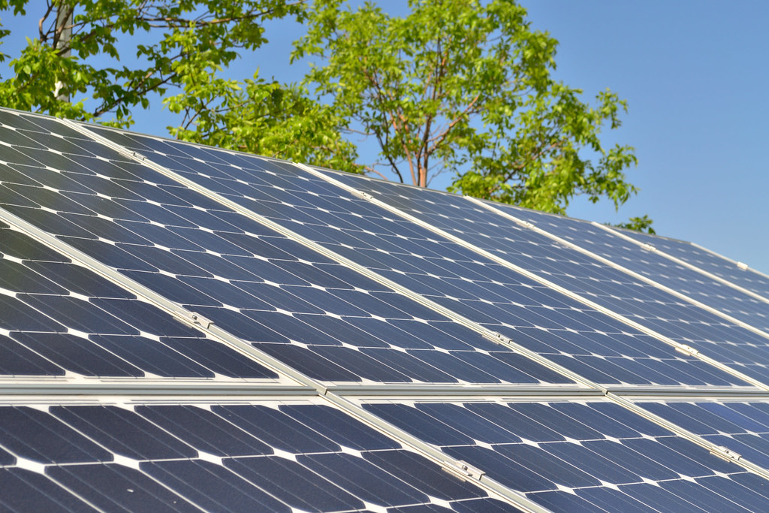
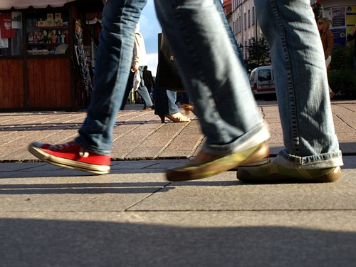
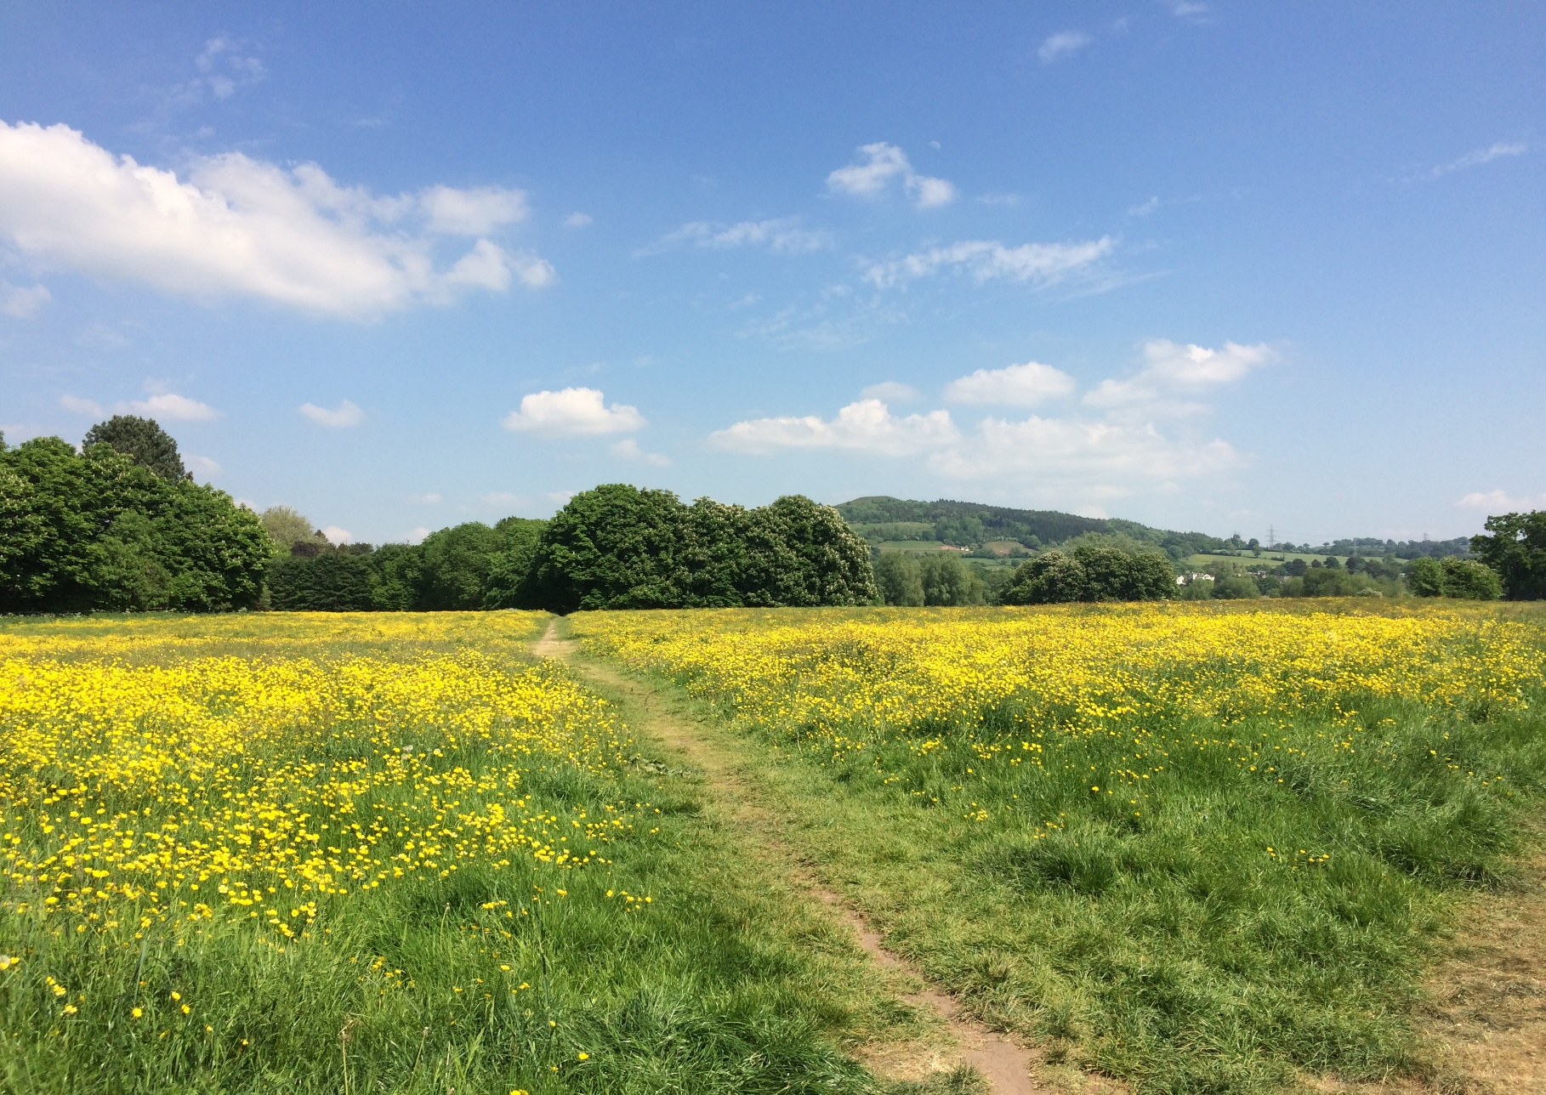

Monmouthshire County Council
Climate Emergency Strategy and Action Plan
Version 2 November 2021

Title | Climate Emergency Strategy
Purpose | This strategy outlines the council’s response to the climate emergency declared in May 2019
Owner | Monmouthshire County Council
Approved by
Date
Version Number | 2.0
Status
Review Frequency | Annual
Next review date | November 2022
Consultation | Version 1 was consulted on in 2019. There has not been consultation on this version 2 of the Strategy, since the changes are just to bring the Strategy data up to date and not change the substance.  The Action Plan has been fully consulted on in October 2021 prior to Council on 4th November 2021. Consultation was via Community Climate Champions; citizen survey; public consultation events; young people’s consultation.

A Note on Terminology
Monmouthshire County Council has committed to becoming net zero by 2030. This means we are committed to making changes to reduce carbon emissions to the lowest amount – and offsetting as a last resort. You will sometimes see the term Carbon neutral used in other documents which refers to a policy of not increasing carbon emissions above and of achieving carbon reduction through offsets.

Foreword
The purpose of Monmouthshire County Council is building sustainable and resilient communities. This feels more relevant than ever. No one can be blind to the threat that climate change poses to our eco-systems, our local environment and our way of life. Carbon emissions from fossil fuels are one of the main causes of climate change and as a council we are striving to reach net zero by 2030.
If we are to stand a chance of slowing the rise in the Earth’s temperature we need to act now. In 2019 councillors in Monmouthshire were unanimous in declaring a climate emergency. We intend to play our part in tackling this issue and we will work with communities and local businesses to help them reduce their emissions. This will require engagement, community involvement and commitments from third parties.
We have made a start:
- We have called for our pension fund to divest its fossil fuel investments and have seen the proportion of the fund invested in such firms decline from 9.10% to 2.35% since 2018;
- We have built a solar farm which contributes towards the £650,000 worth of renewable energy we put into to the national grid each year;
- More than 99% of the energy we buy comes from renewable sources.
And we will continue to do more:
- Developing an investment programme to help our services transition to a low carbon future
- Piloting the use of locally designed and built hydrogen powered cars;
- Trialling digital solutions which make it easier for people to travel through better use of existing transport capacity;
- Installing a network of charging points for electric vehicles.
We will do this while continuing to provide the services which form part of the social foundations on which our communities are built. We know that this will not be easy. It needs bold thinking and we don’t yet have all of the answers. Monmouthshire is blessed with a rich tapestry of caring and committed people, businesses and community groups that make this place what it is. Now, perhaps more than at any time in the past, we need everyone to get behind this commitment and play their part in securing a better tomorrow.


Cllr Jane Pratt,
Cabinet Member for Infrastructure and Neighbourhood Services
Monmouthshire 2030: A Net Zero Council
Why this matters?
Tackling climate change and moving to a low carbon economy is one of the biggest challenges facing our society. Rising temperatures bring increased risks to our communities and are causing long-term and potentially irreversible damage to our planet’s eco-systems, with significant local impacts such as flooding and loss of species. By 2030 this council aspires to reduce its net carbon emissions to zero while continuing to deliver important local services to our communities.
Carbon emissions from fossil fuels are one of the main causes of climate change. The scientific consensus is that human activity since industrialisation has been the major factor in the recent warming of the Earth’s surface. It will take action and ingenuity from humans to halt it.

Climate change, deforestation and agriculture mean the ability of the planet to lock up carbon is reducing. Soil is being eroded at a quicker rate than new soil can be formed while melting ice is contributing to rising sea levels and releasing carbon previously trapped beneath frozen land. These changes result in feedback loops where rising temperatures accelerate the degradation of land and soil through drought, desertification and rising sea levels. This in turn increases the volume of greenhouse gases being released by land, further accelerating global warming.
Time to Act
If we are to stand a chance of addressing climate change and slowing the rise in the Earth’s temperature there is a narrow window of opportunity to take action. The International Panel on Climate Change has indicated that rises above 1.5 °C will affect the ability of the planet to sustain human life as we know it and that crucially, without significant change, that figure will be passed by 2030. In short, we don’t have long to act.
In May 2019 Monmouthshire County Council unanimously passed a motion declaring a climate emergency. This sets out a clear policy commitment for the council to:
- strive to reduce its own carbon emissions to net zero in line with the Welsh Government target of 2030;
- encourage and support residents and businesses to take their own actions to reduce their carbon emissions;
- Work with partners across the county and other councils and organisations to help develop and implement best practice methods in limiting global warming to less than 1.5 °C.
This must be done while continuing to provide the services which create the social foundations our communities are built upon and which no-one should be without. These include the commitments within the council’s Social Justice Strategy. Our challenge is to find a way to exist in the safe space between the ecological limits of the planet while continuing to provide these social foundations. The Cabinet Member for Infrastructure and Neighbourhood Services chairs a group to oversee progress and ensure that the council’s plans are continually challenged to reduce carbon and incorporate emerging technology and concepts. This requires bold thinking, we do not yet have all of the answers and will continue to seek out the people, ideas and evidence about what works and apply this in Monmouthshire. The group comprises of representatives of each political group, senior council officers and representatives of the community

The Benefits of Action
As well as the global and moral imperative to act on climate change we can also expect to see multiple local benefits from moving to a lower carbon society:
- Lower energy bills for residents and businesses
- Better air quality and the resulting health benefits
- Shorter commuting times between home, work and school
- Increased use of active travel like walking and cycling which can help improve peoples’ health
- Less damage to the local environment from drought, floods and fire
- Increased demand for green technologies and the resulting potential for job growth in these sectors
- Better habitat management, increased biodiversity and creation of green space
- Increased connectivity between people and the environment and more globally responsible citizens

Local Carbon Emissions
Climate is a global issue but we all have a part to play. If we are to reduce our net emissions we need to understand what they are now – both in our county and our organisation. Emissions per head of population across Monmouthshire are above UK levels. Since 2005 net carbon emissions in the county have reduced by 32% from 922 kilotonnes to 623 kilotonnes per year by 2019 while our population has increased by 7% over the same period. Although the emissions have reduced, this is still a weight the equivalent of 52,000 London double decker buses.

(Source: UK local authority carbon dioxide emissions, National Statistics)
The downward trajectory mirrors a similar trend as across the UK as a result of things like an increase in the use of cleaner energy. Over this time we have also seen an increase in carbon captured in the county from 5.5 to 36.7 kilotonnes but the amount captured is less than 6% of the total CO₂ produced. If decarbonisation were to continue at this rate we would not achieve the desired reductions until after 2050, too late to prevent catastrophic climate change. We need to do more.
The Tyndall Centre for Climate Change has calculated climate change targets for the county of Monmouthshire that are derived from the commitments enshrined in the Paris Agreement. This gives a carbon budget for carbon dioxide emission for each year up to 2020 and highlights the scale of the challenge we face.
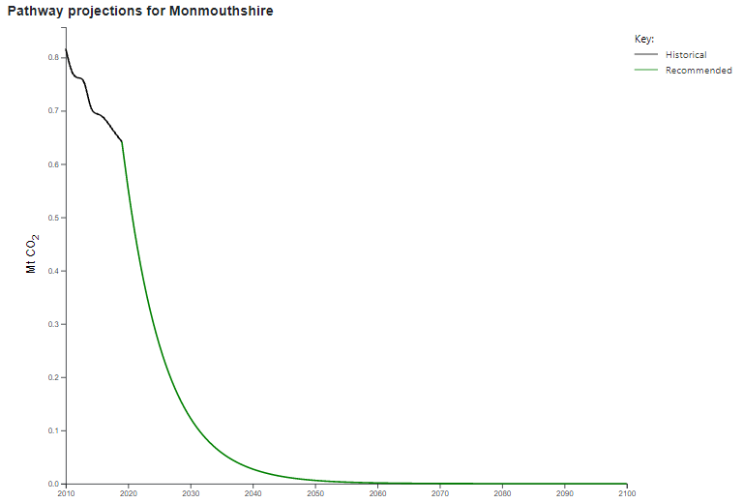
Full details of the carbon budget are available at https://carbonbudget.manchester.ac.uk/reports/
Carbon emissions in the county come from a range of sources including industry, agriculture, road transport and domestic homes. The biggest single contributor is transport, of which 96% is from road transport. This is shown in the chart below:

(Source: UK local authority dioxide emissions, National Statistics)

Monmouthshire County Council will strive to reduce its own emissions while working with partners, including the public sector organisations on the Public Service Board, local businesses and community groups to reduce emissions and improve carbon capture across the county as a whole from things like trees, vegetation and green infrastructure which help to sequester and store carbon.
The Council does not control or have a direct influence on all the things that need to change to reduce emissions in the county. This plan focuses mainly soon those activities which we can control or influence through our own activity, or through things like planning policy. However, a large proportion of the emissions in the county are from domestic energy, road transport and industry. We are able to make some changes to incentivise individuals to reduce their own emissions, for example by making active travel more attractive relative to car journeys, but the majority of the policies that will have the greatest influence, rest with national governments.

We’ve made a start…but have a lot more to do
The Council are already taking steps to reduce our carbon emissions. This infographic shows some of the work that is already underway in Monmouthshire.
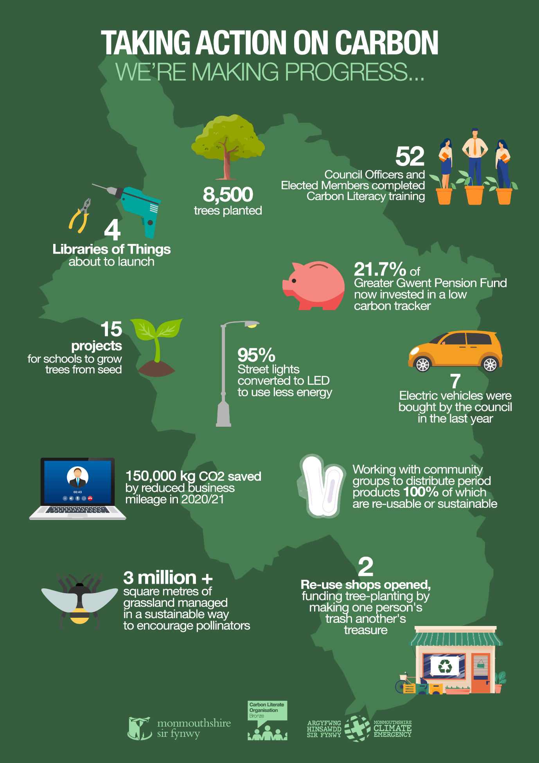

Our Objectives at a Glance
Our action plan covers ten broad objectives that will deliver a net reduction in carbon emissions by 2030. Each of these objectives contains actions for the local authority which will reduce the council’s own emissions, as well as actions that will reduce county wide carbon emissions which will need to be taken forward in partnership with the community, plus steps that everyone can do.
The action plan contained as an appendix to the strategy was updated in 2021. It will continue to be updated and reported on annually but the actions will be continuous, as we look globally for examples of leading edge practice that can help us accelerate our progress. Regular monitoring reports are received by the Climate Emergency Working Group with the Cabinet member reporting to Council on progress. Our priority will be to put our energy and investment into those that offer the most advantageous balance of carbon reduction and feasibility. We also need to ensure some early actions to get the maximum cumulative benefit over the next nine years.
Energy and Buildings |  | Renewable Energy
Reduce the amount of energy that is used for buildings and street lighting |  | Speed up the move from fossil fuels to renewable energy
Nature Recovery and Green Spaces |  | What we Buy
To absorb carbon, to support biodiversity and ecosystem resilience, and the ability to adapt |  | Reduce carbon by thinking carefully about when and what we buy and the whole life costs
Waste |  | Active Travel
Reduce waste by encouraging people to reduce, re-use and recycle more |  | Encourage and make it easier for people to walk and cycle rather than drive
Greener Transport |  | Public Transport
Reduce the impact of vehicles and encourage the use of electric and hydrogen vehicles |  | Encourage people to use public transport rather than cars
Education and involvement |  | Climate Adaptation
Help people understand climate change and what they can do to make a difference |  | Preparing and adapting for the impact of climate change.

Playing your part
The Climate Emergency Action Plan cannot be delivered by the Council alone. We need other partners to join us in helping to reduce carbon emissions across the county. To that end, we will be working with Public Service Board partners over coming months. Much decarbonisation work is also done at a regional scale, with close working with Cardiff Capital Region, and some of our actions will contribute to their Energy Vision and Strategy.
We hugely value the enthusiasm, energy and expertise of the residents of Monmouthshire who have such a lot to contribute, and we continue to collaborate with our communities and other partners to work together on our action plan.
There are things that every resident, visitor or worker in Monmouthshire can do to play their part in reducing carbon emissions and helping to slow down climate change. We are all part of the problem, but can all be part of the solution too.
Climate Adaptation
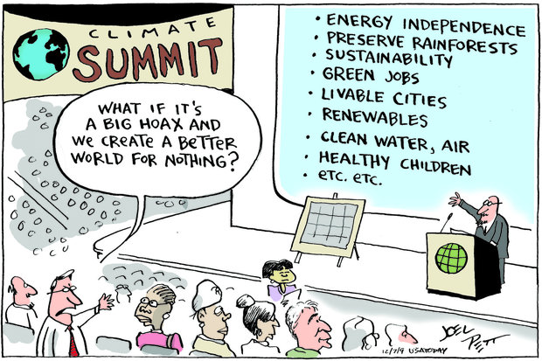
Even if we were to stop all carbon emissions today, we will still have to face the impacts of climate change that are already happening. Over the next few decades we are facing some level of climate change regardless of any action to reduce our emissions now. The 3rd Climate Change Risk Assessment for Wales published in 2021 forecasts hotter, drier summers, warmer, wetter winters and more extreme weather events.
There are lots of things that the council is doing to make sure that we are prepared for the impacts of climate change. In recent years, council services have thought about what the potential risks to their services are, in order to start thinking about how to adapt to these risks. The Local Development Plan has a key role to play in making sure that our communities are sustainable and resilient to the impacts of climate change.
With an increase in winter rainfall and rising sea levels, flooding is likely to increase, and this will be a particular concern in parts of Monmouthshire. Much of the work to co-ordinate emergency responses is organised through the Gwent Local Resilience Forum (LRF). We will continue to work with partners on the LRF to make sure that we are prepared for severe weather events.
If you live somewhere prone to flooding, make sure you know what to do. Find out more at https://www.monmouthshire.gov.uk/services/planning-for-emergencies/flooding/
Keeping tabs on how we are doing
It is important that we know whether the actions we will be taking to reduce climate change are making a difference to our emissions. We can measure how much carbon some of the actions will save. However, we will not be able to measure carbon savings from some of the actions, but we can at least make sure that we are doing what we have said we will do.
We have set up a Climate Emergency Working Group, which is chaired by the cabinet member and includes elected member from each party, senior officers and community representative and meest quarterly. Updates on progress against the actions are collated every three months and reported to the working group to make sure that we are making good progress. The Cabinet member also briefs Council on progress periodically.

References https://www.ipcc.ch/2018/10/08/summary-for-policymakers-of-ipcc-special-report-on-global-warming-of-1-5c-approved-by-governments/
https://democracy.monmouthshire.gov.uk/ieListDocuments.aspx?CId=143&MId=3758
Doughnut Economics (2017); Raworth, Kate
UK local authority and regional carbon dioxide emissions national statistics: full dataset and methodology available at https://www.gov.uk/government/collections/uk-local-authority-and-regional-carbon-dioxide-emissions-national-statistics (accessed 19/10/21)
LULUCF Net Emissions (land use, land use change and forestry) total. Ibid
https://carbonbudget.manchester.ac.uk/reports/W06000021/ (accessed 19/10/21)
UK local authority and regional carbon dioxide emissions national statistics: full dataset and methodology available at https://www.gov.uk/government/collections/uk-local-authority-and-regional-carbon-dioxide-emissions-national-statistics
Council Data for 2020/21
https://www.ukclimaterisk.org/wp-content/uploads/2021/06/CCRA-Evidence-Report-Wales-Summary-Final.pdf

