Appendix 1

Title | Climate Emergency Action Plan
Purpose | This plan outlines the council’s response to the climate emergency declared in May 2019
Owner | Monmouthshire County Council
Approved by | Not yet approved
Date | November 2021
Version Number | 2.0
Status
Review Frequency | Annual
Next review date | November 2022
Consultation | Community Climate Champions; citizen survey; public consultation events; young people’s consultation.

Notes:
Timescale
We have allocated dates that are broadly based on the Welsh Government’s Public Sector Decarbonisation Routemap Net zero carbon status by 2030: A route map for decarbonisation across the Welsh public sector (gov.wales)
It should be noted that the dates given are the timescale for completion and not for starting the work. Many of the actions listed are already underway.

Climate Emergency Action Plan 2021
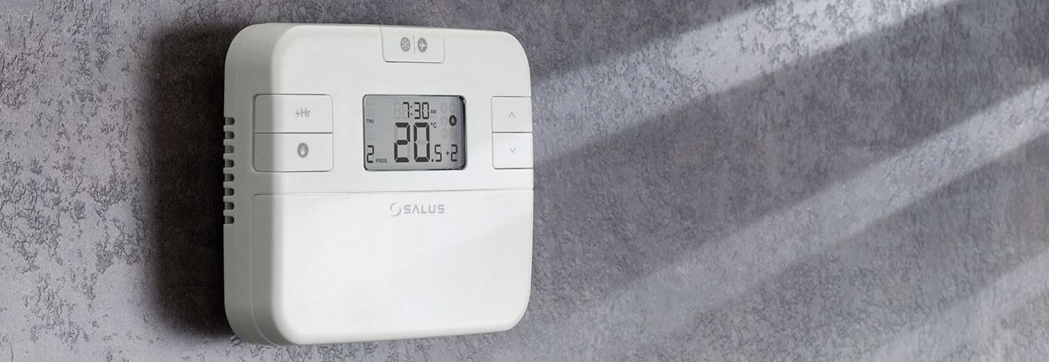
Reducing energy use

Reducing energy use
Reducing the amount of energy that is used for buildings and street lighting
Action to reduce MCC emissions | Timescale | Responsible Officer
Develop a low carbon transition plan to identify and implement decarbonisation measures across the existing council estate | 2021-23 | Energy Manager
All new and replacement lighting within council owned buildings will be low energy LED | 2021-23 | Energy Manager
All remaining street lighting will be converted to LED bulbs and managed to reduce light pollution and negative impacts on biodiversity | 2021-23 | Street Lighting Manager
Where reasonably practicable all new council buildings will be designed to be net zero emissions. | 2021-23 | Head of Property, Fleet & Facilities
Establish a more robust baseline for council carbon emissions in line with the Carbon Disclosure Project* and develop trajectories and pathways to 2030 net zero carbon target | 2021-23 | Energy Manager
Action to reduce Countywide emissions | Timescale | Responsible Officer
Use planning policy to require net zero carbon standards for all new developments in the Replacement Local Development Plan. | 2024-27 | Head of Planning
Use and promote low carbon building technologies like green walls or roofs | 2024-27 | Head of Planning
Work with PSB partners and other organisations to reduce carbon emissions across all public buildings | 2021-23 | Head of Policy Performance and Scrutiny
Encourage builders and developers to undertake training in low carbon technologies | 2021-23 | Building Control Manager
Identify and develop the skills needed by industries of the future including green jobs/apprenticeships, working with the Regional Skills Partnership* | 2021-23 | Head of Enterprise and Community Animation
Promote, educate and help residents take actions to decarbonise their own homes | 2021-23 | Sustainability Policy Officer
What can I do to play my part?

Make sure you have got draft proofing, loft and cavity wall insulation in your home – save money and energy. https://www.energysavingtrust.org.uk/home-insulation
Simple things like switching off the lights, not leaving things on standby and only boiling the water you really need in the kettle can really make a difference. https://www.energysavingtrust.org.uk/home-energy-efficiency
Understand how your heating controls work and using thermostats properly can save energy.
If you use a dishwasher, make sure you only use it when full.
Make sure your washing machine in full and dry clothes on a line rather than tumble dry if you can.

*In addition to work undertaken by officers of the local authority, Monmouthshire County Council is part of the Cardiff Capital Region City Deal. As part of their Energy Strategy work is being undertaken with partners in the South Wales Industrial Cluster to begin decarbonising industry through energy efficiency, fuel switching and the creation of local energy hubs. The Regional Skills Partnership is tasked with identifying and prioritising the skills to support economic prosperity and good growth. The CCR is also commissioning support to enable local authorities to undertake reporting in line with the Carbon Disclosure Project. Some of the work the Council is doing will be run as Challenge Fund projects through Cardiff Capital Region.


Using renewable energy

Using renewable energy
Speed up the move from fossil fuels to renewable energy

Action to reduce MCC emissions | Timescale | Responsible Officer
Generate 8 MW of new renewable energy from the council’s estate, subject to location of renewable sites allocated in the Replacement Local Development Plan | 2024-27 | Head of Property, Fleet & Facilities
Install photovoltaic canopies at council owned car parks to power electric vehicle charge points with renewable energy | 2024-27 | Head of Property, Fleet & Facilities
Action to reduce Countywide emissions | Timescale | Responsible Officer
Identify areas for renewable generation in the Replacement Local Development Plan | 2021-23 | Head of Planning
Work with Welsh Government to develop a Local Area Energy Plan in line with wider Cardiff Capital Region Energy Strategy* | 2024-27 | Head of Property, Fleet & Facilities
Explore potential opportunities for a district heating scheme | 2021-23 | Rural Programmes Procurement Officer
What can I do to play my part?

Switch your energy supplier to a renewable energy contract. https://www.moneysavingexpert.com/utilities/cheap-green-energy/
Find out whether you could install solar panels or another renewable energy in your home. https://www.energysavingtrust.org.uk/renewable-energy
Consider moving your savings or pensions into ethical and socially responsible funds. https://www.finder.com/ca/ethical-savings-accounts
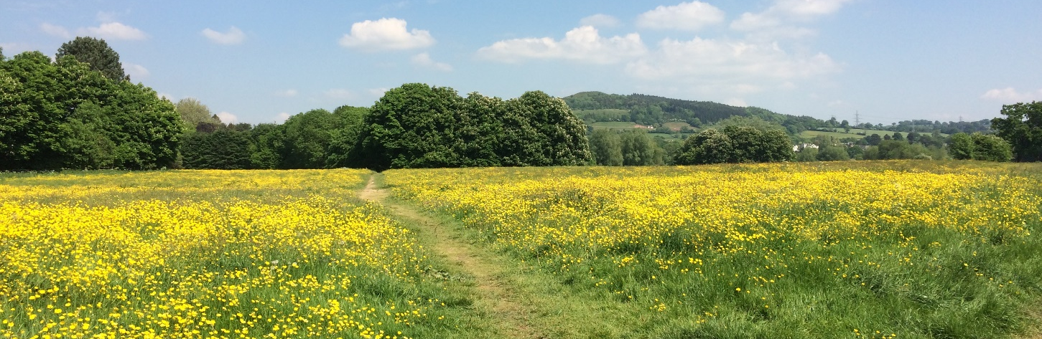
Nature recovery and green spaces

Supporting nature recovery and managing green spaces
Absorb carbon, to support biodiversity and ecosystem resilience, and the ability to adapt

Action to reduce MCC emissions | Timescale | Responsible Officer
Promote and, as opportunities arise, use our county farms as exemplars for sustainable and regenerative agriculture. | 2021-23 | Head of Property, Fleet & Facilities
Expand and promote pollinator friendly management work and reduce grass cutting frequency/extent where appropriate and safe | 2021-23 | Commercial and Operations Manager
Generate renewable energy from grass cuttings through anaerobic digestion | 2024-27 | GI Strategy and Projects Officer
Work in partnership to plant more trees, increase area of woodland, improve woodland management and retain and protect existing woodland and trees | 2021-23 | Environment and Culture Manager
Embed biodiversity throughout decision-making; reduce key pressures on species and habitats; supporting landscape scale nature recovery projects and partnerships to enhance ecosystem resilience | 2021-23 | Environment and Culture Manager
Action to reduce Countywide emissions | Timescale | Responsible Officer
Promote sustainable land management and regenerative agricultural practices, including nutrient/soil management and natural flood management | 2021-23 | Environment and Culture Manager
Work with partners to support and promote actions to improve river water quality | 2021-23 | Environment and Culture Manager / Head of Planning
Explore and establish a target for an increase in the percentage of urban and rural tree cover | 2021-23 | GI Strategy and Projects Officer
Provide information to encourage new tree planting including in private gardens | 2021-23 | GI Strategy and Projects Officer
Work with Stump Up for Trees and other similar local organisations to evaluate benefits of biochar for tree plant health and locking up carbon | 2021-23 | Head of Neighbourhood Services
Protect and enhance green infrastructure through new and existing development | 2024-27 | Green Infrastructure Manager
Promote and support low impact local and community food growing | 2021-23 | Rural Programmes Coordinator
Reduce food miles by working with local and regional growers, distributors and retailers to market local food | 2024-27 | Rural Programmes Coordinator
Develop an adopt-a-garden scheme to increase local food growing and biodiversity | 2021-23 | Community Well-being Development Lead
What can I do to play my part?
Leave part of your garden wild, make habitats for wildlife and plant trees to absorb carbon dioxide. https://www.wildlifetrusts.org/actions
Join a “Friends of” group to get involved in sustainable green space management, or find out about local groups who are doing community gardening and growing. https://www.farmgarden.org.uk/
Try and reduce your food miles by buying food which is locally grown where possible and in season.
Think about where meat you buy comes from and have a varied diet with plenty of fruit and vegetables
Get involved in community allotments or establish a new allotment and have a go at growing your own fruit and veg. https://www.theallotmentgarden.co.uk/Easier-grow/


What we buy

What we buy
Reducing carbon by thinking carefully about when and what we buy and whole life costs

Action to reduce MCC emissions | Timescale | Responsible Officer
Eliminate single use plastics within the council | 2024-27 | Sustainability Policy Officer
Incorporate climate and decarbonisation into strategic procurement collaborations, using robust, easy to understand, achievable, procurement principles that can be scored against | 2021-23 | Strategic Procurement Manager
Commission detailed analysis to effectively measure emissions resulting from our spend with third parties and work with managers to begin moving to lower carbon alternatives | 2024-27 | Strategic Procurement Manager
Eliminate the use of peat based compost from our supply chain | 2024-27 | Commercial and Operations Manager
Continue to phase out fossil fuel investments from our pension fund | 2028-30 | Chief Officer Resources
What can I do to play my part?

Think about how much you buy and whether you really need it.
When you are buying food think local, in season, reduced and recyclable packaging.
Support your local charity shop and buy second hand, or use schemes such as Freecycle https://www.freecycle.org/
Reduce the amount of “stuff” you buy by borrowing from your local Library of Things, and getting items repaired at a Repair Café. https://monmouthshire.benthyg.cymru/
Consider buying “experiences” for people as gifts, or charity gifts that support sustainable projects, rather than buy gifts that aren’t wanted or needed. https://onlineshop.oxfam.org.uk/unwrapped/category/oxfam-unwrapped

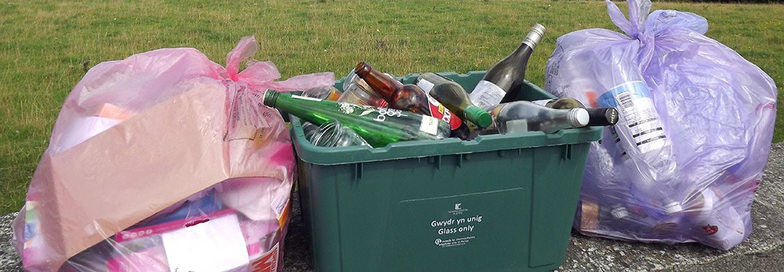
Reducing waste

Reducing waste
By encouraging people to reduce, re-use and recycle more

Action to reduce MCC emissions |  | Timescale | Responsible Officer
Focus on reducing and reusing waste whilst continuing to increase domestic, business and schools recycling in line with Welsh Government’s Towards Zero Waste strategy | 2021-23 |  | Head of Neighbourhood Services
Continue to develop the Council’s Reuse Shops at the recycling centres and support the third sector, charity and voluntary projects to reuse waste. | 2021-23 |  | Head of Neighbourhood Services
Action to reduce Countywide emissions |  | Timescale | Responsible Officer
Develop Libraries of Things, Repair Cafes and Community Fridge projects to reduce waste | 2021-23 |  | Head of Neighbourhood Services
Make all of our buildings water refill stations and promote them |  | 2021-23 | Sustainability Policy Officer
Promote the use of home composters and water butts |  | 2021-23 | Head of Neighbourhood Services
What can I do to play my part?

Find out about and use all the different types of recycling that Monmouthshire does. https://www.monmouthshire.gov.uk/recycling-and-waste/
Get recipes and tips for using food and reducing food waste. https://lovefoodhatewaste.com/
Use refillable water bottles, and reusable containers for your lunch. https://refill.org.uk/
Try and cut down on single use plastics. https://www.sas.org.uk/plastic-free-communities/
Look after your clothes, repair them and don’t buy disposable fashion. https://www.loveyourclothes.org.uk/
Donate unwanted clothes, bric-a-brac, books, furniture etc. to your local charity shop, or textile recycling scheme to reduce landfill and help raise money.


Walking and cycling

Walking and cycling
Encouraging and making it easier for people to walk and cycle rather than drive

Action to reduce MCC emissions | Timescale | Responsible Officer
Develop schemes that will increase walking and cycling to school | 2021-23 | Youth Sport and Active Travel Manager / Road Safety Officer
Introduce no idling at problem locations including schools, and explore feasibility of no parking/dropping off near schools | 2021-23 | Group Engineer, Highways
Reduce business miles travelled by council staff and reduce the amount of commuter journeys made to the office, by building on changes made during the pandemic | 2021-23 | Chief Officer People and Governance
Use place-based working in social care to reduce staff and service user journeys | 2021-23 | Chief Officer Social Care, Health and Safeguarding
Action to reduce Countywide emissions | Timescale | Responsible Officer
Improve, expand and maintain safe and convenient cycle and footpath networks, to encourage active travel. | 2021-23 | Chief Operating Officer, MonLife
Develop e-bike and cycle hire schemes beginning in town centres | 2021-23 | Youth Sport and Active Travel Manager / Rural Programmes Manager
Ensure the RLDP allocates sites that promote the Twenty Minute Town concept to reduce the number of car journeys people have to make | 2024-27 | Head of Placemaking, Highways and Flooding
Work with communities to trial 20 mph speed limits in some areas ahead of a national roll-out of this policy | 2021-23 | Head of Property, Fleet & Facilities
Develop and promote co-working spaces across the county and with partners to reduce the need for long commutes to offices | 2024-27 | Head of Property, Fleet & Facilities
What can I do to play my part?

Try and walk for short journeys, and reduce carbon while getting fit at the same time!
Find out about local cycle routes and cycling groups and get on your bike. https://www.sustrans.org.uk/national-cycle-network/
Try out an electric bike if you live somewhere hilly or could do with a bit of an extra boost! https://www.which.co.uk/reviews/electric-bikes/article/electric-bikes-everything-you-need-to-know
Team up with parents and your local school to develop a walking bus to walk your little ones to school.
Get involved with local public rights of way volunteering opportunities. https://volunteer.monmouthshire.gov.uk/
Ask your employer if they can provide showers and lockers so that you can cycle to work.

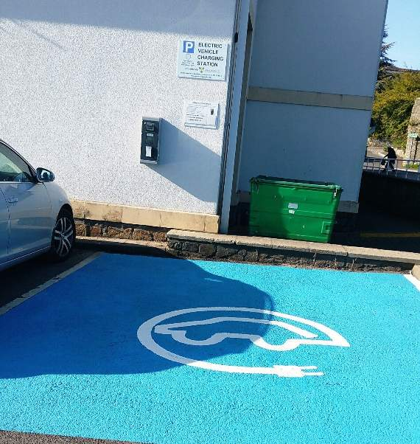
Greener vehicles

Greener vehicles
Reducing the impact of vehicle use and encouraging use of electric and hydrogen vehicles

Action to reduce MCC emissions | Timescale | Responsible Officer
Relocate an operations depot in the south of the county to be geared up for EV charging and a move to a low carbon fleet, subject to the Replacement Local Development Plan | 2024-27 | Head of Property, Fleet & Facilities
Accelerate the transition of the council’s transport fleet to hybrid, electric and hydrogen vehicles as these become available | 2028-30 | Transport Manager
Understand how, when and where staff travel and use the Council fleet, in order to make best use of existing vehicles | 2021-23 | Transport Manager
Learn from the Riversimple hydrogen car pilot in Abergavenny to explore the potential for wider hydrogen use | 2024-27 | Transport Manager
Review our green travel plan for staff and councillor travel, and align it with Changing Spaces work | 2021-23 | Transport Planning & Policy Officer
Develop an Electric Vehicle Strategy, building on good practice from elsewhere. | 2021-23 | Head of Property, Fleet & Facilities
Install EV charging points and e-bike charging at all larger council buildings | 2021-23 | Head of Property, Fleet & Facilities
Action to reduce Countywide emissions | Timescale | Responsible Officer
Encourage the use of electric or hybrid taxis | 2024-27 | Transport Strategy Business Manager
Develop proposals for increased public EV charging including on street and in car parks | 2021-23 | Head of Property, Fleet & Facilities
Develop proposals for EV charging in new housing development | 2024-27 | Head of Property, Fleet & Facilities
Provide free car parking whilst charging in MCC owned car parks for up to 3 hours for electric vehicles | 2021-23 | Head of Property, Fleet & Facilities
What can I do to play my part?

Try and car share when you can, to save fuel and money. There are schemes to help. https://liftshare.com/uk
If you are thinking of replacing your vehicle, think about whether an electric car would work for you. There are grants which can help. https://www.energysavingtrust.org.uk/transport/electric-cars-and-vehicles/electric-vehicles

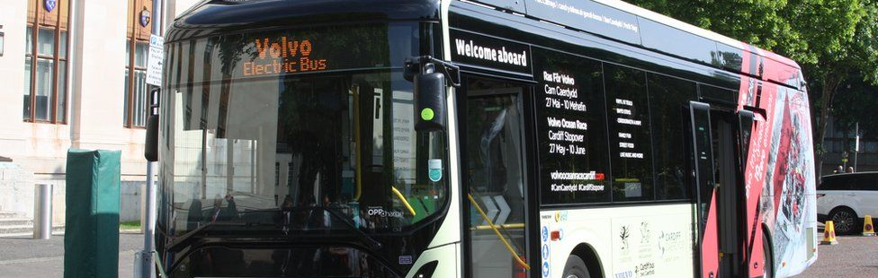
Public transport

Public transport
Encouraging people to use public transport rather than cars

Action to reduce MCC emissions | Timescale | Responsible Officer
Transition Monmouthshire-owned and operated buses to EV or hydrogen when this becomes feasible for rural journeys | 2028-30 | Transport Manager
Action to reduce Countywide emissions | Timescale | Responsible Officer
Encourage public transport use through the increased investment being made in the South Wales Metro | 2024-27 | Transport Planning & Policy Officer
Continue to make the case to national governments for improved public transport provision, including train frequencies and station provision | 2021-23 | Transport Planning & Policy Officer
Develop an app or website that gives people journey information for public transport, booking options for demand responsive transport and access to the volunteer operated community lift-share scheme | 2021-23 | Head of Policy / Head of Enterprise and Community Animation
What can I do to play my part?

Find out about public transport options that could work for you. https://www.traveline.cymru/
If you are 16 to 21 you can get bus travel discounts. https://mytravelpass.gov.wales/en/
If you are 16 to 25 you can apply for a young persons railcard. https://www.16-25railcard.co.uk/
Concessionary bus passes are available from Transport for Wales. https://tfw.wales/info-for/over-60s
Education and involvement

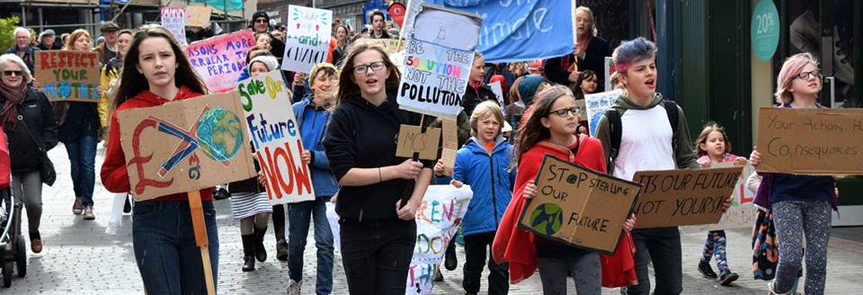
Education and involvement

Education and involvement
Helping people understand climate change and what they can do to make a difference

Action to reduce MCC emissions | Timescale | Responsible Officer
Make energy data available to schools and encourage pupils to get involved in managing energy consumption | 2024-27 | Energy Manager
Develop carbon dashboards to help council staff understand and monitor carbon emissions | 2021-23 | Energy Manager
Use the One Planet Centre as a focus for climate change education for schools, groups and organisations | 2021-23 | Head of Neighbourhood Services
Work with young people to enable them to take positive action on climate change | 2021-23 | Youth Sport and Active Travel Manager / Rural Programmes Manager
Start schemes for local growing, cooking and food waste reduction in schools, linking with local community groups | 2024-27 | Rural Programmes Coordinator
Introduce carbon literacy training for all council staff and embed climate change throughout corporate training and development | 2021-23 | Sustainability Policy Officer
Use the Cardiff Capital Region InFuSe programme to identify and develop innovative and collaborative solutions to the challenge of decarbonisation | 2021-23 | Head of Enterprise and Community Animation
Action to reduce Countywide emissions | Timescale | Responsible Officer
Signpost businesses to support, advice and information to help them to reduce their carbon emissions | 2021-23 | Business Insight Manager
Start a communications campaign about simple steps people can take to reduce their carbon emissions and brand up other activity as Climate Emergency action | 2021-23 | Head of Communications
Support schools to utilise the opportunity provided by the new curriculum to ensure climate change education is embedded into young people’s learning. | 2024-27 | Head of Achievement and Attainment
Deliver carbon literacy training to individuals and community groups to raise awareness and expertise in communities | 2021-23 | Sustainability Policy Officer
Work with local champions in the community to build local action on climate and signpost to useful advice and guidance | 2021-23 | Sustainability Policy Officer
Use Monmouthshire Connect to build a group of people in communities to assist others to decarbonise | 2021-23 | Community Well-being Development Lead
What can I do to play my part?

Get involved with your school’s Eco Committee, or if your school isn’t an Eco School, find out more and ask them if they would consider it. https://www.keepwalestidy.cymru/pages/category/eco-schools
Does your workplace have recycling or other environmental issues in place? Why not try and start something.
Get involved with one of the many voluntary groups in Monmouthshire doing great work on climate change. https://www.transitionchepstow.org.uk/ https://transitionmonmouth.org/ https://www.facebook.com/AbergavennyExtinctionRebellion/
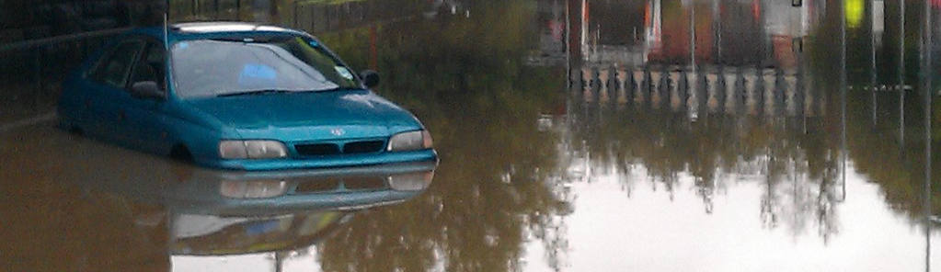
Adaptation
Climate adaptation

Climate Adaptation
Preparing and adapting for the impact of
climate change

 | Timescale | Responsible Officer
Develop and act on Climate Change Risk Assessments for council services to fully understand adaptation requirements | 2021-23 | Sustainability Policy Officer
Develop the management of green infrastructure to improve climate resilience | 2021-23 | Environment and Culture Manager
Increase urban tree canopy including new street trees and in car parks to provide a cooling effect | 2024-27 | Green Infrastructure Manager / GI Strategy and Project Officer
Continue to promote and support council services with business continuity and emergency response strategies | 2021-23 | Emergency Planning Manager
Continue to promote and support business continuity to external businesses. | 2021-23 | Emergency Planning Manager
Work with the Business Resilience Forum to signpost businesses to support and advice on adapting to the impacts of climate change. | 2021-23 | Business Insight Manager
Work with partners to understand potential for and implement natural flood management | 2021-23 | Project Engineer (Flood Risk Management)
Undertake adverse weather planning, including heatwaves for Social Care and other service area | 2021-23 | Emergency Planning Manager
Ensure permeable materials and water storage is incorporated into new development and infrastructure | 2024-27 | Head of Planning
Continue to avoid new development on floodplains, ensuring all new proposals comply with national planning policy guidance in Technical Advice Note 15 (2021) | 2024-27 | Head of Planning
What can I do to play my part?

Do you live in an area prone to flooding? Find out what you can do to be prepared. https://www.monmouthshire.gov.uk/services/planning-for-emergencies/flooding/
Could your community group plant trees to reduce flooding, provide habitat and shade? https://www.woodlandtrust.org.uk/plant-trees/schools-and-communities/
Find out how you can make sure your garden is resilient to our future climate. https://www.rhs.org.uk/science/gardening-in-a-changing-world/climate-change

