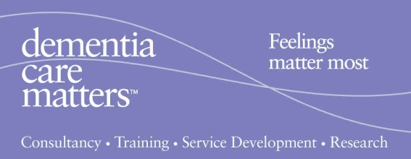
Understanding how Feelings, Thinking & Action link or not
- Red = Feelings
- Amber = Thinking
- Green = Actions

The key message: in dementia care the amber light is faulty or not working at all i.e. people’s thinking ability is damaged so people just ‘Feel’ and then ‘Act’.

