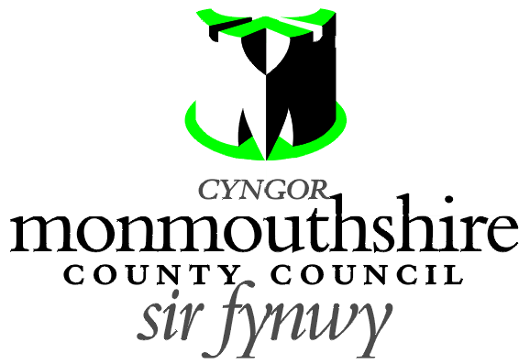
ZEBRA CROSSING
MERTHYR ROAD, ABERGAVENNY
Monmouthshire County Council proposes to amend the existing Zebra controlled crossing facility on Merthyr Road in Abergavenny. It is proposed to extend the existing extent of the zig zag lines to 8 number zig zag lines on both sides of the Zebra Crossing and to install antiskid road surfacing material. These improvements are proposed in the interests of road safety at this controlled pedestrian crossing.

A Plan indicating the location of the zebra crossing and the proposed alterations may be examined online at http://www.monmouthshire.gov.uk/public-consultation-traffic


Any person desiring to object to this proposal can do so by visiting http://www.monmouthshire.gov.uk/public-consultation-traffic or scanning the QR code below and selecting “How to comment on a proposed TRO”, where the public consultation response form can be accessed. Alternatively a statement in writing of their objections specifying the grounds on which they are made can be posted to Traffic section, Monmouthshire County Council, County Hall, Usk NP15 1GA. Any representations should be received not later than 17:00 on Friday 10th December 2021. Monmouthshire County Council will consider objections and representations received in response to this Notice. They may be disseminated widely for these purposed and made available to the public.

Date: 19th November 2021.

Mark Hand
Head of Placemaking, Housing, Highways, Flooding and Planning
Monmouthshire County Council
PO Box 106
Caldicot
Monmouthshire
NP26 9AN

