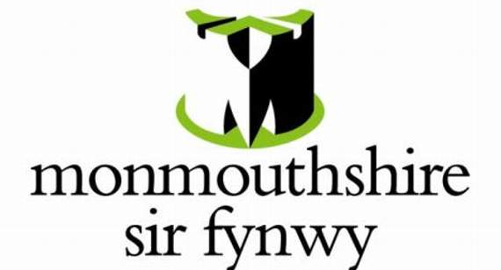

Informal Tender Form for Letting of Land

Site Name: Grazing Land at Undy 1 (approximately 11 acres)

Submission Deadline: 12:00 (noon) on Friday 3rd September 2022

Please complete in full (where applicable) and return tender submissions (preferably by email) to:

Estates@monmouthshire.gov.uk

Estates, Monmouthshire County Council, County Hall, The Rhadyr, Usk
NP15 1GA
I/We (Name): | …………………………………………………………………  …………………………………………………………………
Nature of Legal Interest: | Individual / Partnership / Other (please provide details below)
Contact Address: | …………………………………………………………………  …………………………………………………………………  …………………………………………………………………  …………………………………………………………………
Telephone: | …………………………………………………………………
Email: | …………………………………………………………………

Tender Bid Offered:

Initial Period (Summer 2021 till 31st August 2022) £……………….

(In words)………………………………………………………)

Initial amount per annum from 1st September 2023 until agreement terminated (subject to review linked to RPI after 3 years)
£……………….

(In words)………………………………………………………)

Summary of proposed use (e.g. private horse grazing, farming business):

………………………..…………………………………………………………………………..

………………………..…………………………………………………………………………..

………………………..…………………………………………………………………………..

………………………..…………………………………………………………………………..

………………………..…………………………………………………………………………..

………………………..…………………………………………………………………………..

Subject to the following conditions & notes (if any):

………………………..…………………………………………………………………………..

………………………..…………………………………………………………………………..

………………………..…………………………………………………………………………..

………………………..…………………………………………………………………………..

………………………..…………………………………………………………………………..

………………………..…………………………………………………………………………..

(Please note Monmouthshire County Council do not bind themselves to accept the highest or any offer)

Subject to Contract & Formal Council Approval

I/We agree that Subject to Contract I/we will enter into a binding agreement to let the land within 28 days of receiving an acceptable draft contract from Monmouthshire County Council.

I/We understand that Monmouthshire County Council do not bind themselves to accept the highest or any offer and that I/we shall be notified in writing if my/our offer is accepted.

Contact Telephone for Estates: 01633 644417

