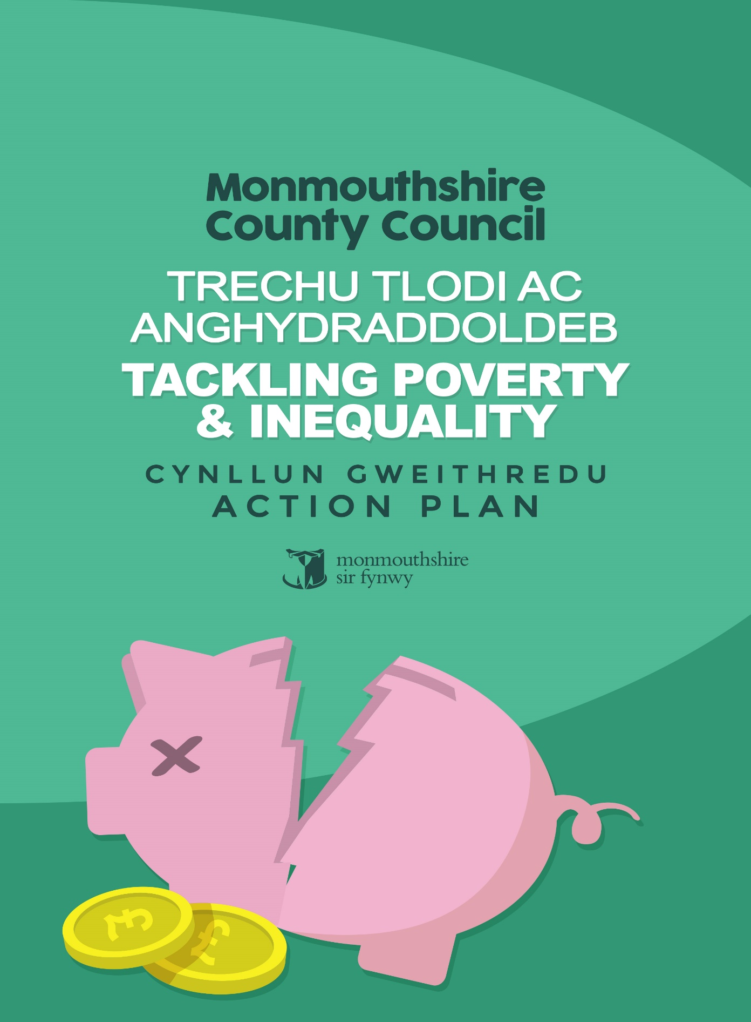
 | Title | Page
 | Summary Document: ‘Plan on a Page’ | 3
1. | Introduction | 4
2. | Situational Analysis – What’s the problem we’re trying to solve | 4
2.1 | How do we define poverty in Monmouthshire? | 4
2.2 | The UK poverty picture in 2020 | 5
2.3 | The poverty picture in Wales | 5
2.4 | Poverty in Monmouthshire: the effects of Covid 19 | 6
3. | Strategic Context | 10
4. | Strategic Partnerships | 13
5. | Aim, Activities and Benefits | 14
6. | Monitoring and Evaluation | 17
7. | Action Plan | 18
 | Appendix A - Understanding Poverty in Monmouthshire | 28
 | Appendix B – Defining Poverty | 44

Tackling Poverty and Inequality: Plan on a Page ’Why is this Activity Important? | Who will we work with?
Nobody is immune from poverty and the causes of poverty can quickly become consequences, trapping people in a cycle from which they need help to emerge. Poverty can affect anyone and issues such as education, crime, health, environment or employment can be exacerbated by poverty.  In attempting to define poverty in Monmouthshire we recognise the tension between objective/ precise/ quantifiable definitions which can be readily measured and tracked (yet can be a blunt instrument when capturing the lived experience of poverty), and more subjective/ loose/ qualitative measures which may provide a truer and more nuanced reflection but are much harder to measure.  We have therefore chosen to adopt the Joseph Rowntree Foundation definition: i.e. ‘when your resources are well below your minimum needs’, and to supplement this with statistical measures of household income and material deprivation. | We will work with partners on a range of footprints, through our county’s Public Services Board, and at a community level through our community support networks, to impact upon the causes of poverty and inequality at every level.  In addition to our PSB partners, we will also work alongside:  - Local organisations such as Food Banks (linking to Food Development Action Plan), Covid Support groups and faith organisations e.g. Christians Against Poverty;  - County-wide providers such as Mind Monmouthshire, GAVO, Citizens Advice, Gateway Credit Union, Registered Social Landlords; and  - Regional and national partners including Department for Work and Pensions, Welsh Government and Cardiff Capital Region City Deal.  We will at all times adopt a co-productive approach.
What will we do? | How will we measure our effectiveness?
We will work together to promote equitable prosperity in Monmouthshire and wherever possible to prevent our citizens experiencing poverty.  However, we recognise that despite our efforts, there will be points in people’s lives at which they experience financial hardship. When this does occur services will come together to provide support to make that experience as brief, as infrequent and as manageable as possible, helping people to emerge from that experience with greater levels of resilience.  Poverty is a result of both individual circumstances (e.g. life events/transition points) and circumstances over which individuals and households have limited control (such as the availability of local employment).  We will take a multi-layered approach, supporting individuals and households who need specific help, whilst also striving to create neighbourhoods, communities and systems within which everybody has the opportunity to flourish. Our immediate priorities will be:  - Employability skills and employment;  - Children and young people disadvantaged by poverty;  - Mental health: poverty as a cause and as an effect;  - Tackling the effects of financial inequality; and  - Crisis prevention: helping people to access support at earliest opportunity, and support to navigate available offer.  A further priority of Housing will feature in each of the above because we know that a secure, good quality home is a pre-requisite for everything we are trying to achieve with this plan | We will use a basket of measures to help us build and deepen our understanding of poverty and inequality in Monmouthshire. Measures will include:  - Number of households below 50% and below 60% GB median income  - % of people in material deprivation  - Number of people in receipt of Universal Credit: in employent and not in employment  - Number of Housing Gateway Referrals  - Number of live applications on housing register  - Number of food bank vouchers issued by MCC  - Number of Monmouthshire pupils in receipt of free school meals  Because we also know that poverty is fundamentally a qualitative experience, we will also work with our communities to develop story-telling and narrative that captures the lived experiences of those living in and on the edge of poverty in our county.

- Introduction
“Like slavery and apartheid, poverty is not natural. It is man-made and it can be overcome and eradicated by the action of human beings. Overcoming poverty is not a task of charity, it is an act of justice”
Nelson Mandela, ‘Make Poverty History’ event, London 2005
Monmouthshire is a beautiful county, blessed with strong communities, some of the finest natural assets in Wales, and a competitive local economy. Our citizens tell us that it is a fantastic place to live. However, we also know that our county’s relative affluence compared to much of Wales – when viewed through the lens of aggregated data - masks the day to day reality and lived experience of those of our citizens who are experiencing poverty, financial hardship and who do so in the context of the considerable financial inequality that exists within our county.
In many ways, living in an area of relative affluence and wealth whilst you are struggling to make ends meet can make that experience even harder and more isolating. This is Monmouthshire’s particular challenge and one that we are determined to understand, to shine a light on, and to address.
- Situational Analysis – what is the problem we are trying to solve?

2.1 How do we define poverty in Monmouthshire?
In order to address poverty and inequality effectively, we first need to describe what we mean by these terms and how we intend to understand and measure them.
In attempting to define poverty in Monmouthshire we recognise that there is a tension between objective/precise/quantifiable definitions which can be easily measured and tracked, (but are often a blunt instrument when capturing the lived experience of poverty), and more subjective /loose /qualitative descriptions which may provide a truer and more nuanced reflection but are much harder to measure and track.
Often the most readily available statistical data used to measure poverty relates to household income, but poverty is not the same as having a low income. People and families have different fixed costs to contend with for example childcare, housing, etc. as well as different levels of savings or assets to draw upon. Therefore individuals and families have different levels of personal and financial resilience and this will influence whether a specific level of income is adequate to live a full and active life.
In balancing this tension Monmouthshire has chosen to adopt the Joseph Rowntree Foundation definition of poverty which is:
‘When a person’s resources (mainly their material resources) are not sufficient to meet their minimum needs (including social participation).’
This will be supplemented with statistical measures:
% households below 60% median income (before and after housing costs); and
% households in material deprivation.

2.2 The UK poverty picture in 2020
According to the work of the UK Social Metrics Commission, the picture of poverty in 2020 at a UK level is as follows:
14.3 million people in the UK are in poverty: 8.4 million working-age adults; 4.5 million children; and 1.4 million pension age adults;
12.1% of the total UK population (7. 7 million people or more than 1 in 10) live in persistent poverty i.e. a person is living in poverty in the current year and two of the last three years);
More than 6 in 10 working-age adults and children, who live in families who are more than 10% below the poverty line, are also in persistent poverty. For those less than 10% below the poverty line, the figure is 4 in 10.
Of the 14.2 million people in poverty, nearly half, 6.9 million (48.3%) are living in families with a disabled person.
Far fewer pensioners are living in poverty than previous measures suggested. Poverty rates amongst pension-age adults have nearly halved since 2001 (falling from 20.8% in 2001 to 11.4% in 2017).
The majority (68%) of people living in workless families are in poverty. This compares to just 9% for people living in families where all adults work full time.
Around 2.7 million people are less than 10% below the poverty line, meaning that relatively small changes in their circumstances could mean that they move above it.
2.5 million people in the UK are less than 10% above the poverty line. Relatively small changes in their circumstances could mean they fall below it.
The Social Metrics Commission pays close attention to families living just above or below the ‘relative’ poverty line, since relatively small changes to family circumstances could move a family either ‘in to’ or ‘out of’ poverty. For example, data from the ONS shows that half or more of families in all industries - aside from professional/scientific/Information and communication - would struggle to cover a three-month loss of income. Therefore the impact of Covid 19 on many of families may have been significant.

2.3 The poverty picture in Wales
One of the limitations of the Social Metrics Commission work is that it does not investigate below UK level; however Welsh Government undertook some analysis in April 2018 and March 2019, the results of which can be seen below:
23% of all people in Wales were living in relative income poverty between 2016-17 and 2018-19. That is around 750,000 people.
This figure has remained relatively consistent for some time. At 23%, the figure is marginally lower than last year. That is around 280,000 children.
Children were the age group most likely to be in relative income poverty (at 28%) and this has been true for some time. This is only the fourth time this figure has been below 30% since the period ending 2005-06.
One reason why children are consistently the age group most likely to be in relative income poverty is that adults with children are more likely to be out of work or in low paid work due to childcare responsibilities.
22% of working-age adults were in relative income poverty between 2016-17 and 2018-19. That is around 418,000 adults. This is down from the 23% reported last year. The figure has been around 21% to 23% for most of the time since the late 1990s.
19% of pensioners in Wales were living in relative income poverty between 2016-17 and 2018-19, the same as that reported last year. This is around 120,000 pensioners. This remains below what it was throughout the mid to late 1990s.

Source: https://gov.wales/relative-income-poverty-april-2018-march-2019

2.4 Poverty in Monmouthshire: the effects of Covid 19
Many debt-counselling services work on the principle that we are all only three monthly paydays away from being in financial difficulty. As a result of the Covid 19 pandemic, many households who have previously not made use of the benefits system, Foodbanks or other sources of support are now attempting to navigate these for the first time. Across Monmouthshire, people will have been relying on savings, family & friends to tide them over during the first few weeks/months of the crisis, but these sources of support and personal resilience will now be running dry, and so we can expect an increase in those seeking support. With the number of furloughed staff across our region, together with those on zero hour contracts who have not been working and those who have lost their jobs, the ability of households to cover a three-month loss of employment income will become strained.

During the Covid 19 Pandemic it has often been said that crisis has affected us all in the same way – and whilst to a certain extent this is true, the virus does not discriminate, its impact has been felt differently depending upon gender, ethnicity and income. Therefore, whilst we are all in the storm, we are not all in the same boat.

Figures from a recent DWP/Cardiff Capital Region City Deal presentation (Diagram Four below) suggest that manufacturing will suffer the largest jobs losses in Wales, followed by accommodation and then retail.

Diagram one – Potential Job Losses in Cardiff Capital Region
The same DWP/Cardiff Capital Region City Deal presentation also indicated that 9,100 people were furloughed in Monmouthshire during the Covid 19 crisis (Diagram Five below) and that there was a doubling of claims for Universal Credit (UC) in Monmouthshire from January to June 2020.

Diagram two– Wales Furlough Numbers in the 22 Local Authority Regions as a percentage of the LA population
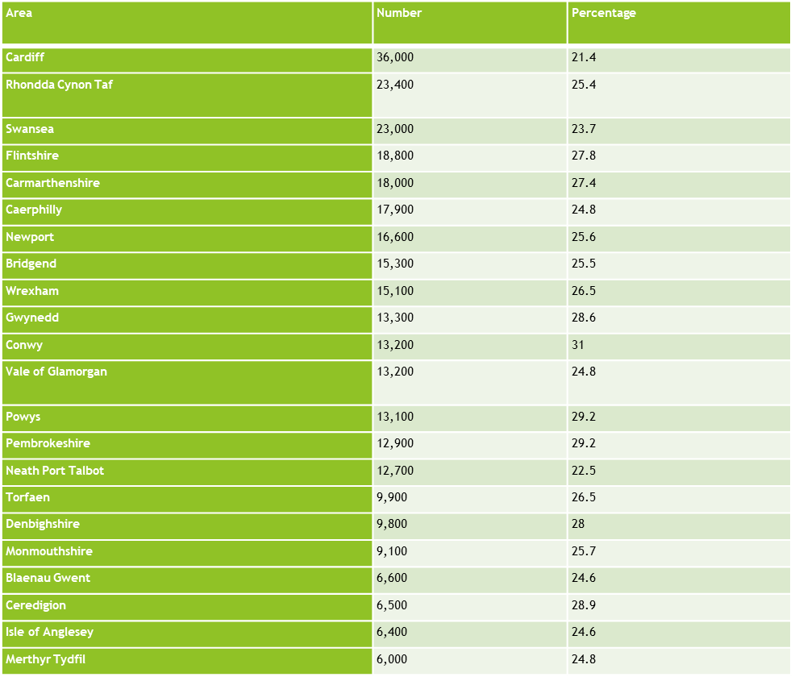
It is likely that the increase in Universal Credit claims were as a result of the significant number of self employed people and micro business owners in the county who were awaiting payments from the Government’s Self-Employment Income Support Scheme and the Non Domestic Rates Business Grants scheme and therefore the rate is likely to fall over the coming months. However, if we use the current Office for Budget Responsibility prediction that 15% of those furloughed will be made redundant, then we could make an assumption that approximately 1365 citizens could lose their jobs in Monmouthshire as a result of the Covid 19 crisis which would have a significant impact on local families.

The four sectors likely to re-open gradually as a result of the Covid 19 crisis are (Accommodation, Non-food retail, Pubs and restaurants, Arts and leisure) which are some of the main employment sectors across Monmouthshire. These groups are most likely to suffer from a lack of consumer confidence due to perceived health risks inherent in the activities represented by these sectors. Staff in these sectors have been most heavily impacted by employment changes due to Covid 19 although ONS data for 24th July shows that there has been a relative increase in consumer confidence in eating out both indoors (33%) and outdoors (52%) over recent weeks.

Although widely regarded as being a leafy and affluent area, Monmouthshire has many families who are currently living in poverty. The peaks in demand for support during Covid-19 have simply amplified pre-existing issues around poverty and inequality across Monmouthshire has been demonstrated with the increase in calls to Monmouthshire County Council for support with benefits and council tax during the peak of the crisis in March.

In assessing the level of poverty in Monmouthshire, the following statistics have been drawn using the Council’s Monmaps Database and data from partner organisations such as Registered Social Landlords. The detailed diagrams and ward information for the headline data below can be found in Appendix A – Defining Poverty in Monmouthshire Data.

Before taking into account housing costs there are large areas across Monmouthshire with less than 10% of children living in poverty, a significant area with between 10 – 20% of children and a large area with 20 – 25% of children in poverty;
When housing costs are included, the number of children living in poverty increases significantly. There are several large pockets in Monmouthshire with over 25% of children living on poverty, a large area with 20 – 25% of children living in poverty and the rest of the county with between 15 – 20% of children living in poverty;
The distribution of Free School Meals families broadly reflects the pattern of the distribution of children living in poverty with a high concentration in the main towns and some rural pockets reflecting larger, hidden poverty especially when the associated higher costs of transport, broadband and food are considered.
The distribution of the three main Registered Social Landlords (RSLs) in Monmouthshire (Monmouthshire Housing Association, Pobl and Melin Homes) also mirrors the distribution of Free School Meals families. Whilst providing much needed social support for tenants the RSLs also provide hardship funds, the uptake of which has shown a sharp increase during the Covid 19 crisis as would be expected.
As described, there is no single measure which can effectively capture the extent or severity of poverty within Monmouthshire. Fundamentally, poverty is an experience which is qualitative in nature (i.e. having sufficient resources to live a good quality of life) rather than quantiative. However, there are a number of quantitative measures which, when considered collectively, can give a useful indication of trends around household income and, by extension, likely changes in the experience of poverty in the county.
Some of these measures are set out below in Table Four, with information about the latest data in Monmouthshire (as at September 2020). Working in partnership with other organisations and with our communities, we will seek to continually track, develop and refine these measures to give us the best indication possible of poverty and inequality in Monmouthshire.
Table One: Quantative Key Performance Indicators
Indicator | Data source | Position as at September 2020
Number of households below 60% GB median income | CACI Paycheck estimates | 9,076
Number of households below 50% GB median income | CACI paycheck estimates | 6,713
Number of people in receipt of Universal Credit: not in employment | DWP Statexplore | 3,202
Number of people in receipt of Universal Credit: not in employment | DWP Statexplore | 2,063
Number of live applications on housing register | MCC Homesearch quarterly report | 3,387
Number of clients supported by housing gateway services
Number of children in receipt of free school meals | MCC education database | 1,379
Percentage of people living in households in material deprivation by local authority | National Survey for Wales | 10%

Whilst the above data are not necessarily particularly revealing when viewed at a single point in time, the real value will come with tracking these figures over time to monitor trends.
- Strategic Context
3.1 A Monmouthshire that works for everyone: Monmouthshire County Council Corporate Business Plan 2017-2022

The Corporate Business Plan sets out the Council’s clear direction and resources required for delivery, informing and shaping a series of enabling and delivery plans focussed on People; Digital; Economy; Customers, Land and Assets.
The overall purpose of the Council is:
We want to help build sustainable and resilient communities that support the well - being of current and future generations
The Council’s five organisational goals which also serve at the Council’s Well-being Objectives, set out the aspirations and the actions necessary to deliver on them and identify the future we want. Of the five priorities the one that is the most appropriate for the Tackling Poverty and Inequality Action Plan is:
D: Lifelong well-being
Within the priorities there are specific actions which give context to the ambitions for the Tackling Poverty Action Plan as detailed below:

Action | Purpose
THE COUNCIL WORKS COLLECTIVELY TO DELIVER ON SOCIAL JUSTICE, ENABLING PROSPERITY AND REDUCING INEQUALITY BETWEEN COMMUNITIES AND WITHIN COMMUNITIES | Continue to develop programmes to tackle poverty addressing worklessness and in-work poverty through schemes such as the Skills at Work programme.  Ensure that all council policies services are focused on ensuring equity of access  Promote equality and diversity and ensure opportunities are genuinely available to all  • Support and enable the development of community-led plans and placed-based working to improve well-being and increase prosperity.

3.2 People, Place, Prosperity: A Strategy for Social Justice 2017 -2022
This Strategy demonstrate the Council’s commitment to address inequalities in the county in order to make our society function better. The Strategy provides an approach that will help turn lives around by removing barriers and facilitating practical support and solutions to enable citizens to realise their full potential. This Action Plan supports the ambition of the Strategy and will be the sister document to the forthcoming Food Development Action Plan the aim of which will seek to reduce food insecurity in the County.
3.3 Gwent Homelessness Strategy
Under the Housing (Wales) Act 2014, it is a statutory requirement for the Council to publish a Homelessness Strategy that sets out its plans to prevent and tackle homelessness in their area. The Gwent Regional Homelessness Strategy 2018-2022 and Action Plan, includes Monmouthshire specific actions setting out the approach for tackling homelessness across Gwent. The report also includes a regional review of homeless services for Gwent, which informed the development of the strategy.
3.4 Welsh Government, Prosperity for All
Welsh Government consider delivering ‘Prosperity for All’ as part of their mission defining prosperity as ‘Not just about material wealth but about ‘every one of us having a good quality of life, and living in strong, safe communities’. One of the four themes of the strategy is ‘Prosperous and Secure’, their aim being to ‘drive a Welsh economy which spreads opportunity and tackles inequality, delivering individual and national prosperity. We will enable people to fulfil their ambitions and enhance their well-being through secure and sustainable employment. We will break down the barriers many face to getting a job, and create the right environment for businesses to grow and thrive’.
3.5 Child Poverty Strategy for Wales
In 2015, Welsh Government produced the Child Poverty Strategy for Wales which set out the Welsh Government ambition to make sure no child is living in poverty by 2020. Welsh Government undertook a review of progress in 2019 which considered an analysis of the Family Resource Survey (2015-16 to 2017-18). The Survey indicated that there are more children living in relative income poverty in working households than there are in workless households – 67% of children living in relative income poverty are in households where at least one person is working. As a result, 29% of children in Wales live in poverty. The report stated that this is largely because of UK Government austerity cuts and reforms to tax and welfare policies, such as universal credit, the benefit freeze and the two child cap, with single working parent households being particularly susceptible to poverty. In conclusion the report stated that whilst there had been a near 20% drop in the number of workless households in Wales there was still much to do.
3.6 Joseph Rowntree Foundation – Prosperity Without Poverty 2016 – A Framework for Action in Wales
The JRF Framework seeks to answer what it would take to make a dramatic difference to poverty with an aim that by 2030 – No one is ever destitute; Fewer than one in ten people are in poverty at any one time; and nobody is in poverty for more than two years. The report written in partnership with the Bevan Foundation, draws on evidence and key recommendations for the UK to set out a framework for action for Wales. It includes measures that should be taken by Welsh Government and Local Authorities, along with measures practices that should be adopted by businesses, actions that should be taken by charities, social landlords and others, and steps that should be taken by individuals to help lower their own risk of falling into poverty.
3.7 Socio-Economic Duty
Section 1 of the Equality Act 2010 requires relevant public bodies, when taking strategic decisions, to have due regard to the need to reduce the inequalities of outcome that result from socio-economic disadvantage. This duty will come into force in Wales on April 1sr 2021.

There is no reporting duty attached to the duty, however, it is a statutory duty and relevant bodies should be able to demonstrate how they have discharged it. Once the duty is commenced, if an individual or group whose interests are adversely affected by a relevant public body’s decision, in circumstances where that individual or group feels the duty has not be properly complied with, they may be able to bring a judicial review claim against that authority.
Whilst is self-evident that Monmouthshire Council and its affected partner bodies will need to comply with the duty, perhaps more significantly the duty will provide an important lens to our decision making and will support the aims and principles already set out in this plan

- Strategic Partnerships
As illustrated throughout this plan, poverty and inequality are complex problems which no single organisation has the ability to solve working in isolation.
The catalyst for driving and delivering the actions set out in this plan will be the Tackling Poverty and Inequality Partnership, which will report directly to the Public Service Board. This Partnership will also link appropriately with other key partnerships which come under the auspices of the PSB.
Through the various MCC service areas that are represented on the Partnership, its work will also be reported to MCC’s Social Justice Advisory Group, Strong Communities Select Committee and Cabinet.
In keeping with the principles of the Social Justice Strategy, co-production will be at the heart of our approach to tackling poverty and inequality; as such we will work with our communities as equal partners, working in a local, place-based way, using the local neighbourhood partnerships to bring the skills, knowledge and passions of local communities to the fore.
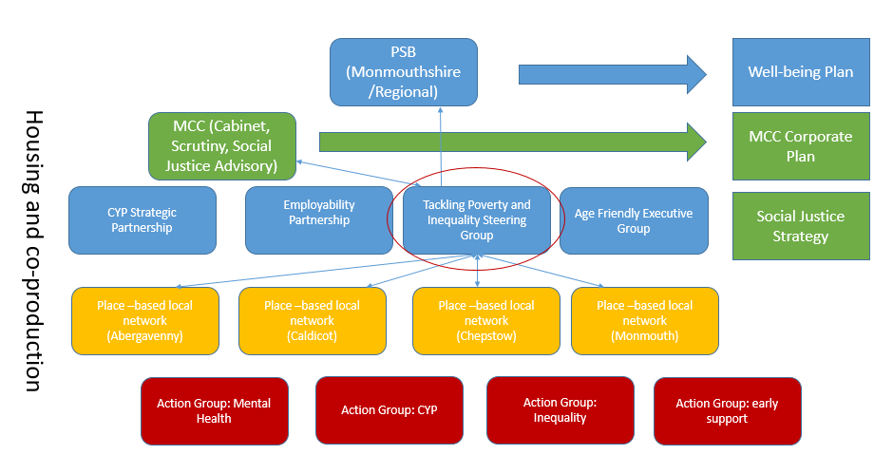
Diagram three: Monmouthshire’s model for Tackling Poverty and Inequality

- Aim, Activities and Benefits
5.1 The Aim of this Tackling Poverty and Inequality Action Plan:
We will work together to promote equitable prosperity in Monmouthshire and wherever possible to prevent our citizens experiencing poverty.
The Council recognises that despite our efforts, there will be points in people’s lives at which they experience financial hardship. When this does occur services will come together to provide support to make that experience as brief, as infrequent and as manageable as possible, helping people to emerge from that experience with greater levels of resilience.
5.2 In adopting the right approach to promote equitable prosperity, the Council recognises that there will be different layers of intervention as detailed in Figure One below:
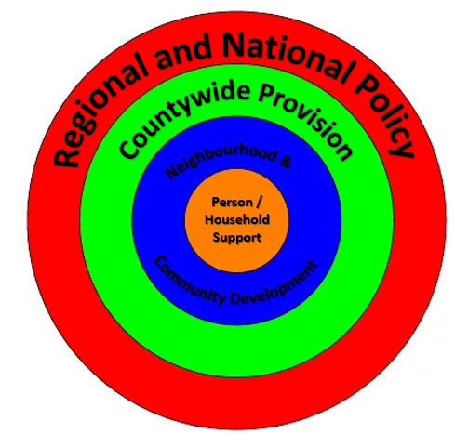
Diagram four: Layers of Intervention
These different layers of intervention will require differing levels of activity as detailed in Table Five below:

Table two: Layers of Intervention

Layers of Intervention | Activity
Regional and National Policy | Where we seek to lobby, influence and disrupt in order to address a specific issue e.g. labour market opportunities, welfare provision, cost of housing, etc.
Countywide Provision | Where we seek to connect and enable in order to provide efficient services e.g. in county transport, shared benefit service, housing support, etc.
Neighbourhood and Community Development | Where we seek to create conditions in which people can be supported and thrive e.g. social capital building, community development, community focussed schools, community service provision, etc.
Person and Household Support | Where we seek to provide joined up, wrap around support e.g. Communities 4 work+, Foodbanks, Skills@Work, Housing Support Gateway, debt counselling etc.

5.3 Priorities
In light of the Covid 19 crisis the emerging priorities for this Action Plan will focus initially upon the following, whilst recognising that the challenge will be to build sufficient humanity into the system to recognise that when people are under financial stress they are not at their most rational:
- Employability skills and employment support;
- Children and young people disadvantaged by poverty;
- Mental health as a cause and as an effect of poverty and inequality;
- Inequality - the particular character of poverty within a relatively affluent county; and
- Crisis prevention: helping people to access support at earliest opportunity, and support to navigate available offer.

In addition, there are two further themes which will weave throughout these priorities. These are:

- Housing, because a secure, high quality home underpins every other aspect of a person’s wellbeing; and
- Community development and co-production, because lasting solutions can only be developed if the ‘subjects’ of interventions are empowered, involved and are able to exercise real agency in their own lives.

These priorities have been developed with partners in response to intelligence that has been gathered on the ground in a rapidly changing environment. They will be kept under constant review and may be subject to change over the life of this action plan. Any such changes will be reviewed by the Tackling Poverty and Inequality Action Group and Partnership on the basis of evidence and a clear rationale.

5.4 Activities and Benefits
The individual activities contained within the Action Plan (Section Six) will be structured around four specific layers of intervention, all of which impact upon the person or household at the centre:
Support for individuals, families and households to include the provision of timely, accessible support to build self- resilience;
Creating prosperous and supportive neighbourhoods and communities to include the development of support measures such as access to debt advice, Community Fridges, Community Car Schemes, Community Focussed Schools activities, etc. to enable communities to build local resilience;
A connected county where people and communities can thrive to include the provision of affordable homes, access to affordable broadband, provision of shared benefits services, etc. to reduce inequality; and
Using our leverage to influence the structural causes of poverty and disadvantage to include creating conditions for a fair housing market, playing an active role in regional partnerships to create opportunities for individuals to flourish, working collectively to influence policy to improve opportunities for prosperity for all, etc.
The Tackling Poverty Action Plan in Section Seven the follows details the activity, the Lead Officer(s), Partners, Progress and the RAG rating.
- Monitoring and Evaluation

6.1 The progress of the Action Plan will be monitored through the Tackling Poverty and Inequality Sterring Group and the Social Justice Advisory Group who will monitor the progress of the overarching Social Justice Strategy and associated Food Development Action Plan, both of which will be updated on an annual basis.

6.2 A basket of success criteria and measures are being developed that will be tracked in order to monitor improvements and to demonstrate how the actions associated with this Plan are helping the Council to achieve the aim of this Plan which is to ‘work together to promote equitable prosperity in Monmouthshire and wherever possible to prevent our citizens experiencing poverty. We recognise that despite our efforts, there will be points in people’s lives at which they experience financial hardship. When this does occur services will come together to provide support to make that experience as brief, as infrequent and as manageable as possible, helping people to emerge from that experience with greater levels of resilience.’
6.3 The measures we will use to understand the changing picture of poverty in Monmouthshire will include those set out in Table One on page 9 of this document. We are also developing measures which will help us to locally track :

- Poverty depth – using the CACI paycheck to look at distribution, including those slightly above the ‘poverty line’;
- Poverty persistence – how long citizens are remaining in poverty;
- Inequality – including income and wealth inequality, its geography and its effects within specific contexts (e.g schools, effect on mental health)

6.4 It is important to recognise that the national economic context – particularly in relation to Covid19 and its social and economic consequences – will be felt in Monmouthshire in ways that local strategies will be unable to prevent; it is highly likely that the numbers of households experiencing some form of financial hardship will increase in the coming twelve months. Our success measures, therefore, will also include measures such as income maximisation, access to appropriate and timely advice and support, support to gain qualifications etc, rather than absolute measures of financial hardship in the county.

- Tackling Poverty and Inequality Action Plan
Priority Column Key: E= employment and skills, C= Children and Young People, M= Mental Health, I= Inequality, P= crisis Prevention, H= housing

Action | Purpose | Lead Officer (MCC) | Partners | Measure / Progress | Priority* | RAG Rating
- Support for individuals, families and households
1.1 Provision of timely, accessible, high quality debt advice | Make sure people get the help they need to deal with their creditors and reduce their debt, leaving them financially sustainable and resilient for the long term. | Ian Bakewell  MCC / Torfaen Shared Benefits Service | Citizens Advice, Christians Against Poverty, MHA, Melin, Pobl, United Welsh Working Families, Mind, Housing Support Service | No. benefits entitlement checks completed  No. referrals for debt advice via Housing Gateway | P, M, H
1.2 Provision of personal budgeting and financial planning advice | Equip households with the skills to make the best possible use of their financial resources and to plan for the future. | Ian Bakewell – Housing Gateway | Christians Against Poverty, MHA, Melin, Pobl, Housing Support Service, benefits team | No. referrals for financial planning advice via Housing Gateway | P, M, I, H
1.3 Support for those who are out of work to find employment | Preventing and relieving poverty through access to employment opportunities providing a decent and reliable household income | Hannah Jones, Employment Team | DWP, RSLs, Communities 4 Work+, | No. clients successfully supported to find employment through MCC employability programmes | E, P, H
1.4 Support to improve skills | Access to high quality, dependable employment and pathways | Hannah Jones, Employment Team | Skills@ Work, RSLs – Pathway to Work, Passport to Employment | No. clients successfully supported to gain further qualifications through MCC programmes | E, I
1.5 Support for families to remain strong and resilient | Family breakdown and stress increases risk of experiencing poverty | MCC – Building Stronger Families | Acorn, Edge of Care, Building Strong Families, children and communities grant services | No families supported through Flying Start, Acorn and Building Strong Families projects | P, C, M
1.6 Housing – support to find and sustain tenancies and avoid homelessness | A secure, good quality home is an essential pre-condition for many of the actions which are required to prevent or to alleviate poverty | Ian Bakewell – Housing Gateway | Housing Gateway services, Mind, RSLs | No. referrals to Housing Gateway support | H, P
1.7 Implementation of Homelessness Transition Plan | Preventing homelessness and providing the right support to those with complex needs. | Ian Bakewell – Housing Gateway | Housing Gateway services, Mind, RSLs | No. households in temporary accommodation | H, M, I
1.8 A network of emergency support for those who are experiencing or on the edge of crisis | Ensuring that people who are experiencing or on the edge of poverty are able to fulfil their basic needs and are kept physically safe and well. | Jude Langdon – Tackling Poverty and Inequality | RSLs, community support (e.g. local hardship funds), Fare Share, Foodbanks, primary care, churches, community hubs, RABI | Total households supported via emergency support networks and services in Monmouthshire | C, H
1.9 Digital skills development | Giving individuals and households the skills and the confidence to interact digitally, in order to access employment, skills development opportunities and benefits entitlement | Ryan Coleman – Tackling Poverty and Inequality | GAVO, RSLs, DCW, Community Learning, | No. people in total engaged in digital skills projects | I, E, C
1.10 Mental health support | Poor mental health is both cause and an effect of poverty and low income. | Sharran Lloyd - Community and Partnership Development Team Manager with Gwent Community Psychology | RPB, PHW, Mind, ABUHB Primary Care and SCH | Under development through relevant partnership action group | M, H
Creating prosperous and supportive neighbourhoods and communities
2.1 Provision of budgeting and financial planning advice | Creating an environment in which good financial planning is spoken about, information is readily available and knowledge is shared | Ian Bakewell – Housing Gateway | Moneywise, CAP courses, Gateway CU products | No. referrals for financial planning advice via Housing Gateway | H, P
2.2 Promotion of emotional and mental wellbeing services | Poor mental health is both cause and an effect of poverty and low income. Creating a neighbourhood environment which supports good mental health is a protective factor in supporting individual and community resilience | Tackling Poverty and Inequality Manager – working with Gwent Psychology Service | Mind, employers, Community Psychology Service | Delivery progress of specific wellbeing projects | M, H, C
2.3 Community Fridges/Community Food Hubs | Access to healthy and nutritious food and the skills to eat healthily. Developing ‘community fridges’/community pantry programme and expansion of Fare Share Programme in four towns across Monmouthshire in partnership with the local community and housing associations.  Hubs will be based around food – offering a community fridge to develop a wider partnership approach marrying up local community groups, established charities and other third sector groups to address local social issues linked to food. The hub could also offer opportunities to signpost people to other sources of support in MCC or wider. | Rural Programme Food Development Officer and Tackling Poverty and Inequality Lead | Partners to include financial/debt support (e.g. CAB), mental health sessions (e.g. MIND), coffee morning drop in (e.g. Re-engage), cookery classes (e.g. Foodbank), lunch club (e.g. Chepstow Community Focused Schools Approach), as well as other social activities based around food. | Delivery underway although currently paused due to Covid-19 restrictions | P, I
2.4 Community Development | Strong, connected communities promote personal and household resilience. Strong individual social capital is a predictor of a range of positive outcomes including employment, health, housing and educational attainment | Owen Wilce – Community and Partnership Development Team | MCC CPD team, RSLs, Bridges, GAVO, churches, wider community | Community projects initiated through place-based neighbourhood networks | P, M, I, H
2.5 Community Car Schemes | Friendly, flexible, door-to-door transport for people who require additional support getting to local shops, social activities or appointments – keeps people connected and prevents loneliness and isolation | Owen Wilce – Community and Partnership Development Team | Bridges / Volunteering for Wellbeing | No. clients supported through scheme | E, I, P
2.6 Community Focused Schools | Developing connections between schools and their wider communities in order to create opportunities for young people to benefit equitably from the social capital of the county | Ryan Coleman – Tackling Poverty and Inequality Lead / Sharon Randall-Smith – MCC Education | MCC Community Focused Schools | Update on specific programmes delivered through CFS programmes (including developing support for closing attainment gaps resulting from school closures). | C, P, M
2.7 SHEP – School Holiday Enrichment Programme  Provision of food & nutrition education, physical activity, enrichment sessions and healthy meals to children in areas of social deprivation during the school summer holidays. | Provision of free healthy breakfasts and free healthy lunches to primary aged children (5-11 years) as part of a structured play provision to 80 children per site per day on 19 days of the school summer holiday period. | Mike Moran, Community Infrastructure Coordinator (MCC play lead) Tel: 07894 573834 Email: mikemoran@monmouthshire.gov.uk | Welsh Government (WG)  Welsh Local Government Association (WLGA)  Aneurin Bevan Health Board (ABHB) Dietetics Service  Gwent Psychology Service  Participating Primary Schools  Town and Community Councils (in 2019, 11 of the 33 councils participated – in 2020, 15 councils had “signed up” before the scheme was cancelled due to Covid-19) | SHEP operated for the first time in Monmouthshire in 2019 at two sites, with attendances/meals delivered totalling 2,494.  The take up of places available at Overmonnow Primary School was 97% and at Thornwell Primary School 66%. | C, P, I, M
A connected county where people and communities can thrive
3.1 Provision of quality affordable homes | A secure, good quality home is an essential pre-condition for many of the actions which are required to prevent or to alleviate poverty | Mark Hand / Ian Bakewell – MCC Place making / Housing | RSLs | No. additional units of affordable housing developed (annual) | H, M, C, I, E, P
3.2 Rural broadband / digital infrastructure | Ensuring equitable access to the opportunities provided by high speed broadband | Mike Powell – Rural Development Programme | RDP |  | E, I, P
3.3 Developing the foundational economy – public service procurement | Utilising public resources to secure the maximum possible benefit for the local economy and environment and supporting the development of local opportunities. | Scott James – MCC Procurement and Commissioning | PSB | In development | E, I
3.4 Investment in in-county and out of county public transport | Providing the infrastructure that allows equitable access to employment, learning and cultural opportunities | Mark Hand / Richard Cope | MCC PTU |  | E, I
3.5 Provision of Shared Benefits Service | Ensuring that citizens are able to swiftly access all the resources to which they are entitled | Richard Davies – MCC/Torfaen Shared Benefits Service | MCC | No. clients supported to access benefits | C, M, H
3.6 Working with CYP Strategic Partnership to fully understand impact of poverty on children, young people and families. | Provide evidence base and understanding to design services which recognise and address impacts of poverty in the lives of children and young people | Tackling Poverty and Inequality Lead / CYP Strategic Partnership lead | Tackling Poverty Partnership / CYP Strategic Partnership | In development | C, I
3.7 Communications campaign to promote existing services to support people experiencing financial and related hardship | Ensuring that citizens are able to swiftly access all the resources to which they are entitled – particularly those who have never had cause to access provision before. Encouraging people who are struggling to seek help at earliest possible opportunity. | Tackling Poverty and Inequality Manager / MCC Communications and Marketing team | Tackling Poverty Steering Group | Campaign reach and effectiveness | C
3.8 Voices, experiences and assets of those who are experiencing and have experienced poverty within Monmouthshire are brought to the fore through meaningful co-production | To ensure that services and projects reflect the experiences of and utilise the skills of people they are designed to support. | Tackling Poverty and Inequality Manager / Communities and Partnerships Development Team | PSB, Tackling Poverty Steering Group / Network | Tackling Poverty and Inequality network established  Specific projects resulting from network | I, C
3.9 Qualitative research undertaken to understand the lived experience of both poverty and inequality within Monmouthshire | To enable service provision to be reviewed and adapted where appropriate to most effectively meet the needs of citizens experiencing financial hardship | Tackling Poverty and Inequality Manager | Tackling Poverty Steering Group / Inequality Action Group |  | I, C
3.10 Recommissioning of WG flexible funding grants in line with emerging priorities | Aligning funding and resource with need in the most effective way possible to prevent and tackle homelessness and poverty | Lyn Webber – Flexible Funding Manager | MCC | Progress of CCG and HCG recommissioning | C, H, E
3.11 Implement the requirements of the Socio-Economic Duty from April 2021 | To ensure that MCC decision have due regard to the experiences of those who are already socio-economically disadvantaged and to ensure that disadvantage is not deepened or extended. | Equalities and Welsh Language Officer |  | Mechanisms established to consider socio-economic implications within MCC decision making. | I, P
Using our leverage to influence the structural causes of poverty and disadvantage
4.1 Creating the conditions for a fair housing market | Delivery of revised Local Development Plan  Creation of a publicly owned housing company which can counteract unhelpful or socially unjust market forces | Mark Hand / Deb Hill Howells | PSB priority | Progress of revised LDP against plan  No. new affordable housing units proposed though revised LDP  Progress of MCC housing company / investment proposal | H, E, I
4.2 Working as a regional partner to develop employment and other infrastructure which creates the opportunities for people to flourish | Cardiff Capital City Region projects | Cath Fallon / Frances O’Brien | Cardiff Capital Region partners | Progress of CCR projects | E, H, I
4.3 Working collectively to influence national policy to recognise the social impact of inequality through the provision of a specific grant | The effects of extreme wealth and income inequality are corrosive and impact on almost all areas of social and public policy | Tackling Poverty and Inequality Manager | PSB | Key areas for collective campaigning identified and clarity of shared messages established | I, C, H, M
4.4 Investigate the extent and effects of income and wealth inequality across Monmouthshire’s communities. | Evidence shows that high levels of income inequality within and between communities can have a corrosive effect on many social outcomes. It can also perpetuate forms of social injustice. In order to develop effective and widely-supported interventions we require a deeper understanding of the current situation. | Tackling Poverty and Inequality Manager | PSB | Report to PSB and MCC Members completed | I, C

Appendix A – Understanding Poverty in Monmouthshire

1.1 Children in poverty in Monmouthshire, before housing costs
Diagram one below details children living in poverty before housing costs there are large areas across Monmouthshire with less than 10% of children, a significant area with between 10 – 20% of children and a large area with 20 – 25% of children.

Diagram One – Children in Poverty in Monmouthshire, before Housing Costs

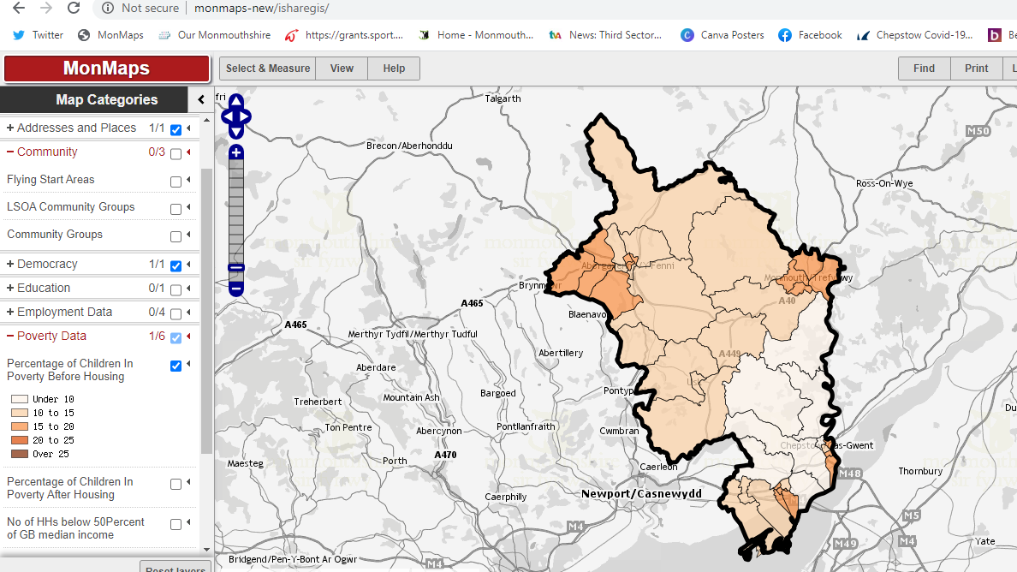

1.2 Children in poverty in Monmouthshire, after housing costs
When housing costs are included, the number of children living in poverty increases significantly. There are several large pockets in Monmouthshire with over 25% of children living on poverty, a large area with 20 – 25% of children living in poverty and the rest of the county with between 15 – 20% of children living in poverty as detailed in Diagram 2 below:

Diagram Two - Children in poverty in Monmouthshire, after housing costs
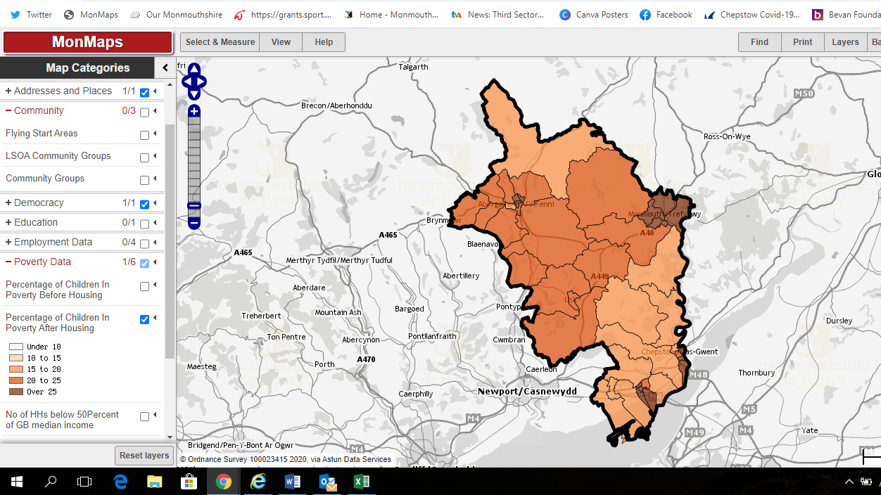

1.3 Registered Social Landlords
The distribution of the three main RSLs in Monmouthshire (MHA, Charter and Melin) mirrors the distribution of FSM families i.e. largely across those more deprived areas. The RSLs provide much social support for their tenants and have staff whose role is specifically around community development. Diagram Three below compares the RSL distribution with the WIMD data for housing in Monmouthshire.
Diagram Three – RSL Distribution
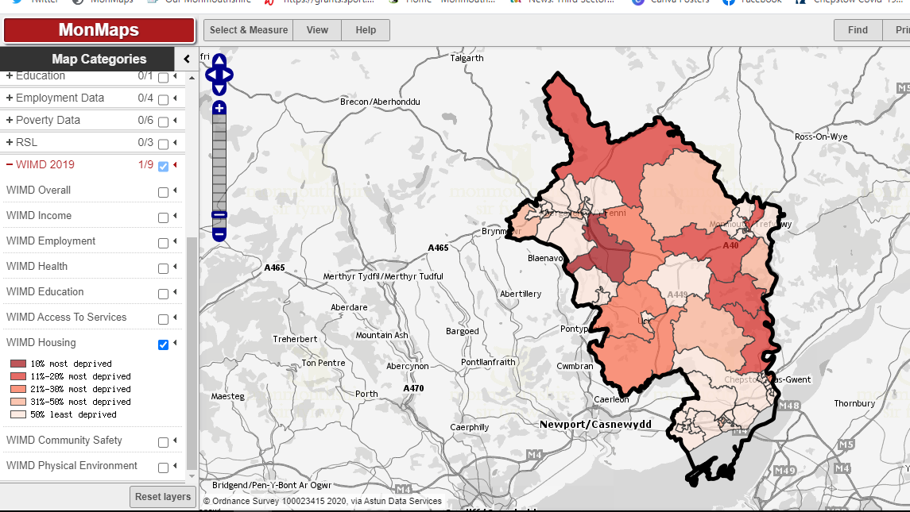
1.4 RSL Hardship Funds
Additionally, the RSL have hardship funds that are accessible to their tenants in times of exceptional need. One of the local RSL has given data for the uptake of the hardship fund over the last few months as detailed in Diagram Four below. Again, there is a spike in money allocated during the peak of the first Covid 19 crisis, but it is important to highlight that there is a regular average paid out each month to tenants – reflecting a wider, ongoing need.
Diagram Four – Distribution of RSL Hardship Funds

1.5 Median Household income
In keeping with the leafy affluent image of Monmouthshire, Diagram Five below demonstrates a wide distribution of £50 – £60K and over £60K income households.
Diagram Five – Distribution of £50k+ income
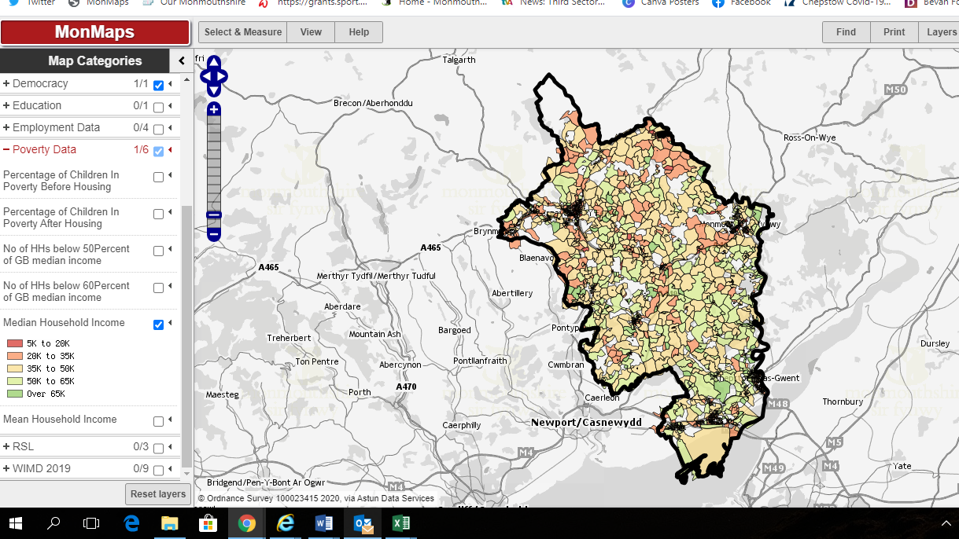

A closer look at Diagram Six demonstrates a large distribution of households in the £20k – £ 35K and £35 – £50K.
Diagram Six - £20k - £50k 35k and below
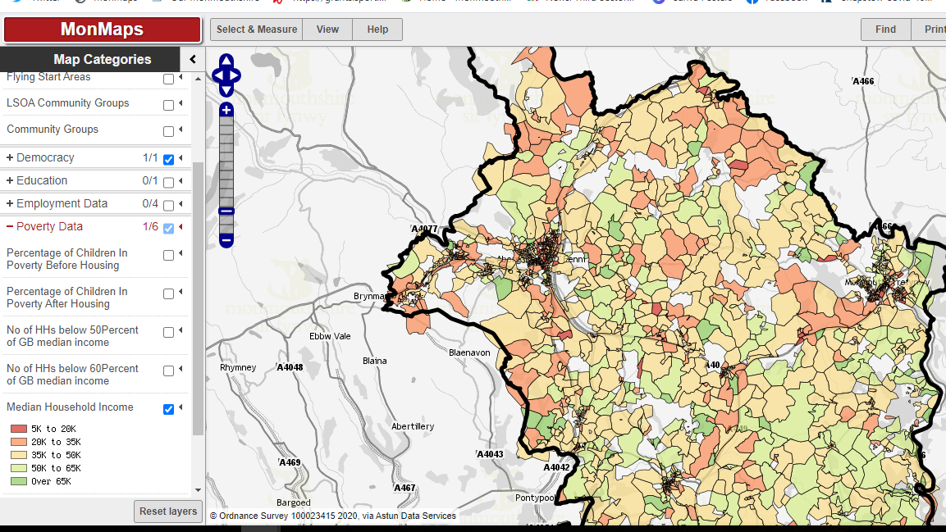

Diagram Seven - £5k – £20K income range.
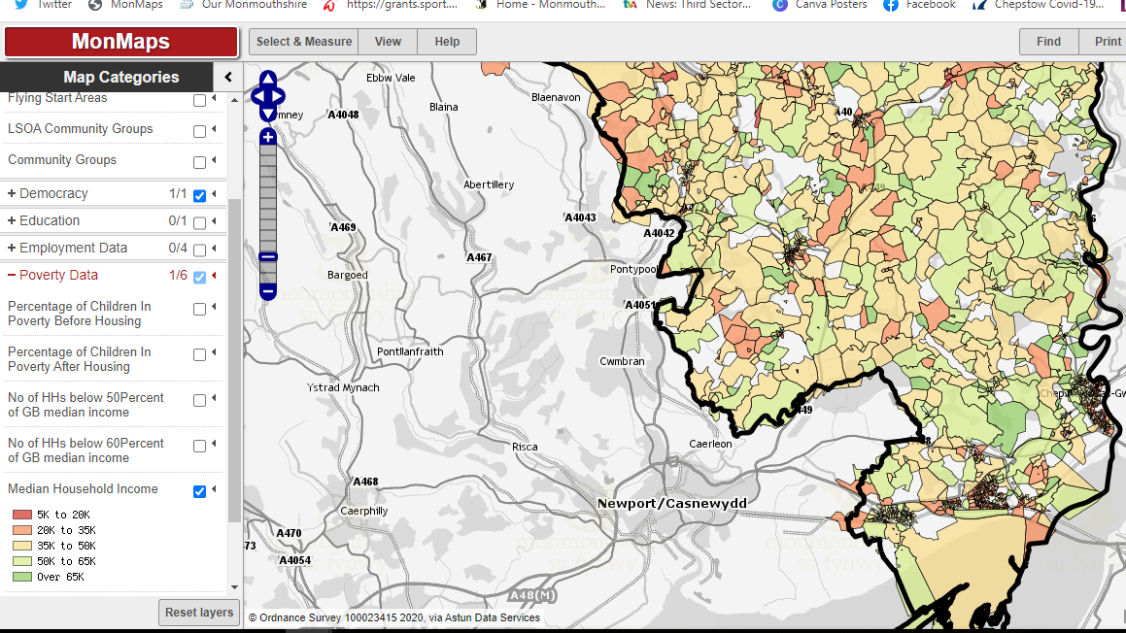

Diagrams Eight, Nine and Ten depict the WIMD data for income across the county reflects the median income distribution and shows those areas of higher deprivation focused around the towns.
Diagram Eight – Median Income Distribution and Higher Deprivation around Monmouthshire Towns
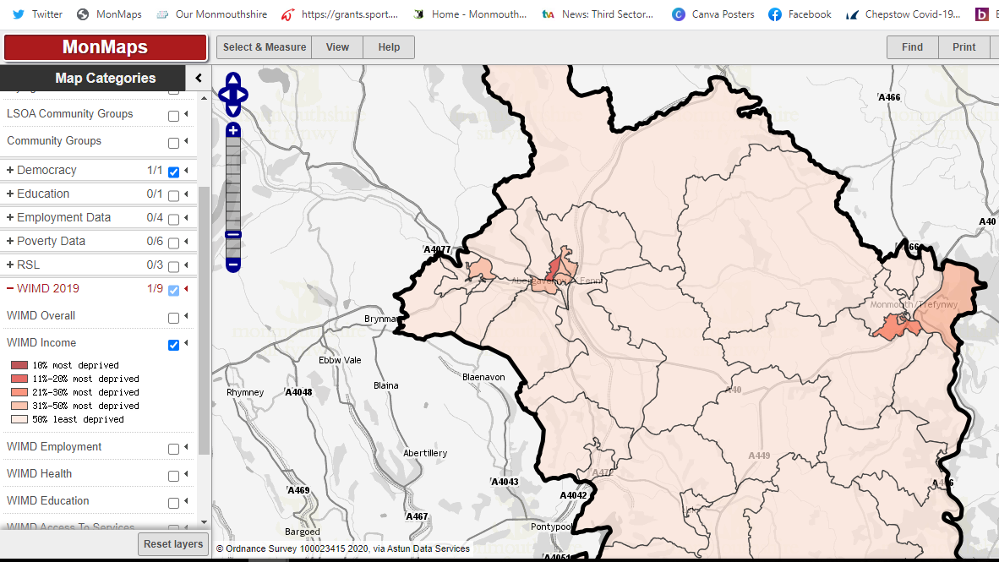

Diagram Nine

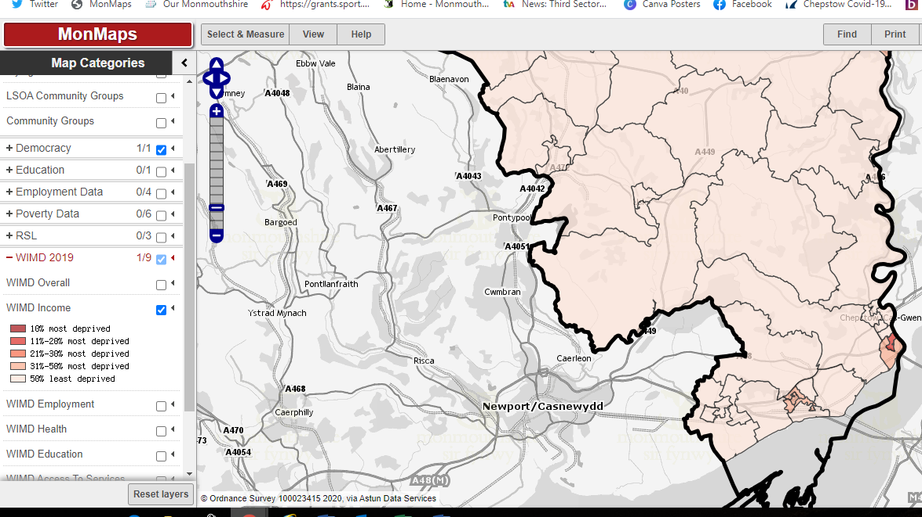

Diagram Ten

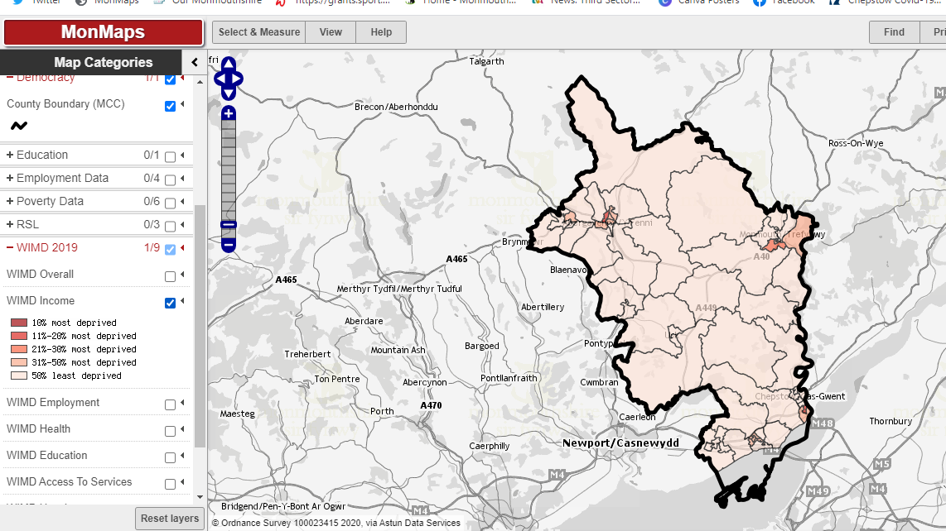

    - Housing
    - Monmouthshire has a significant number of families living in social or private rented homes. Many of these families will also have been significantly affected by the economic impact of Covid 10 – there is potential here for a large knock-on to family financial circumstances and may lead to an increase in demand for support. A profile of Monmouthshire’s Housing Stock can be found in Diagram 11 below:
Diagram 11: Monmouthshire profile of housing stock
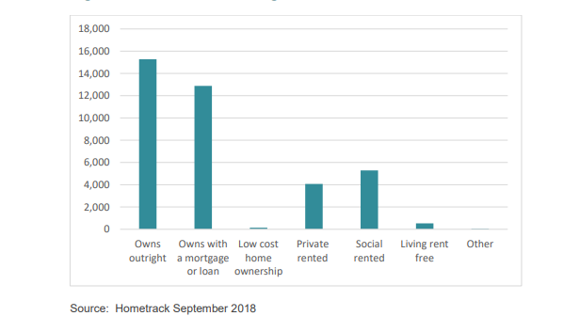

  - Community Cohesion
Diagram 12 below demonstrates that community groups are not equally distributed across Monmouthshire. This is something that might affect the ability of place based teams to really connect with people at a local level and through this enable local communities to fully engage in any action plans.
Diagram 12 – Community Group Distribution
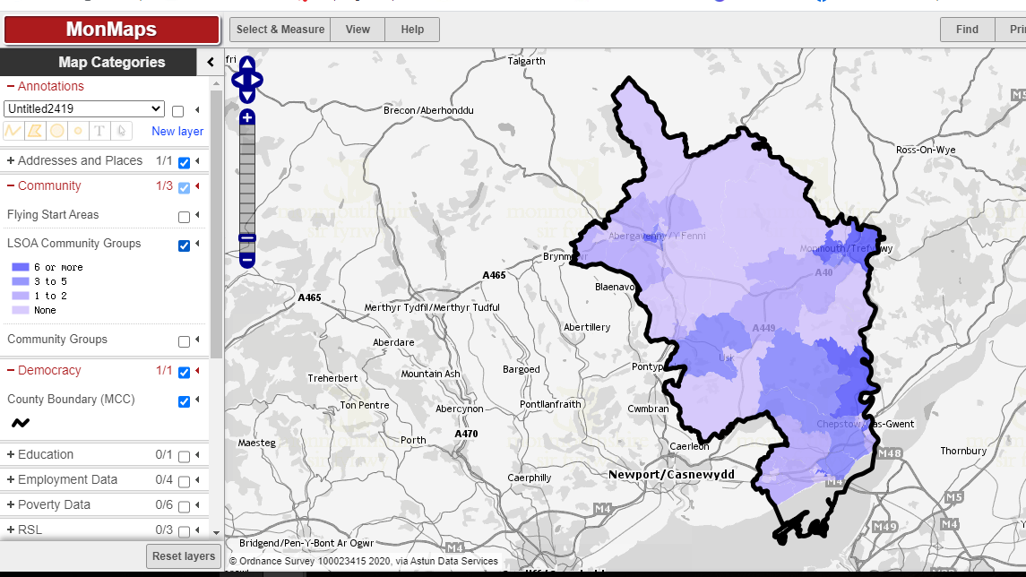

1.8 Context of poverty data
It is worth noting that there are a significant number of individuals with relatively high incomes in the UK, and this produces a non-symmetric income distribution curve. As a result, the mean income can be skewed due to these extreme outlier values. The median income (currently £514 per week) is the standard measure of average income. The median represents the income of the individual in the middle of the distribution curve. Relative poverty is typically measured as 60% below or less than this median income level.

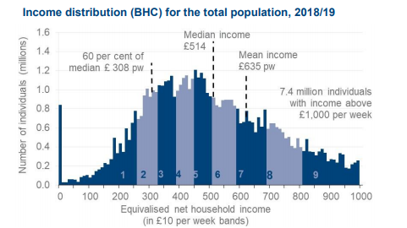
DWP National Statistics: Households on Below Average Income analysis 1994 – 2019

Percentiles divide the population into 100 equal sized groups, when ranked by household income. The chart below indicates the amount of weekly net equalised (see diagram below for explanation) household income needed at each percentile of the UK income distribution. Income before housing costs (BHC) at the 10th percentile is around half of the median (50th percentile) implying that around 10 per cent of the population have less than half of the median household income BHC. Incomes increase sharply past the 90th percentile BHC. In 2018/19, income at the 90th percentile is nearly double that of the median, whilst the top 3 per cent of the population (97th percentile and above) have at least three times that of the median.
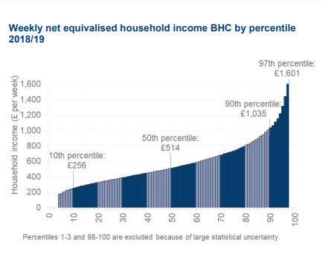
DWP National Statistics: Households on Below Average Income analysis 1994 – 2019

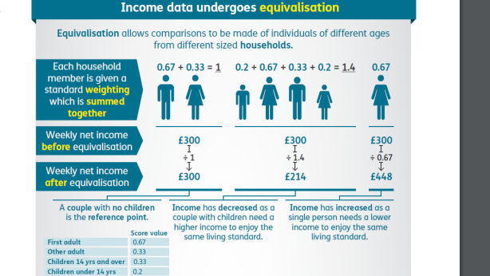
DWP National Statistics: Households on Below Average Income analysis 1994 – 2019

- Covid 19 Trends - The Resolution Foundation

In their April briefing note, ‘Risky Business’, the Resolution Foundation outlines some of the key economic impacts of different groups of workers during the first Covid 19 crisis. They found:
- Key workers are disproportionately likely to be female, with employed women more than twice as likely to be in this group as employed men;
- Parents are more likely to be key workers than non-parents, and mothers even more so; 39 per cent of working mothers were key workers before this crisis began, compared to just 27 per cent of the working population as a whole;
- Workers in shutdown sectors are the lowest paid across the workforce. Typical pay for workers in shutdown sectors is less than half that of those able to work from home – £348 a week compared to £707 a week;
- Those in shutdown sectors are younger – their average age of 39 is four years below the average age of those who can work from home. Differences are even more pronounced at the very bottom of the age distribution: nearly two in five of every 16-24-year old who works are in these sectors and for those born after 2000 this figure is over than three-fifths;
- Workers with little job security are some of the most likely to be in the most exposed groups. Almost three-quarters of those on zero-hours contracts are either key workers or work in shutdown sectors;
- A similar trend is visible when looking at housing security: private renters, who generally face the greatest insecurity in their housing situation, are 40 per cent more likely to work in shutdown sectors than homeowners; and
- With schools and day-care closed to all except key workers, parents faced extra challenges. People born in the early 1980s are the most likely to be parents of children under nine.
- Table One: Children in Wales in relative poverty by tenure type -% Households below average income

Type of Tenure | 2016 – 2019
All households | 28
Social rented | 52
Private rented | 53
Owner occupied | 12
- Source: Family Resources Survey, Department for Work and Pensions March 2020

- Table Two: Percentage of all individuals, children, working-age adults and pensioners living in relative income poverty Wales 2016-17 to 2018-19 (3 year averages of financial years) (after housing costs)
All individuals | United Kingdom | 22
All individuals | Wales | 23
Children | United Kingdom | 30
Children | Wales | 28
Working age adults | United Kingdom | 21
Working age adults | Wales | 22
Pensioners | United Kingdom | 16
Pensioners | Wales | 19
- Source: Family Resources Survey, Department for Work and Pensions March 2020

- Table Three: Food bank usage in Wales 2013 – 2020

 | 2013/14 | 2014/15 | 2015/16 | 2016/17 | 2017/18 | 2018/19 | 2019/20
Wales | 79,996 | 87,935 | 86,314 | 97,144 | 100,362 | 116,087 | 134,646

- 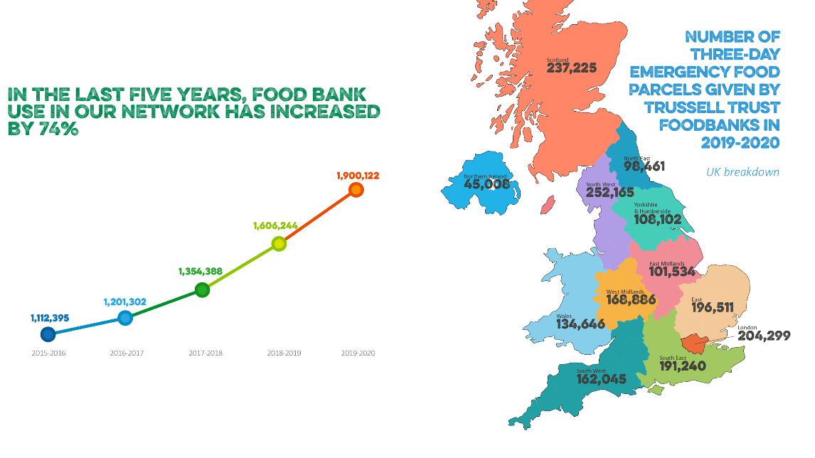
- Source: Trussell Trust Annual Statistics 2020
- 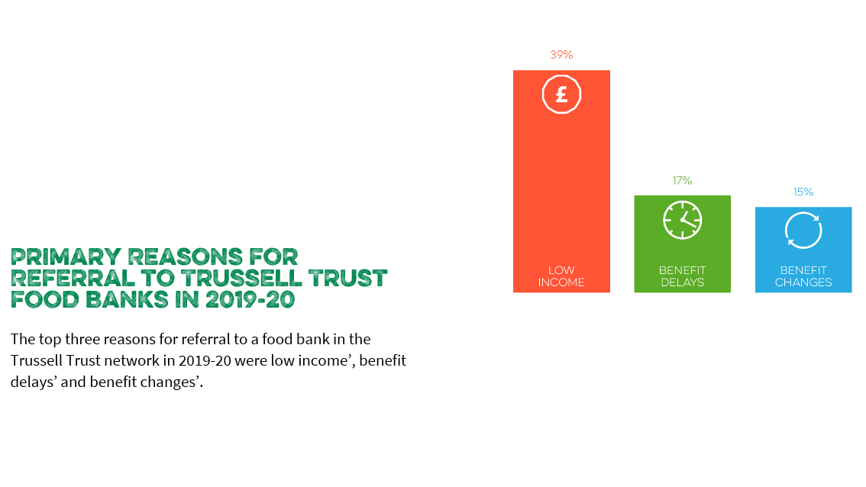Source: Trussell Trust Annual Statistics 2020

The impact of Covid 19

2.5 Covid 19 Trends

2.5.1 The Social Metrics Commission
The Social Metrics Commission (SMC) and YouGov carried out polling during March to May 2020 to explore how Covid-19 has affected people’s financial situation, attitudes towards society, experiences of loneliness and the extent to which they are confident about the future.
There were some concerning trends. Those in the deepest levels of poverty have felt the largest employment impact. 65% of those employed prior to the Covid-19 crisis who were in deep poverty, experienced some kind of negative labour change (reduced hours or earnings and/or been furloughed or lost their job). This compares to 35% of those who were employed and more than 20% above the poverty line prior to the Covid-19 crisis as detailed in Diagram Two below:
Diagram Two: Impact of Covid 19 on Employment

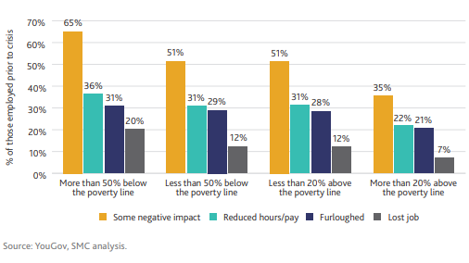
Those in poverty, or close to the poverty line, who have remained in employment have also been more likely to be furloughed and/or to see their hours or wages cut in response to the Covid-19 crisis.
Combined with the results of this polling (which suggests larger increases in unemployment and a higher incidence of pay cuts for those below the median), this suggests that, even with the support provided through temporary increases in the social security system and the Government’s Coronavirus Job Retention Scheme, under the Commission’s measure of poverty:
- Many of those already in poverty could move deeper into poverty because of losing their jobs, or having lower earnings because of reduced hours or pay. This would exacerbate the already increasing trend in deep poverty seen over the last 20 years; and.
- Those previously close to, but above, the poverty line could move into poverty by their changing employment status.
2.5.2 The Office for Budget Responsibility
The UK’s GDP fell by 25% between February and April 2020 but is now in recovery as detailed in Diagram Three below. The pace of recovery and long-term ‘scarring’ of the economy will depend on the:
- Course of the pandemic and development of effective vaccines and treatments;
- Speed and consistency with which Government lifts health restrictions;
- Response of individuals and businesses as it does so; and
- Effectiveness of policy in protecting viable businesses and sustaining employment
Diagram Three: GDP Impact and Projected Recovery

Source: Office for Budget Responsibility

2.5.3 Rent Smart Wales
A Rent Smart Wales survey (survey) of 1,343 private landlords found 38% had tenants unable to pay the full rent since lockdown began on the 23rd March. The survey also found that 40% of an estimated 180,000 tenants in private housing in Wales have fallen behind on rent in lockdown – and 28% of those were more than two months in arrears. Rent Smart also found that one in five landlords were struggling to pay their mortgage during lockdown.

2.5.4 Citizens Advice Cymru

Citizens Advice Cymru have said they are concerned about a potential "wave of evictions" from the point at which the pause on evictions ends. They have experienced a doubling of calls for help with rent during lockdown. Monmouthshire Citizens Advice have also seen an increase in calls, the top reason for needing help was employment, followed by help with benefits and tax, then housing, benefits and Universal Credit and then relationship and family issues.
2.5.5 Community Issues
The ONS data for 24th July reports that of those receiving medical care for a long term mental or physical health condition before the pandemic, 51% had had their care cancelled or reduced since the outbreak. Of these, 24% said they feel their health had become worse during this time. This – and the wider impact of lockdown and economic impact – has the potential for significant effect on people’s mental health and general wellbeing.
One of the wonderful positive aspects to have come from the Covid 19 crisis is the emergence of many local community groups who have supported neighbours with shopping, collecting prescriptions, dog walking and keeping people socially connected. However, a report from the new, all-party parliamentary group for left behind neighbourhoods found that, despite volunteering ballooning in some areas, the amount of mutual aid groups in ‘left behind’ areas equated to 3.5 per 100,000 people. This compared to an average of 10.6 per 100,000 people across the rest of England.

Appendix B – Defining Poverty

Whilst there are some well-known methods of measuring poverty, these are not always useful at local level where the statistical measures that they rely on are not available.
• Relative income poverty – where households have less than 60% of contemporary median income (this can be measured before and after housing costs)
• Absolute income poverty – where households have less than 60% of the median income in 2010/11 (JRF - https://www.jrf.org.uk/our-work/what-is-poverty)
• Minimum Income Standard (MIS) – run by Joseph Rowntree Foundation (JRF) and Loughborough University. Based on research with groups of members of the public, specifying what items need to be included in a minimum household budget – in order for people to have a decent standard of living. (Loughborough University - https://www.lboro.ac.uk/research/crsp/currentresearch/mis-uk/)

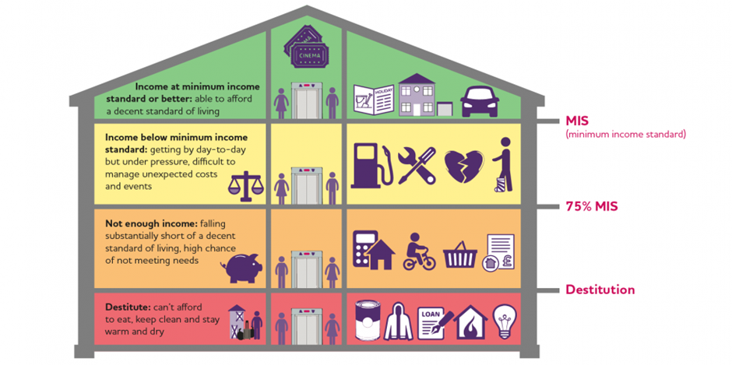
Diagram One: Joseph Rowntree Foundation ‘What is Poverty?’

2.2 How is poverty measured and defined at a UK level?
The Social Metrics Commission (SMC) (https://socialmetricscommission.org.uk/wp-content/uploads/2020/06/Measuring-Poverty-2020-1.pdf) was specifically tasked by the UK Government with identifying new ways of measuring poverty. Their first annual report in 2016 identified three key areas for understanding and measuring poverty, to enable a better understanding of inequality:

Identifying those least able to make ends meet. The Commission’s measure:
- Accounts for all material resources, not just incomes. For instance, this meant including an assessment of the available liquid assets that families have;
- Accounts for the inescapable costs that some families face, which make them more likely than others to experience poverty. These include the extra costs of disability, costs of childcare and rental and mortgage costs; and
- Broadens the approach of poverty measurement to include an assessment of overcrowding in housing and those sleeping rough.

Providing a better understanding of the nature of poverty, by presenting a detailed analysis of poverty depth and persistence for those in poverty; and

Providing an assessment of Lived Experience Indicators that shine a light on the differences in experiences of those living in poverty and those above the poverty line.

