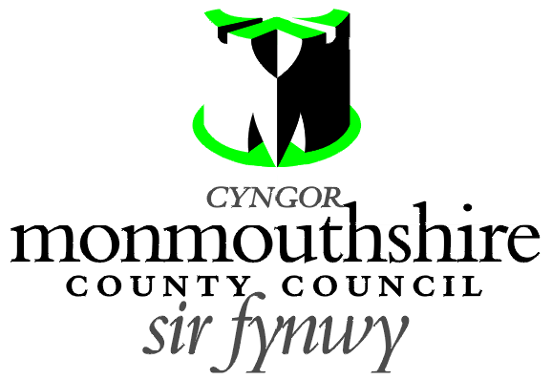

PUFFIN CROSSING
B4245, UNDY

Monmouthshire County Council propose to provide a new Puffin controlled crossing facility on the B4245 in Undy. The puffin crossing is proposed to be located 214 metres south east of its junction with Pennyfarthing Lane.

A Plan indicating the location of the proposed puffin crossing may be examined online at http://www.monmouthshire.gov.uk/public-consultation-traffic.

Any person desiring to object to this proposal can do so by visiting http://www.monmouthshire.gov.uk/public-consultation-traffic or scanning the QR code below and selecting “How to comment on a proposed TRO”, where the public consultation response form can be accessed. Alternatively a statement in writing of their objections specifying the grounds on which they are made to Traffic section, Monmouthshire County Council , County Hall, Usk NP15 1GA. Any representations should be received not later than 17:00 on Friday 16th July 2021. Monmouthshire County Council will consider objections and representations received in response to this Notice. They may be disseminated widely for these purposed and made available to the public.


Date: 24th June 2021.

Frances O’Brien
Chief Officer
Enterprise Directorate

