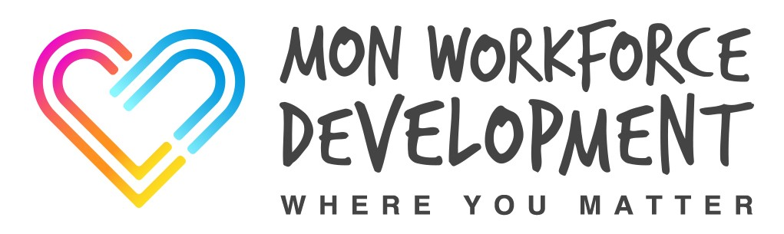

All Wales Manual Handling Passport

Handbook to Support Modules A & B Theory



JC/MCC/MH/DEC/2020

Aim
To provide underpinning knowledge necessary to reduce the risk of musculoskeletal injuries caused by poor manual handling in the workplace
Objectives
On completion of the workbook, the learner will be able to:
- Define the term manual handling
- Describe the causes and effects of musculoskeletal disorders (MSDs)
- Outline considerations for the prevention and management of MSDs
- Outline the legislation that applies to manual handling at work
- Describe the importance of ergonomics and risk assessment in reducing the risk of manual handling injury
- Describe the principles of safer handling
- Describe the effects of static loading
- Identify the risks involved in team handling
- Describe the importance of good communication in relation to manual handling
- Outline the management of safer handling within your organisation e.g. policy, organisation of training and occupational health
Manual Handling - Definition
Transporting a load by hand or bodily force or supporting a load in a static position. Actions include lifting, lowering, pushing, pulling or carrying. Manual handling also includes intentionally dropping or throwing a load.
Load - Definition
A person, animal or an inanimate (non-living) object
LOOKING AFTER YOURSELF: PREVENTION OF MUSCULOSKELETAL INJURIES
The Human Spine
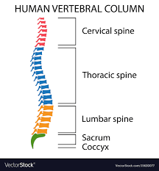
The spine is the strong core of your body. It is a made up of 33 bones called VERTEBRAE. These are divided into four areas, the cervical spine, the thoracic spine, the lumbar spine and the sacrum and coccyx. Muscles and ligaments support the spine. These can be strained if over-used or over-stretched.
The spinal cord runs from top to bottom through a hollow channel in the vertebrae. Spinal nerves emerge between each pair of bones. These nerves send messages to and from all areas of your body to control bodily functions.
Functions of the Spine
- To provide support for the body
- To allow flexibility and body movement
- To protect the spinal cord
- Attachment points for muscles and ligaments
- Intervertebral Discs
Intervertebral Discs
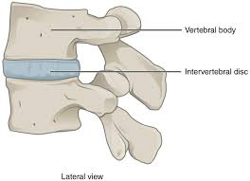
Between each pair of vertebrae lies an intervertebral disc. These act as shock absorbers, keep the bones apart to stop them grinding together and control movement of the spine.

Posture
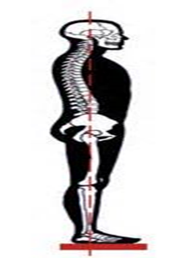
Posture is the way we hold ourselves when we are sitting, standing, walking or lying down. 'Good' posture allows us to move in the way we want, without causing strain and damage.
The vertebrae of the spine form a gentle “S-shaped” curve. This is the most efficient posture for the spine as the joints, discs, ligaments and muscles are in neutral positions. Any change from this position places extra pressure on the spine. While bending, twisting or stretching may not be immediately harmful, staying in these positions for long periods can lead to static postures. Repeating this postures frequently or while handling loads can lead to damage, possibly severe over time.
Musculoskeletal Disorders
Musculoskeletal Disorders (MSDs) are conditions that affect the nerves, tendons, muscles and supporting structures, such as the discs in your back. They result from one or more of these tissues having to work harder than they are designed to. MSDs occur most commonly in the back or upper limbs. Most MSDs are not one-off accidental injuries but are the result of accumulated damage over time
Background and Injury Rates
Health and Safety Executive (HSE) figures show that in the UK in 2018/19 there were:
- 539, 000 musculoskeletal injuries occurred in the workplace (41% of all workplace injuries) 8.8 million working days were lost because of these (34% of all days lost due to ill health)
This cost society an estimated £4.8 billion
Risk Factors for Developing MSDs
- Repetitive and/or heavy lifting
- Bending or twisting
- Repeating an action too frequently
- Uncomfortable working position
- Exerting too much force
- Working too long without a break
- Adverse working environment
- Time pressures, staffing levels, lack of control
- Not responding to symptoms quickly enough
Costs of MSDS to employers
- Lost time from work
- Sickness benefits
- Overtime costs for pay for staff to cover for their injured colleague
- Replacement costs e.g. bringing in agency workers
- Bad publicity
- Lowered staff morale
- Potentially court and legal fees
- Compensation costs
- Increased insurance premiums
Costs to employees
- Pain and suffering
- Buying non-prescription medication
- Paying for physical therapies or alternative therapies
- Loss of earnings
- Restrictions on normal duties
- Emotional stress of being in pain and unable to work
- Strain on family relationships
- Possible legal costs of accident investigations
Keeping Your Back Healthy
Exercise
Research shows that a fit and healthy person becomes injured less often than someone less fit. They also recover more quickly from injury. 4-5, 30 minutes sessions of exercise per week, such as brisk walking, is one of the simplest ways to keep your back healthy.
Diet and Weight
A well-balanced diet will ensure your body gets the nutrients it needs to function properly. Too much weight will put undue strain on your joints, ligaments and discs and can lead to long-term problems with posture.
Smoking
There is some evidence to suggest that smoking is bad for your spine: cigarette chemicals in your blood stream displace oxygen leading to your muscles working less efficiently over time.
Good Handling Technique
Using your body effectively by recruiting strong muscle groups and adopting a balanced posture is more efficient and easy than using strength alone. Is your spine in a natural ‘S’ position? Are your feet giving you a good, stable base? Could you bend your legs instead of your back? Could you hold the load closer to your body to reduce the strain on your arms and upper back?
Good Posture
Try to maintain good posture 24 hours a day, 7 days a week. Poor posture is often a habit you fall into without realising. Think of how you sit while watching TV, driving or at work and how you stand in a queue or while doing household tasks.
Upper Limb Disorders (ULDs)
ULDs include aches and pains in the shoulders, arms, wrists, hands and fingers, as well as in the neck. They are widespread across a range of industries and jobs.
Upper limb disorders are more common in tasks that involve:
- prolonged repetitive work, particularly using the same hand or arm action
- uncomfortable or awkward working postures
- sustained or excessive force
- carrying out a task for a long time without suitable rest breaks
- working with hand-held power tools for long periods of time.
Other things that may have an influence are:
- poor working environment (including temperature and lighting)
- poor work organisation (including workload, job demands and lack of breaks)
- individual differences (some workers are more affected by certain risks).
Workers may be more likely to suffer a ULD if there is more than one risk factor in their work. If an employer introduces a new process or changes existing processes and several workers complain of pain in similar places, such as the hand or forearm, this indicates that work may be a factor and the employer should investigate the cause.
An individual can get symptoms, even though several workers may do the same task with no problems. Symptoms can include:
- aches and pains, tenderness, weakness, tingling, numbness, cramp, burning, redness and swelling
- stiffness, pain or reduced movement in their joints
- carpal tunnel syndrome
- tendonitis or tenosynovitis
- osteoarthritis
- cramp of the hand or forearm from prolonged periods of repetitive movement.
Employers should encourage workers to report any signs and symptoms at an early stage, before they become more serious. They can then take steps to reduce the risk in the workplace. People with ULDs often completely recover, particularly if the problem is recognised early and treated appropriately.
Posture at work

- Correct workstation posture
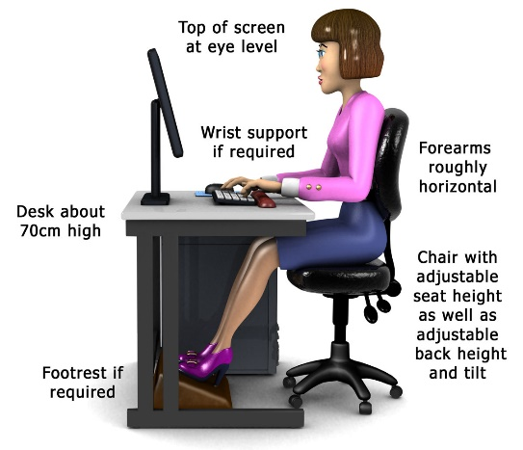
- Posture when using portable IT equipment

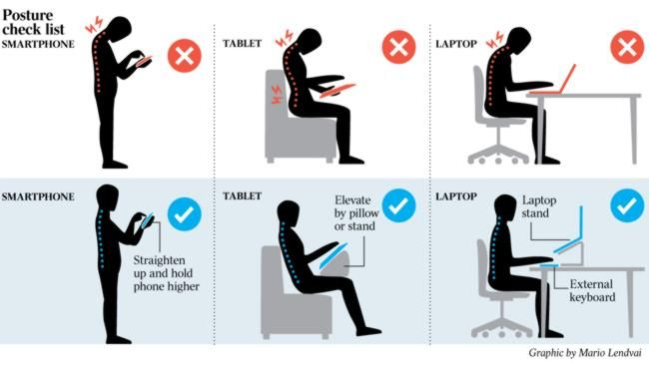
- The effects of texting on the neck and spine
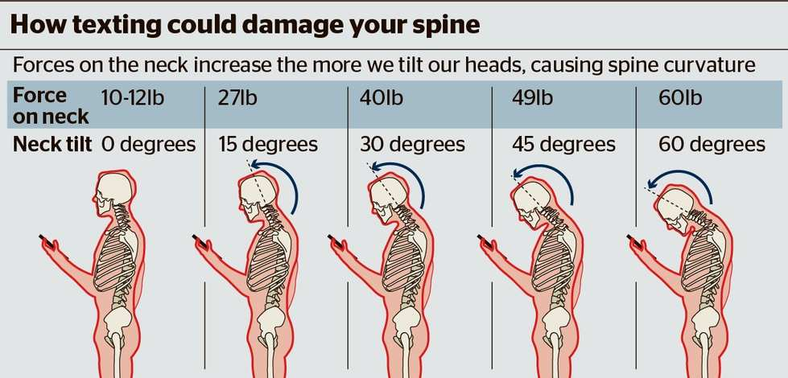

- Posture when driving
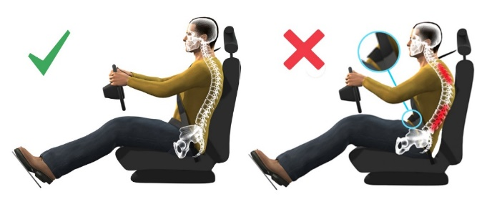

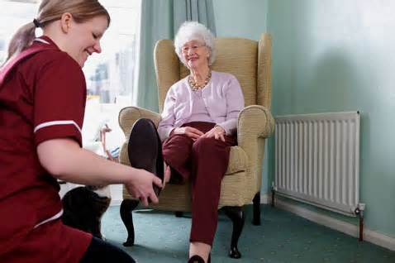
Static Loading

This refers to any position held for longer than 30 seconds. It can put uneven stress on our joints and prevent normal blood flow through the muscles. This can result in pain, fatigue and cumulative injury.

MANUAL HANDLING AND THE LAW
Health and Safety at Work Act 1974
Employers must:
“So far as is reasonably practicable ensure the health, safety and welfare at work of all employees”
“Provide information, instruction, training and supervision necessary to ensure, as far as is reasonably practicable, the health and safety at work of their employees”.
Employers must also provide and maintain
- Safe and suitable equipment
- Safe systems of work
- Safe working environments
Employees must:
- Take care of your own health and safety
- Not put anyone else’s health and safety at risk by anything you do or don’t do
- Co-operate with others on health and safety
- Not interfere with, or misuse, anything provided for your health, safety or welfare
- Follow training
Manual Handling Operation Regulations 1992 (amended)
Employers must:
- Avoid manual handling where there’s risk of injury
- Use mechanical means of lifting when possible
- Make a suitable and sufficient risk assessments
You, the employee must:
- Use equipment, machinery and aids in accordance with training and instruction given by their employer.
Management of Health & Safety at Work Regulations MHSW (1999)
Employers must:
- Ensure suitable and sufficient risk assessments (when there are 5 or more employees)
- Do what is reasonably practicable to eliminate, minimise or control risks
- Assess risks to all young people under 18 years of age before they start work
You must:
- Use equipment, machinery and aids in accordance with training and instruction given by their employer.
- Avoid manual handling where there’s risk of injury
- Use mechanical means of lifting when possible
- Make a suitable and sufficient risk assessments
Provision and Use of Workplace Equipment Regulations - PUWER (1998)
Any equipment provided for use at work must be:
- Suitable for intended use
- Maintained in a safe condition and inspected regularly
- Used only by people who have received instruction and training
- Accompanied by suitable safety measures, e.g. protective devices, PPE
- Risk assessed
Lifting Operations and Lifting Equipment Regulations - LOLER (1998)
All activities using lifting equipment must be:
- Properly planned by a competent person
- Appropriately supervised
- Carried out in a safe manner
All lifting equipment must be:
- Fit for purpose
- Suitably marked
- Subject to thorough examinations:
- on initial installation
- then 6 monthly (lifting people
- following exceptional circumstances
The Reporting of Injuries, Diseases and Dangerous Occurrences Regulations – RIDDOR (2013)
Employers must:
- Provide a reporting procedure
- Report any reportable* incidents
Employees must:
- Report any incidents to employer
NB: * Reportable Incidents are Major Injuries including:
- Fractures & dislocation (not fingers/toes)
- Amputation
- Loss of sight, or serious eye injury
- Electrocution
- Acute illness, unconsciousness
- Hospitalised for more than 24 hours

THE IMPORTANCE OF ERGONOMICS AND RISK ASSESSMENT IN REDUCING THE RISK OF INJURY TO YOURSELF AND OTHERS
The Manual Handling Operation Regulations require that if it is not “reasonably practical” to avoid a manual handling task the employer should make “suitable and sufficient assessment of all such manual operations to be undertaken
A risk is a combination of the likelihood that harm from a hazard occurs and the severity of the harm
Risk assessment A risk assessment helps to identify what harm could result from an activity or situation and what control measures are needed. It involves thinking about:
- What you want to do
- What could go wrong
- What you can do to stop it going wrong
Risk assessments at the task that needs doing, the capabilities of the person carrying out the task, the load you are moving and the environment you are working in.
Formal Risk Assessments These are written records that are dated and signed. Copies are shared with anyone who needs to comply with them.
Informal (or dynamic) Risk Assessments These are brief, mental checks carried out by anyone who is about to undertake a handling task. They are not recorded or communicated unless a problem comes to light that will prompt the need for a new formal assessment.

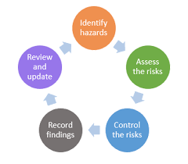

The Five Steps of Formal Risk Assessment

- Identify Hazards
Walk around to identify anything that you think could cause harm

- Assess the Risks
For each hazard you need to be clear about: Who may be harmed and How they may be harmed
- Evaluate
Can you get rid of the risks altogether? If not, how can you control the risks so that harm is unlikely?

- Record your Findings
- Who, what, where and when
- Risk levels
- Risk controls
- Assessor’s details
- Date and time
- Review date

- Review and Update
It is a legal requirement to review risk assessments regularly, but also when any changes occur e.g. different staff, condition of the person you are supporting, the environment, equipment or activities
Ergonomics
This is the science of fitting environments to the people working in them and fitting tasks to the people performing them.
We are all used to using ergonomically designed equipment in our everyday lives to make the tasks we do easier e.g. vacuum cleaners have been made increasingly lighter and are re-chargeable so we are not restricted by a lead when using them.
The equipment used in the safer handling of people is ergonomically designed to reduce the risk of injury for carers and for the people they are supporting. E.g. hoists and slings, wheelchairs, specialist beds
Manual Handling Operations Regulations recommend the use of an ergonomic model to risk assess any tasks involving manual handling. This model is called T.I.L.E. which stands for Task, Individual worker, Load and Environment.
When you use T.I.L.E. you must consider the following:
TASK
- Do you have to move the load?
- Will you have to bend, stoop, twist, stretch or hold the load away from you?
- Do you need someone to help you?
- Can you take your time?
- Is the equipment suitable and safety checked?
- Have you been trained to use it?
INDIVIDUAL WORKER
- Do they need additional knowledge or training?
- How familiar are they with the environment/person?
- What is their present state of health?
- Do they have any existing injuries?
- Are they pregnant?
- Is PPE required?
LOAD
- Is it bulky, unwieldy or too large to hold close to the body?
- Too heavy?
- Difficult to grasp?
- Unstable, or have contents which are likely to shift when moving?
When you are involved in the safer handling of people, the person is “the load”, (although you must never refer to a person as a “load”). You must also consider the following:
- Person’s preferences and concerns
- Height and weight
- Relevant medical history
- Ability to weight bear
- Behavioural constraints
ENVIRONMENT
- Temperature
- Slippery/uneven surfaces
- Variation in work surfaces
- Poor lighting
- Obstructions
- Confined or restricted space
- Equipment

THE PRINCIPLES OF SAFE HANDLING

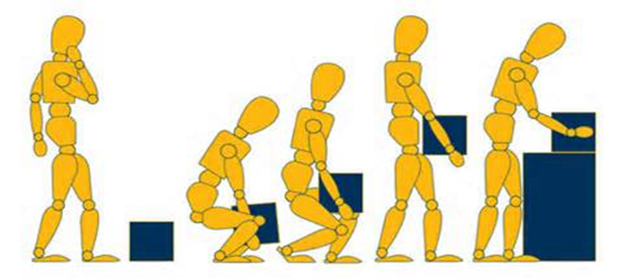
- Think before lifting/handling.
Plan the lift. Can you use handling aid? Where are you going to place the load? Will you need help? Clear the pathway. For a long lift, consider resting the load midway to change grip.

- Adopt a stable position.
The feet should be apart with one leg slightly forward to maintain balance (alongside the load, if it is on the ground). Be prepared to move your feet during the lift to maintain your stability. Avoid tight clothing or unsuitable footwear, which may make this difficult.

- Keep the load close to the waist.
Keep the load close to the body for as long as possible while lifting. Keep the heaviest side of the load next to the body. If a close approach to the load is not possible, try to slide it towards the body before attempting to lift it.

- Avoid twisting the back or leaning sideways, especially while the back is bent.
Keep your shoulders level and facing in the same direction as the hips. Turn by moving your feet rather than twisting and lifting at the same time.

- Keep the head up when handling.
Once you have a secure load, look ahead, not down at the load,

- Move smoothly.
You should not jerk or snatch the load as this can make it harder to keep control and can increase the risk of injury.

- Put down - then adjust.
If you need to position the load precisely, put it down first and then slide it into the desired position.

NB: There is no such thing as a ‘safe’ weight to lift or move. There is a difference between what people can lift and what they can safely lift. Many things will affect someone’s ability to lift, carry and move particular objects e.g. the size and shape of the load, how far you have to carry it, your capabilities. The Manual Handling Operations Regulations (MHOR) state that we should avoid or control risks associated with manual handling. If in doubt, seek advice or get help.

Pushing and Pulling

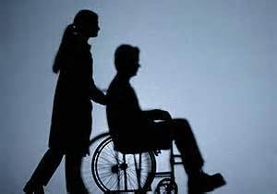
In general, pushing is preferable to pulling
Keep your hands between your waist and shoulder height when gripping the load
Where possible, push with the hands high, pull with the hands low
Start the movement slowly to minimise forces on your body and do not go faster than walking pace.
Use 2 hands to push or pull when you can, as using 1 hand tends to make you twist

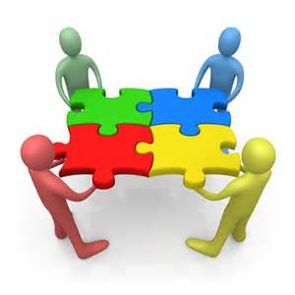
Team Handling

Working in a team to move loads or people is not always better than using equipment as guidelines note that two people CANNOT lift twice as much as one person. Lifting with three or more people is even more awkward.
To lift successfully as a team:
- People need to be roughly the same height and build
- They all need to have roughly the same lifting ability
- Enough space is needed for the whole team and the load to be moved freely
- They all need to be able to get a secure grip on the load
For these reasons the MHOR recommend using equipment to lift whenever possible
COMMUNICATION is extremely important when lifting as part of a team. Co-operation, timing and co-ordination are essential:
- Nominate a team leader
- Agree on the instruction
- Only the team leader should give instructions
- Remember, when moving people they are part of the team!
The safest instruction to use when manual handling is “READY, STEADY, LIFT”. This is a clear and controlled instruction that leaves no room for ambiguity. You can also replace the “doing” word at the end of the instruction to make it clearer still. E.g. Instead of “Ready, steady, lift” you could use ready steady stand* (or sit*, or roll*, or slide* etc.)



