

All Wales Manual Handling Passport

Workbook for Modules A & B Theory

Name:
Job role:
Place of Work:
Line Manager:
Date of completion:
Score (Pass rate 75%)
NB: To be completed by Trainer only)


JC/MCC/MH/DEC/2020
You will find answers to all the questions in the Handbook.
Define the term manual handling

LOOKING AFTER YOURSELF: PREVENTION OF MUSCULOSKELETAL INJURIES
The Human Spine
Label these sections of the spine
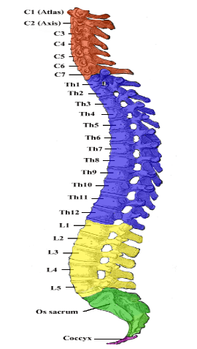

List three functions of the spine
1.

2.

3.

List three functions of the intervertebral discs
1.

2.

3.

What are musculoskeletal disorders (MSDs)?

How much did MSDs in the workplace cost UK society in 2018/19? Tick box
£4.8 million
£ 48 thousand
£4.8 billion

List three risk factors for developing of MSDs
1.

2.

3.

List three effects on employers if staff take time off work caused by work related injuries
1.

2.

3.

List three effects for employees if they have to take time off work because of work related injuries
1.

2.

3.

State one thing you can do to keep your back healthy

List three factors that may contribute to upper limb disorders (ULDs)
1.

2.

3.

List three symptoms that might mean you have a ULD
1.

2.

3.

Name one activity you do, at home or in work, where you are static loading

MANUAL HANDLING AND THE LAW

List four things your employer has to do under the Health & Safety at Work Act - 1974 (HSW)
1.

2.

3.

4.

List three things you, the employee, have to do under the Act
1.

2.

3.

Which Regulations state that employers must?:
- Avoid manual handling where there’s risk of injury
- Use mechanical means of lifting when possible
- Make suitable and sufficient risk assessments

Which Regulations apply to all equipment where lifting and lowering is the principal function e.g. hoists and slings?

How often should equipment used in the safe handling of people have a formal, thorough examination by the company that supplies/maintains it?
- Every six months and following exceptional circumstances
- Every year and following exceptional circumstances
- Only and following exceptional circumstances

What is your responsibility under RIDDOR? (Reporting of Injuries, Diseases and Dangerous Occurrence Regulations – 1995)

THE IMPORTANCE OF ERGONOMICS AND RISK ASSESSMENT IN REDUCING THE RISK OF INJURY TO YOURSELF AND OTHERS
Define the term “risk assessment”

Which one of these describes a formal risk assessment and which one describes an informal or dynamic risk assessment? Write your answer in the top box.
1. | 2.
Brief, mental checks by the person carrying out the activity, at the time of the activity  Not recorded or communicated unless a problem is identified | Written records.  Shared with others  Required by law  Has a review date

Name a piece of ergonomically designed equipment used in the safer handling of people.

The 4 Elements of Moving and Handling Risk Assessment

Give some examples of risk factors you need to think about when considering T.I.L.E
Task  (i.e. what you have to do) | Individual  (i.e. you and your capabilities)
Load  (the object/person you’re helping to move) | Environment  (i.e. where you are carrying out the task)

THE PRINCIPLES OF SAFE HANDLING
What do you need to think about before lifting or handling a load?
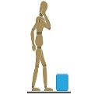

How would you adopt a stable position before moving the load?


Describe how you would lift a load, like a box, from the floor
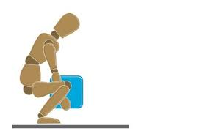

Team Handling
List three things you can do to lower the risk of injury when manual handling as part of a team
1.

2.

3.

When manual handling in a team, which of the following commands is the safest to use? Put a cross next to the safest option.
 | ONE, TWO, THREE …..
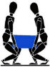 | AFTER THREE, LIFT!
 | READY, STEADY, MOVE

Case Study: Manual Handling Problem
Mr G has full use of his hands and arms but little strength in his legs and feet. Mr G weighs around 12 stone. He is able to communicate fully. Two social care staff visit him every morning to assist with washing, dressing and getting up. Mr G sleeps in a double bed, with access from both sides. The bedroom is quite small with lots of furniture and very little space either side of the bed. The care staff wash Mr G while he is still in bed. One care worker climbs onto the double bed and rolls Mr G towards her. She holds him in that position while a second care worker washes his back. This takes about 5 minutes. The holding task is uncomfortable for the care worker and causes lower back pain. The one washing is more experienced than the one rolling Mr G towards them.
Use TILE to answer the following questions:
TASK
(What do the carers have to do?)

INDIVIDUAL
(What do you know about the carers and their capabilities?)
LOAD
(What do you know about Mr G?)

ENVIRONMENT
(What do you know about the bedroom area?)

Can you think of anything the carers could do to make this task easier and safer for Mr G and the carers? (If not, discuss it with your Manager/Senior Carer)



