Carer’s Information and Support

You have been given this letter, and Carers Handbook because of a conversation you have had with a health and social care professional or someone working in the voluntary sector. They think you may be looking after or supporting someone else and this letter and handbook might be of interest and help to you.

Many people do not identify themselves as being a carer, as they see themselves as simply supporting someone else in their life. There may come a time though, that you feel or others feel you need support too. If you provide care, regardless of your age, and do it unpaid for for a friend, neighbour or family member who due to illness, disability, a mental health problem or an addiction cannot cope without your support, there is a good chance that you are a carer.

We want to let you know that there is support out there for you, and if after reading the handbook, and “What is a Carers Needs Assessment” section, you want the opportunity to talk to someone about your caring role and how it is impacting upon your life, then please get in touch.

There’s some helpful advice on the back of this letter, to help you think about what you might want to talk about, and what you hope to get out of your conversation.

Monmouthshire Carers Team

PTO

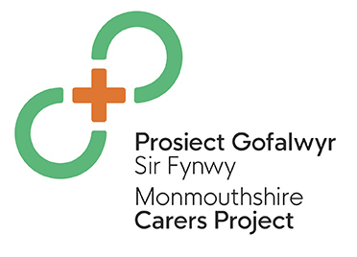

A carer’s needs assessment is an opportunity for you to talk to a social care professional about what could make caring easier for you and what help and support is available. It allows you the time to think about what your needs are, and how you can be supported as someone who looks after someone else.

Some examples of what can be covered within this conversation are:
- your caring role and how it affects your life
- your health – physical, mental and emotional
- your feelings and choices about caring
- your work, study, training, leisure
- your relationships, and your goals
- thinking about how you would manage if there was an emergency in your caring role and what could be done to help you
- your respite options, breaks, social activities
- thinking about your financial needs
- how you can maintain or regain your own identity
Who can have a Carers Needs Assessment?
Any carer is entitled to a needs assessment, even if the person you care for has refused an assessment or support, you can still have one.
The carer’s needs assessment will take place somewhere that is convenient for you, in your home, the home of the person you care for, or somewhere else if you prefer.

To ask for a Carers Needs Assessment
If you are over 18 and want to discuss your caring role more contact the Integrated Service Team for your area.
Abergavenny Tel: 01873 735885
Monmouth/Raglan/Usk/Trellech Tel: 01600 773041
Chepstow/Caldicot Tel: 01291 635666
If you are under 18 and want to discuss your caring role more you either talk to the
Young Carers Service -Carers Trust South East Wales
Tel: 01495 366993
Or
Children's Services - Monmouthshire County Council
Tel: 01291 636355

PTO

