APPLICATION FOR THE REGISTRATION OF A

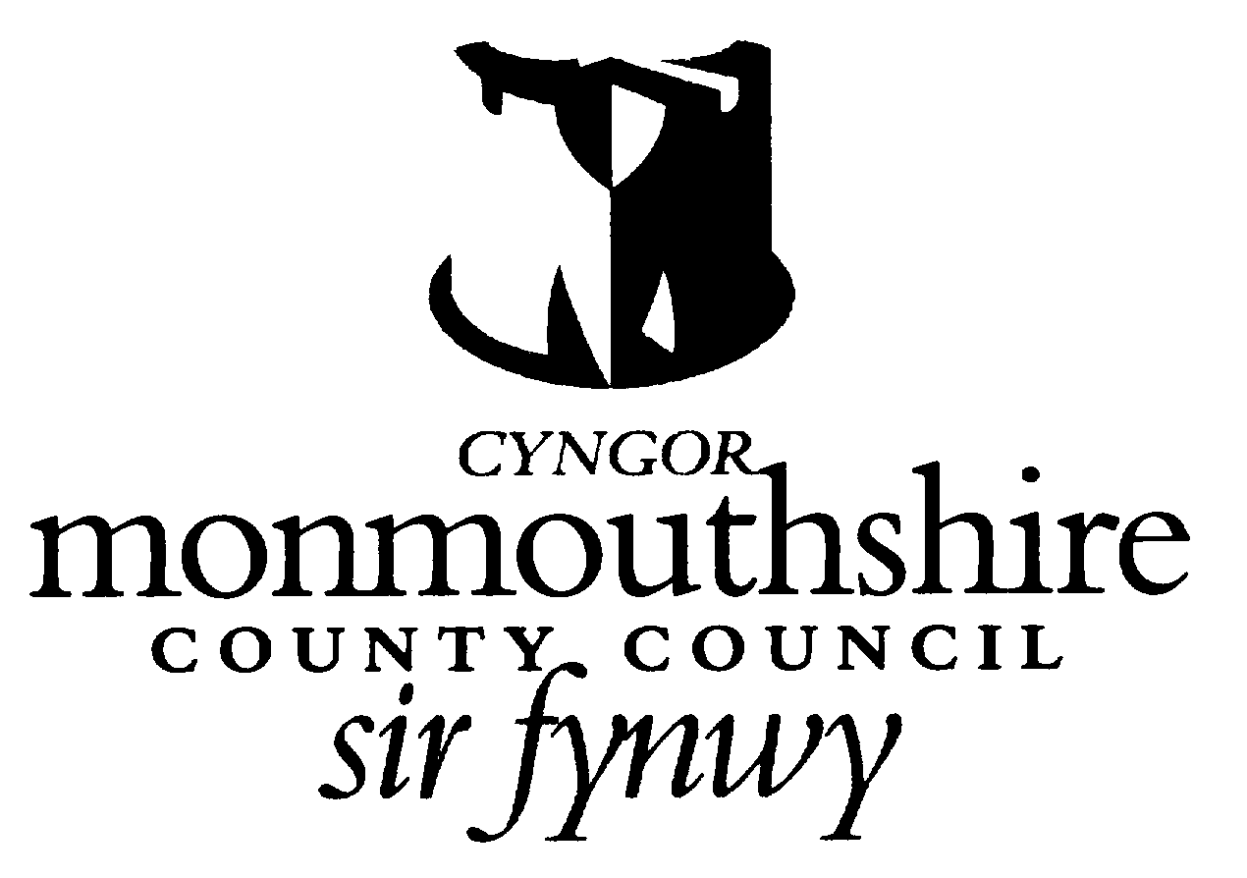

NON-COMMERCIAL SOCIETY
(THIS FORM IS PRESCRIBED BY REGULATION 3(1)(a) OF THE SMALL SOCIETY
LOTTERIES (REGISTRATION OF NON-COMMERCIAL SOCIETIES REGULATIONS 2007)

If you are completing this form by hand, please write legibly in block capitals using ink.
To: MONMOUTHSHIRE LICENSING SECTION
Abergavenny Community Education Centre
Old Hereford Road
Abergavenny
NP7 6EL

SECTION A – Details of society applying for registration.

1. Name of Society …………………………………………………………………………………………………………..
……………………………………………………………………………………………………………………………………

2. Address (including postcode) of office or head office of society ……………………………………………….
……………………………………………………………………………………………………………………………………
……………………………………………………………………………………………………………………………………
……………………………………………………………………………………………………………………………………

3. Telephone No. of society ……………………………………………………………………………………………….

4. Please state the purpose(s) for which the society is established ………………………………………………
……………………………………………………………………………………………………………………………………
……………………………………………………………………………………………………………………………………
……………………………………………………………………………………………………………………………………
……………………………………………………………………………………………………………………………………
……………………………………………………………………………………………………………………………………
……………………………………………………………………………………………………………………………………
……………………………………………………………………………………………………………………………………

5. If the society is a registered charity, please give the society’s unique charity registration number
……………………………………………………………………………………………………………………………………

6. Has the society held an operating licence under the Gambling Act 2005 in the period of five years ending with the date of this application? ‘Yes’ □ ‘No’ □

7. If the answer to question 6 is ‘Yes’ has the operating licence been revoked in the period of five years ending with the date of this application. ‘Yes’ □ ‘No’ □

8. If the answer to question 7 is ‘Yes’ please state the reasons for revocation and enclose a copy of the notice of revocation if one is available.
……………………………………………………………………………………………………………………………………
……………………………………………………………………………………………………………………………………
……………………………………………………………………………………………………………………………………
……………………………………………………………………………………………………………………………………

9. Has the society applied for and been refused an operating licence in the period of five years ending with the date of this application? ‘Yes’ □ ‘No’ □

SECTION B – General information about person applying on behalf of society

10. Name …………………………………………………………………………………………………………………….

11. Capacity …………………………………………………………………………………………………………………

12. Address (including postcode) ………………………………………………………………………………..………
……………………………………………………………………………………………………………………………………
……………………………………………………………………………………………………………………………………
……………………………………………………………………………………………………………………………………
……………………………………………………………………………………………………………………………………

13. Daytime telephone number …………………………………………………………………………………………..

Section C – Contact details for correspondence associated with this application

14. Please tick one box as appropriate to indicate address for correspondence in relation to this application:
Address in Section A □ Address in Section B □ Address Below □
Address (including postcode)……………………………………………………………………………………………
……………………………………………………………………………………………………………………………………
……………………………………………………………………………………………………………………………………
……………………………………………………………………………………………………………………………………
……………………………………………………………………………………………………………………………………

Telephone number …………………………………………………………………………………………………………

Email address (if the applicant is happy for correspondence in relation to this application to be sent via e-mail: ……………………………………………………………………………………………………………………………
……………………………………………………………………………………………………………………………………

Section D – Declaration
15. Please complete the following declaration and checklist:

I [full name] ………………
……………………………………………………………………………………………………...
a. make this application on behalf of the society referred to in Section A and have authority to act on behalf of that society.
b. Enclose payment of the registration fee of £40.00 (Cheques made payable to Monmouthshire County Council)
c. Confirm that, to the best of my knowledge, the information contained in this application is true. I understand that it is an offence under section 342 of the Gambling Act 2005 to give information which is false or misleading in, or in relation to, this application.

Signature ………………………………………………………………………………………………………………….

Date ………………………………………………………………………………………………………………………….

Capacity ……………………………………………………………………………………………………………………

Note to the societies applying for registration:

The application will be refused if in the period of five years ending with the date of the application:
(a) an operating licence held by the society has been revoked under section 119(1) of the Gambling Act 2005, or
(b) an application for an operating licence made by the society has been refused.

The application will be refused if the local authority think that:
(a) the society is not a non-commercial society
(b) a person who will or may be connected with the promotion of the lottery has been convicted of a relevant offence, or
(c) information provided in or with the application is false or misleading.
PLEASE NOTE: The Council’s Licensing Committee is, with specific exceptions, a public forum. Not all applications require consideration by the Committee. Where our processes, as defined by relevant legislation, policies and guidance, require your application for a licence/permit/consent to be considered by the Licensing Committee, the identifying details you provide in your application may appear on documents which are considered by the Committee and are therefore available to the public. The personal information you provide will be used only for purposes related to the assessment of your application and future management of any licence/permit/consent granted. If you believe there is a legitimate reason for non-publication of your personal data, please provide those reasons with your application so that they can be considered in advance of preparation of Committee papers

