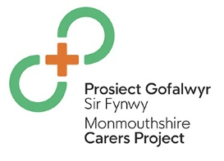
Monmouthshire Carers Newsletter

By signing up to receive a copy of the Monmouthshire Carers newsletter, you will
- receive a twice yearly newsletter,
- access to free training,
- discounted offers eg pamper sessions & access to Monmouthshire Leisure Services
- opportunities to socialise and meet with other carers
- free access to local events
To register so you can receive regular updates on the above via the Carers Newsletter either telephone the Carers Co-ordinator at GAVO on 01291 675474 or fill in the details below and return to Carers Co- ordinator, GAVO, Sessions House, Maryport Street, Usk, NP15 1AD
Name:

Email address:

Home address:

Telephone Number:

Would you be happy to receive your updates and newsletters via email? YES / NO Please provide your email address.

Signed: Date:

