
Caldicot Cross Destination Space
Project Bulletin
September 2020
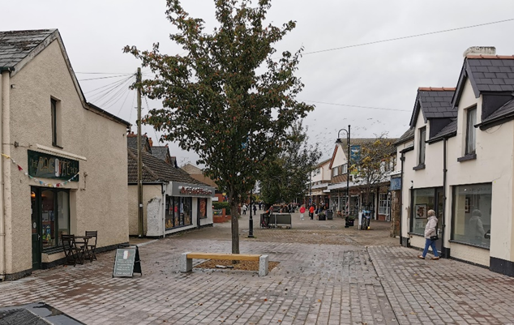
Project Progress and Upcoming Works
Throughout August, we have substantially completed all Phases except for Phase 1 East - our scheme phasing map can be found on our “Griffiths in the Community” website.
We still have some minor activities to complete in all phases, such as landscaping. We achieved our target of completing the paving around the cenotaph for the VJ Day Celebrations which were successfully held on 15th August 2020. The temporary traffic lights, which have been positioned on the junction for several months, have now been removed allowing two-way traffic to flow through Sandy Lane and Church Road. All paving works to Phase 5 have been completed and the footpath is now open to the public.
With the overall scheme coming to an end, we will be undertaking extra works within the grassed area on Sandy Lane. Works will include the removal of the current information sign and the construction of a plinth to house the Caldicot sign that was positioned there before the works began.
Unfortunately, due to unexpected issues with an existing culvert within Phase 1 East, Chepstow Road will remain closed to vehicular traffic until these works are complete. Please note, these works are being undertaken on behalf of Dwr Cymru Welsh Water (DCWW) and will result in the overall completion of the project to be delayed.

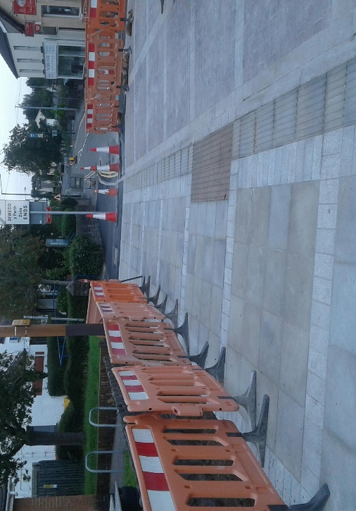

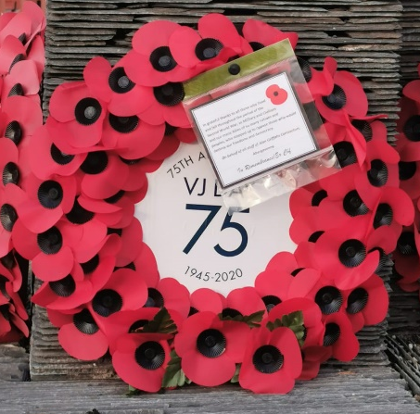
Caldicot Choir Hall Update
Since our last bulletin, we have made good progress at the Choir Hall. To date, we have donated various materials and resources. The foundations for the extension have been excavated, filled with concrete and the brickwork has been constructed to damp-proof course level.
We are looking forward to seeing the finished result, hopefully in a few weeks’ time.
For more information on the Caldicot Male Voice Choir, please visit https://www.caldicotmalevoicechoir.co.uk/

A view of the completed works around the Cenotaph
Completed footpaths in phase 5 – Chepstow Road


We would be pleased to hear your comments. You can get in touch via our web site community.alungriffiths.co.uk or by contacting our Public Liaison Officer Georgie Davies on 0330 041 2183* or email at georgie.davies@alungriffiths.co.uk
*Calls to this number are charged at national call rates and included in inclusive minute plans from landlines and mobiles
Poppy Wreath Donation
To mark the 75th Anniversary of VJ Day and to support the local community with their celebrations, Griffiths donated a poppy wreath which was kindly laid by members of the Royal British Legion on our behalf.

