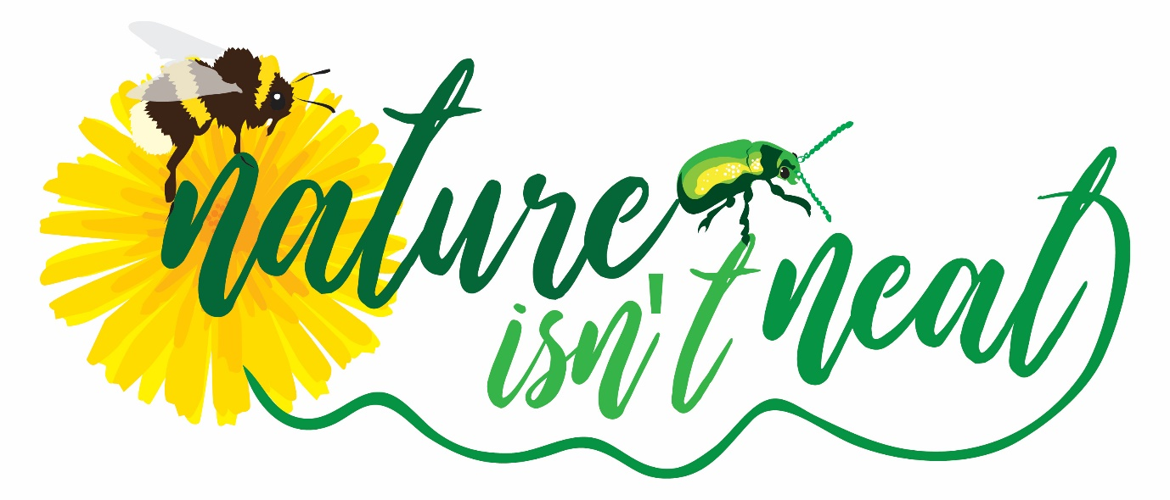
Nature Isn’t Neat Flower and Pollinator monitoring guidance notes
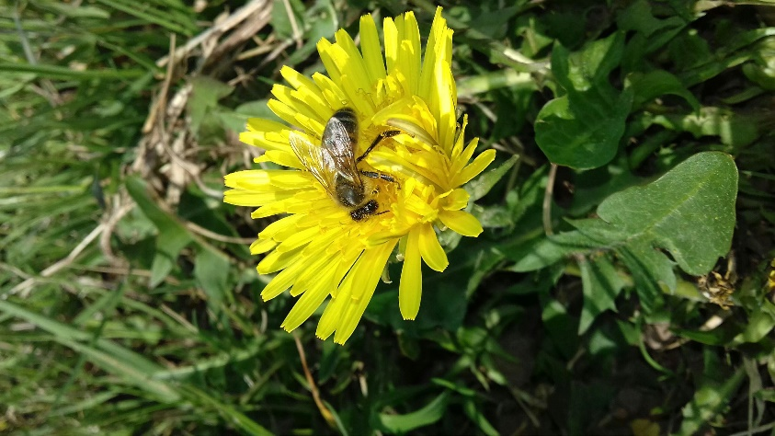
Many wild and cultivated plants depend on insects to pollinate their flowers, with successful pollination leading to successful seed or fruit production. There are concerns that numbers of pollinating insects such as bees and flies may be declining, but we need more data to be able to track changes in abundance. Nature Isn’t Neat is a pilot project in Monmouth that has involved changes in management of some public green spaces, including reduced mowing frequency and height as well as planting pollinator friendly plants.
This monitoring scheme will assess the impact of Nature Isn’t Neat over time on pollinator abundance and species range.
While this monitoring scheme is based on the Flower-Insect Timed (FIT) count devised by Bumblebee Conservation, Centre for Hydrology and Ecology and others, we have simplified it so that more people with less in depth specialist knowledge can take part. We will still get very useable information from our monitoring scheme which will help us to make decisions on future management of green spaces.
Planning your survey
Equipment needed:
- Survey form
- A tape measure, piece of string or sticks to roughly measure a 50cm square
- A mobile phone with a timer and camera (alternatively a watch and digital camera will suffice).
- A clipboard or hard surface to lean on
You will also need
- To select a Nature Isn’t Neat site from the leaflet guide to Monmouth NiN sites. You don’t have to choose the same precise spot on your chosen site for each visit as different flowers will be out
- About 15 minutes of your time once you reach the site (you can choose more than one site if you wish). Ideally visit once a month.
- Right time of the year – between April and end of September
- Right weather conditions – reasonably warm and dry: If sky is clear (less than half cloud) the minimum temperature for a count is 13°C . If sky is cloudy (half cloud or more) the minimum temperature for a count is 15°C. There is no maximum temperature threshold.
Recording your survey results
Record your results on the Excel spreadsheet provided. Sheet 1 only needs to be completed on your first visit as the information there is unlikely to change
Please complete one column on sheet 2 each time you visit your site. Submit your spreadsheet at the end of the monitoring period, or when you have made your last visit.
Target flowers
Wherever possible we would like surveyors to find one of the list of 12 target flowers on their survey plot. We need you to count how many individual heads, spikes or flowers of the target plant are in the survey plot each time you survey. The count will help us to understand which plants are more attractive to which pollinators. The twelve target plants are as follows:
Buttercup
Dandelion
Hawthorn
White deadnettle
Bramble
Hogweed or cow parsley
Knapweed
Ragwort
clover
buddleia
ivy
thistle
If you don’t have one of these in your plot, choose a different flower. Take a photograph and email it to us if you are unable to identify it yourself. It is worth pointing out that flowers are seasonal, so if you survey the same area from April to the end of September, you will notice that different flowers will be out through the year. You do not have to choose exactly the same spot on your area each time you visit, choose a spot where there is a group of one of the flowers on the target list, or another of your choice.
How many flowers?
We are asking for information about 2 aspects of your survey patch
- How much of your 50×50cm patch is occupied by the target flowers? – less than half the patch, half, or more than half
- How many of the target flowers are there within the 50×50cm patch?
To answer the second question you will need to count the individual flowers, but different types of flowers have different structures.
Individual flowers (e.g. hawthorn or daisy) – each flower counts as one unit. Flower umbels (for flowers that have small flowers grouped into ‘umbels’, like inside-out umbrellas, e.g. hogweed) – each umbel counts as one unit. Flower heads (where there are lots of tiny flowers within a larger flower head, e.g. dandelion) – each flower head counts as one unit. Flower spikes where a number of small flowers are arranged along a stem (e.g. deadnettle) – each spike counts as one unit.
Do not count flowers that have gone over or gone to seed, as these will have no value to pollinators.
Counting insects
The actual count lasts for 10 minutes, and it helps if you have a mobile phone or other device with a time keeper. Stand, kneel or sit close enough to see all the flowers in your patch, but don’t cast a shadow on it.
- Only count insects that land on flowers of your target plant species, within the patch
- Unidentified insects large and small should still be counted, in the “Other insects” category
- Ignore insects that do not land, or that land on flowers of other plant species, or that land on leaves
- Ignore any spiders, snails or other non-insects that may occasionally be seen on flowers
- Occasionally you may find insects ‘hiding’ at the bases of flowers, but these should not be counted unless you saw them actively land on or move over the flower during your 10 minutes
You are asked to identify insects into different groups (e.g. bees, wasps, flies, butterflies and moths), and you do not need to say which actual species you have seen. Identifying insects into groups is not always straightforward: some are fairly obvious (for instance many people are familiar with what a bumblebee looks like), but others can be tricky (such as the smaller hoverflies, wasps and solitary bees).
We do want you to count all the insects you see, but it is very likely that you will see some that you cannot confidently put into one group or another. That is absolutely fine, and there is a category for “other insects”, where you can count insects that you can’t identify.
Try not to count an individual insect more than once. For example if a bee lands on a target flower within your plot, and then lands on another target flower in the plot, this counts as one bee, not two.
The survey will be more valuable if volunteers are able to visit one or more sites every month, but if volunteers are unable to commit to this, any surveying is a great help to us and we will be very grateful indeed.
If you need more help or advice please contact Sue Parkinson Green Infrastructure and Litter education officer 07826 914981 susanparkinson@monmouthshire.gov.uk . Please send completed spreadsheets to this email address as well.

Monitoring sites for Nature Isn’t Neat
- Wyesham Community Woodland
- Wyesham Avenue pollinator patch
- Two River Meadow and Community Orchard
- Drybridge Park verge
- St James Square war memorial garden
- Monmouth cemetery species rich grassland
- Rockfield Community Centre garden
- Herb and pollinator garden at the bus station
- Bank of the Monnow (not sure about public access to this site)
- Lancaster Way community orchard
- Wonastow SINC
- Beech Road pollinator verge
- Beech Road corner pollinator verge
- Portal Rd pollinator verge
- Castle Close orchard and tree planting
- Drybridge Park
- Drybridge Pond
- Bigham Close pollinator areas
- Overmonnow open spaces
- Flood bank pollinator grassland
- Vauxhall Fields
Proposed comparison, non-intervention sites:
Clawdd Du
Overmonnow school fenced off area of land
Chippenham Mead (mown area)

