
Caldicot Cross Destination Space
Project Bulletin
August 2020
Project Progress
We have made good progress throughout June and July and have been working on all five phases of the scheme (our phasing map can be found on the Griffiths in the Community website). To date, phases 1 and 3 are nearing completion, however there are still a few things to do. We are now aiming to finish the paving around the cenotaph as part of Phase 1, in time for the VJ Day celebrations on the 15th August 2020. The photographs below show planters with incorporated seating and benches being installed this week. A bus shelter has also been installed on Chepstow Road (Phase 1 east). Phase 2, which includes the carriageway on Sandy lane, is complete and we are just waiting for trees to be planted in Phase 3. The reconstruction of the carriageway on Chepstow Road as part of Phase 4 is really starting to take shape, especially now that all the service ducting, drainage and kerbing is complete. We are hoping this will soon be open to traffic. With our concentration on getting the cenotaph complete, we have postponed the paving works on Phase 5, and this will be one of the last things to focus on. We envisage the footpath to be complete by late August. The above works will continue throughout August and into the beginning of September where the scheme will come to an end. A further update will be provided before completion.

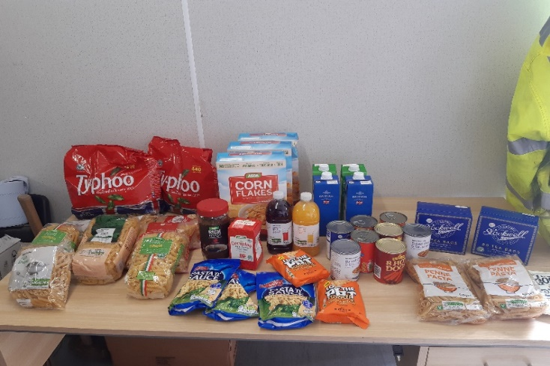
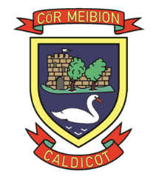
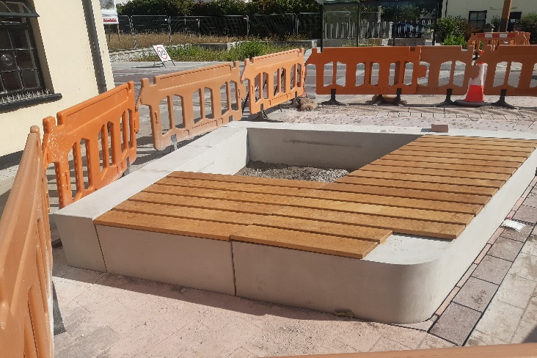
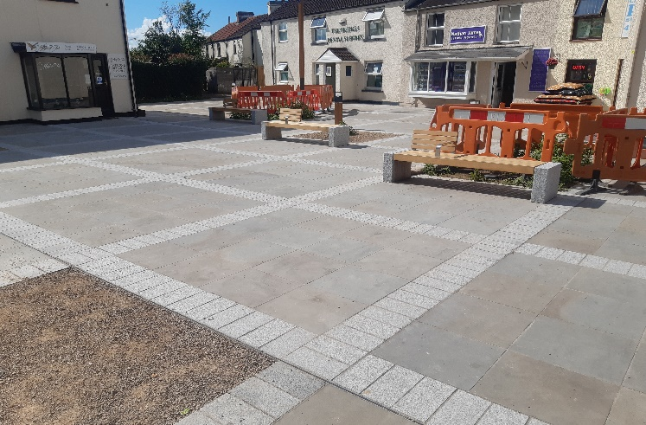
Griffiths donate to local foodbank Since the remobilisation of site, staff have been helping local families who have been affected by the pandemic, by donating various items of food to Caldicot Food Bank.
Donation to help
Caldicot Choir Hall
Our Good Causes Committee were contacted by Caldicot Male Voice Choir seeking material support to start the approved extension to their Choir Hall, which would allow extra space for storage. The hall, which is run by volunteers and depends entirely on donations, is used by many charitable organisations like the Welsh Blood Service and the local community for various events such as weddings and birthday parties
Griffiths are proud to be involved with and support such a worthwhile local project which will benefit the whole of the community. If you would like more information on the Caldicot Choir Hall, please visit http://www.caldicotmalevoicechoir.co.uk



We would be pleased to hear your comments. You can get in touch via our web site community.alungriffiths.co.uk or by contacting our Public Liaison Officer Georgie Davies on 0330 041 2183* or email at georgie.davies@alungriffiths.co.uk
*Calls to this number are charged at national call rates and included in inclusive minute plans from landlines and mobiles

