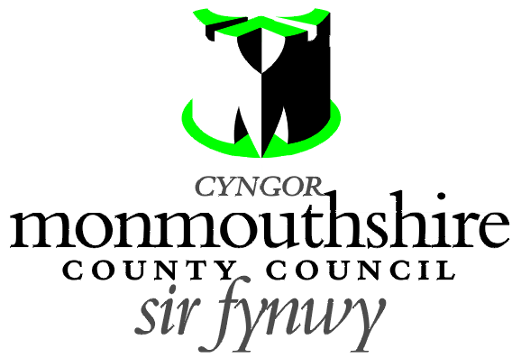

ZEBRA CROSSING
STAR ROAD, PENPERLLENI

Monmouthshire County Council propose to provide a new zebra crossing facility on Star Road, Penperlleni. The zebra crossing is proposed to be located 13 metres east of its junction with School Lane.

A Plan indicating the location of the proposed zebra crossing may be examined online at http://www.monmouthshire.gov.uk/public-consultation-traffic or alternatively contact laurabazely@monmouthshire.gov.uk for a copy of the plan.

Any Objections in respect of this proposal should be made in writing only, stating the grounds on which the objection is being made and should be sent to traffic@monmouthshire.gov.uk or to the Traffic section, Monmouthshire County Council , County Hall, Usk NP15 1GA to be received not later than 5 pm on Friday 24th July 2020.

Date 2nd July 2020.

Frances O’Brien
Chief Officer
Enterprise Directorate

