


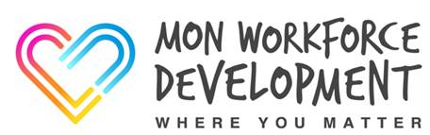


Mon Workforce Development Newsletter #10
15th June 2020
This week’s newsletter will have a focus on Outcome Focused Practice and will signpost you to some useful resources.
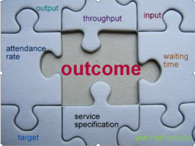
Outcome Focused Practice

The Social Services and Well-being (Wales) Act 2014 provides the legal framework for improving the wellbeing of people who need care and support, and carers who need support. Promoting wellbeing is a fundamental principle of the Act.

The Act requires us to ascertain and have regard to the individual’s views, wishes and feelings in order to identify the personal outcomes that the person wishes to achieve. Personal outcomes should primarily be understood as what matters to the person. So the starting point is to work with the individual to define what is important to them, and to plan activities and support from there. At a later stage it is possible to review whether outcomes have been achieved, to measure progress, and to amend the plan (Cook and Miller, 2012a, p. 8).

An outcomes-based approach is based on the following principles:

- People are experts in their own lives
- They are best placed to tell you what’s important to them and what gives them a sense of well-being, but they may need help to do this
- People want to do the things that matter most to them, in their own way
- People’s strengths are important and need to be acknowledged
- We start by identifying what the person wants to achieve, and then thinking through how to achieve that outcome and agree a plan to help them to do this
- The person’s family, carers and local community can also contribute to this plan
- Meaningful conversations are central to understanding a person’s outcomes
- A personal outcome is the picture the person paints of what it is they want to achieve
(Social Care Wales)

Outcomes Approach to Assessment

The “exchange model” of assessment fits with an outcomes approach as the aspirations of the individual is central to the assessment. This model of assessment also fits with being;

- strengths based
- solution focussed
- person centred

The Exchange model…

- Involves a conversation between the
Individual and SW in order to exchange
Information
- Assumes that the individual is the expert in
their own lives
- Needs to arrive at a joint understanding of
the individuals strengths, difficulties needs
and resources
- Is less concerned with finding deficits

Having “What Matters” Conversations

Social Care Wales, in partnership with Rhoda Emlyn-Jones from Achieving Sustainable Change, has developed video resources to help you have good ‘what matters’ conversations with people who may need care and support. The videos are aimed at social care workers, volunteers, or people who have been redeployed.

There are four videos in the series:

- Good Beginnings. This helps us think about the structure of our first conversation with someone.
- Working with People. This helps us to think about the style and approach of the on-going conversations we have with people we support.
- Good Endings. This helps us to plan for when people no longer need our support.
- Why we have Strengths-based Conversations. This provides an overview of why we focus on ‘what matters’ to people.

You can view the videos here

More about outcome focussed conversations can be found here; Research in Practice Outcome Focussed Work

Outcome Focused Plans

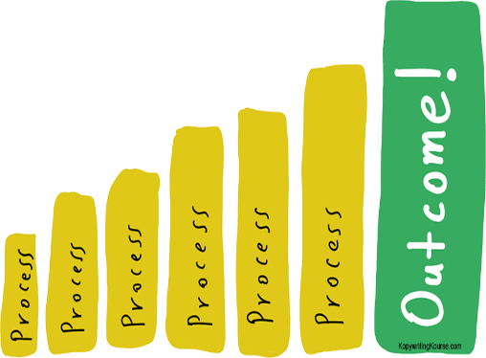
Making plans to support individuals and families is a core part of social work activity. Effective outcome focused support planning seeks to promote the independence, health and wellbeing of individuals, while at the same time giving them more choice and control over the support they receive. The outcome focused support plan should be prepared in partnership with the individual wherever possible.

Outcomes should be grounded in the goals that individuals want and can achieve and should be….



Outcome Focused Recording

Recording is a critical link in a personal outcomes approach and it is an essential task when working with individuals as it helps to focus the work and supports effective partnership and planning with people who use services. When adopting an outcomes focused approach, practitioners should be encouraged to use recording as an analytical tool and as a way of clarifying the purpose of their interventions.

Recording what matters to the person is the bridge between the conversations about what matters and the actions taken.

The core criteria for recording outcomes;

- There should be outcomes (agreed purpose) not just outputs (services)
- The outcomes should be personalised
- The person’s/family’s contribution should be noted
- The person’s voice included as appropriate

Tips for recording conversations

Other useful resources can also be found here;

Relationship-based conversations: practice scenario videos
Solution Focused Practice a toolkit for working with children

