

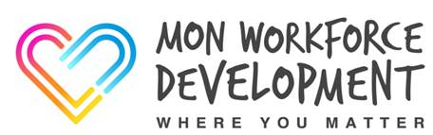
Mon Workforce Development Newsletter #07
12th May 2020
This week’s newsletter signposts you to some useful resources


Legislation Resources
Covid-19 and the MCA 2005 | - Essex Autonomy Project: Covid 19  - Essex Chambers: Holding onto principles – the MCA and Covid-19
Covid-19, DoLS and Best Interest   | - Webinar: The first National Mental Capacity Forum special webinar. (Held on 1 April 2020)
The Coronavirus Act 2020   | - Coronavirus Act 2020 and the implications for Wales (please see email attachment)  - Acting Lawfully and Ethically under the Coronavirus Act 2020 (please see email attachment)

Other Social Care Resources
Dementia   | - A Quick Guide to Care & Support of People with Dementia  Social Care Wales (in partnership with other organisations) has developed a quick guide to basic skills for supporting someone living with dementia. The guide is aimed at people new to care or redeployed from other areas.
Manual Handling  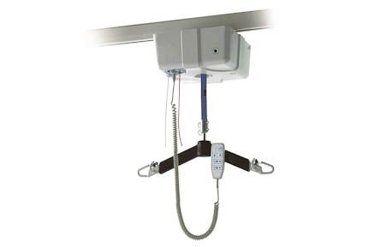 | - The EthosGPS Webinar Programme:  In collaboration with OTAC, Handicare’s National Patient Handling Adviser, Mark Ripley, will be presenting weekly EthosGPS webinars to continue supporting and providing moving and handling guidance for healthcare professionals.
COVID-19: Supporting autistic people and people with learning disabilities  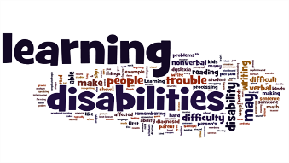 | SCIE (Social Care Skills for Excellence) Guides for:  - Social Workers and OTs  - Social Care Staff  - Carers and Families
Young People’s Mental Health   | Newport Mind:  - A Changing Minds Guide to Lifting Up in Lock Down (free download)

