
Home Learning Strategies for SpLD

Having Fun with Literacy

Have you tried these informative and fun YouTube videos?
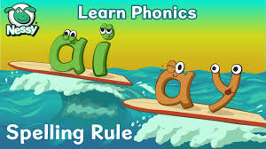
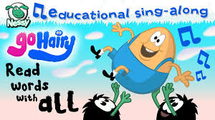
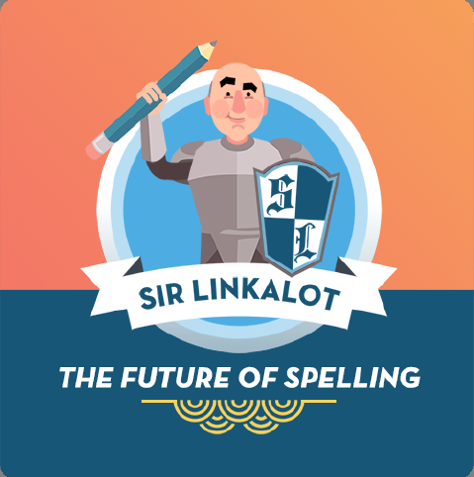

Nessy will guide you through lots of different phonic patterns and spelling rules. https://www.youtube.com/watch?v=v_URzFmlSS4
Sir Link-A-Lot with help you with learning spellings through finding amazing words within words and give you masses of way to memorise spelling difficult words in the most fascinating of ways!
youtub.be/Pz1loHZ1xsk
Many apps are free while home schooling is taking place. Try them out! For example: Hairy Letters App. Hairy Letters is an award-winning phonics app that helps letter and sound recognition. Trace the letter shape with your finger. Play games to build letters into simple words. Letter sounds come to life with animated characters.

Did you know with library memembership you have free online access to EBooks, eAudio books, comic and magazines? Click on the www.monmouthshire.gov.uk/community-bugs-libraries/digital-downloads/
Free eBook library – practise reading with phonics / Oxford Owl
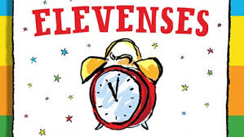
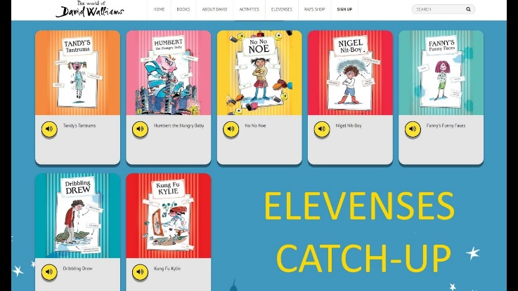
Are you listening to free audio stories? What’s great about this one is David Walliams is reading them! Bit.ly/AudioElevenses? If you can track as well as listen this will really help with reading skills.

Try listening to some of his great stories. Helpful for vocabulary acquisition, storylines, sentence structure and making imaginative stories of your own!

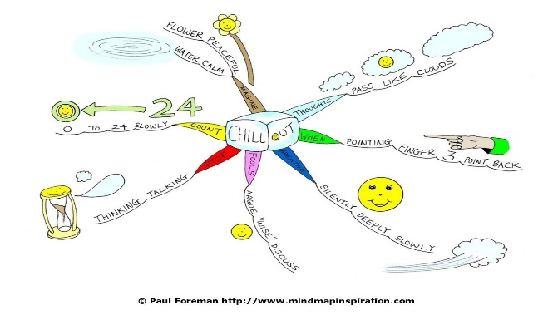
Maybe when you’ve heard the story you can make your own mind map depicting the main events! Mind maps are a great multisensory way to prompt ways of remembering information!

Writing Your Own Stories
Great time to write your own stories! If you don’t feel like putting pen to paper why not try using some great Speech to Text programmes? You speak into the computer and it will type up your story for you!

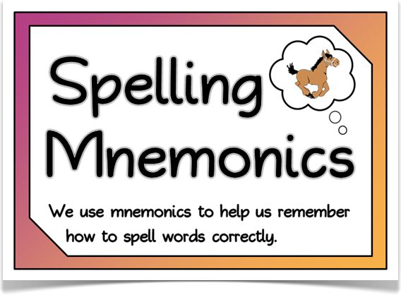


Have you thought about making your own mnemonics up while you’re at home? This one is good!

Games that are great for playing at home

Have you got junior scrabble, Boggle, Uno? We’re used to playing SWAP and TRUGS in our lessons but have you thought about making your own card games, your own word searches or your own crosswords?
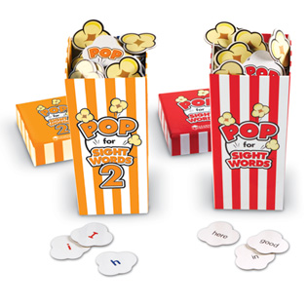
There are many websites that will make them for you if you input your own words. wordmint.com/CrosswordMaker.

Have you got POP at home to learn all those high frequency words? You could try to beat someone in your family!
https://www.learningresources.co.uk/pop-for-sight-wordstm-game

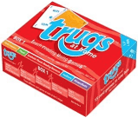

This is a home version of the Trugs games we love to play!

Free Teaching Resources
Free printable reading and spelling resources, for use by parents, teachers, tutors and those who are homeschooling.
https://www.phonicbooks.co.uk/ 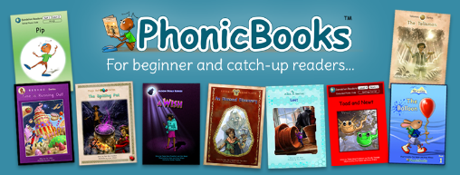
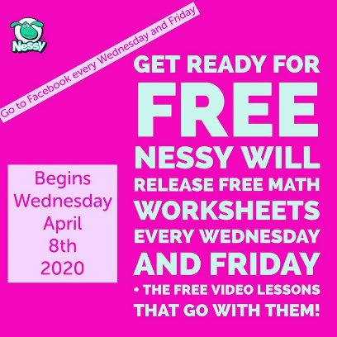

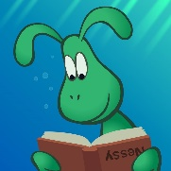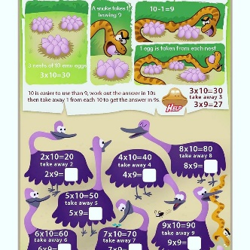
Nessy is providing FREE maths materials to the public for use at home during the
Coronavirus lockdowns. Check them out. They have a facebook page.

Have fun while you’re at home! See how many words you can make out of CoronaVirus!
These are a start using all the different letters in Coronavirus. Can you find some more?
c | o | r | n | a | v | i | u | s
car | on | ran | nor | arc | virus | iron | us | sun

