
Building
Attachments
Security and
Emotional well-being

Information Leaflet

Using attachment principles to improve outcomes for children & young people in care
What is BASE?
- BASE works in partnership with Social Services supporting young people who are looked after by Foster Carers, Kinship Carers and Special Guardians.
- BASE is situated within Monmouthshire Children’s Services but is linked to Aneurin Bevan University Health Board (ABUHB) through our Clinical Psychology employees.
- BASE works within an attachment model and offers direct work, consultations, training and network meetings. Please see overleaf for services and process.
BASE believes that:
- Children and young people need access to safe and nurturing relationships and stable homes and experiences to promote well-being and development.
- Professionals and carers have the right to feel confident and supported in their work with children and young people.

The BASE team
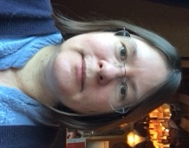
Charlotte Drury
Service
Manager
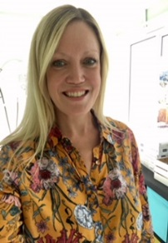
Dr Sarah Hobson
Clinical Psychologist
(3 days)

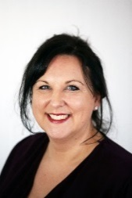
Tina
Morgan
Play Therapist
(5 days)

Dr Hayley MacGregor
Clinical Psychologist (3 days)

Laura Jones
Business Support Administrator
(1 day)

Vicky Hepburn-John
Play Therapist
(1 day)

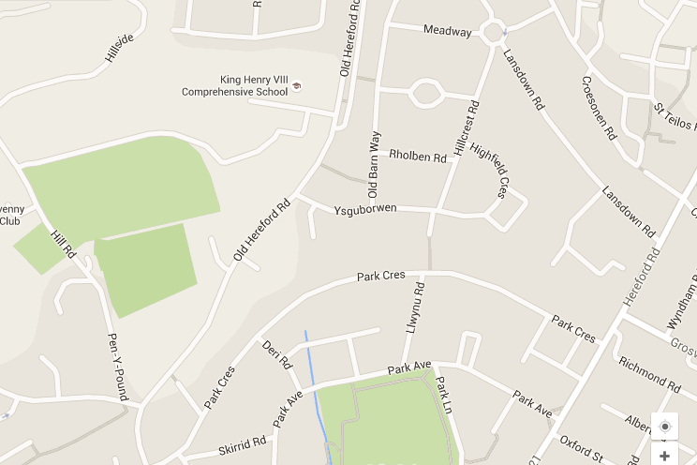
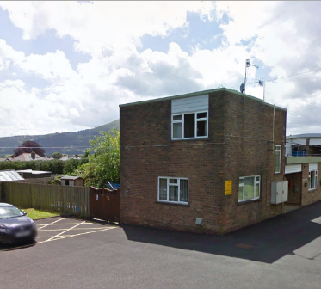
BASE Contact information:
Feel free to contact BASE for further information or for directions.

Email: Base@monmouthshire.gov.uk
Phone: 01873 858652
Address:
35 Old Hereford Road,
Abergavenny, NP7 6EL

Directions: Once in Abergavenny, head towards the Leisure
Centre on Old Hereford Rd. Come through the traffic lights on
Old Hereford Road and take the next main turning on the right
hand side into Ysguborwen.
Take an immediate right into car park of the housing complex.
We are the square red brick building at the far bottom
right end of the car park.




What do we offer? | Who is it for? | When might you need it? | How can you request it?
No referral required – email Base@monmouthshire.gov.uk to request:
CV  Placement meetings | The whole network around a child | When a child comes into foster care or changes placement and you want to bring the network together and think about how this child is likely to present and what support they and their carers might need. | Email us to request one of our regular slots.
CV  One off consultation | Staff only | When, as a professional, you have a focused question or dilemma to discuss regarding a child or family. | Email us to request one of our regular slots.
No referral required: drop in service
CV  Workshops | Foster and kinship carers | Carers can attend as and when they think it might be helpful or relevant. The programme of regular workshops will be sent direct to carers. | If you would like to be added to our circulation list please email us.
CV  Reflective Practice | Social services teams | Reflective practice increases reflective capacity and skills, it will be ongoing. | BASE will arrange in liaison with managers
Referral through LAC Panel:
CV  Regular consultation for carers | Parents, carers and social workers | When the carer is seeking consultations to inform their parenting and approach with the child and this is felt to be both necessary and more appropriate than direct work. | Social worker takes a referral form to LAC panel. If approved, social worker emails us to arrange an initial consultation for formulation and planning.
CV  Direct therapeutic work | Young people and their families | When specialist direct input is needed. This may occur alongside consultation work.
Services and Process:

