Toolkit #5
Emergency First Aid at Work for Adults

This Toolkit provides some of the knowledge and skills needed to carry out the duties of a workplace emergency first aider until more experienced or professional help arrives.
It is an interim measure during the Covid 19 pandemic and does not replace the requirement for face-to face First Aid training when we are able to provide this again.
Please watch all the accompanying video clips and download the free British Red Cross First Aid App to your mobile phone from Google Play or Apple Store


Always Remember: You are the number one priority

If you cannot approach the casualty safely then don’t – call 999

CPR in Community Settings  During the Covid 19 period  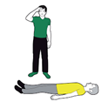 | If you come across someone who is unconscious, unresponsive, not breathing or not breathing normally, they are in cardiac arrest. The most important thing is to call 999 and start CPR to keep the blood flowing to the brain and around the body.  Check for Danger – Ensure it is safe to approach the casualty. If it’s not safe - call 999  Check if the casualty is responsive – Ask them: “Are you alright?” “Can you hear me?”  If the casualty is unresponsive - shout for someone to come and help you, if you know where the nearest defibrillator is ask them to get it straight away  Check whether the casualty is breathing: Look for visual signs of life and the absence of normal breathing.  *Do not listen or feel for breathing by placing your ear and cheek close to the patient’s mouth during the Covid 19 period*  Call 999: Tell them the casualty is unconscious and not breathing. Inform them if you suspect the person has Covid 19. Stay on the phone and put it on loudspeaker. The emergency services operator will talk you through what to do next. They will also tell you where to locate the nearest defibrillator. If anyone has come to help you, send them to get the defibrillator/AED  Chest compression only CPR: If there is a perceived risk of infection, rescuers should place a cloth/towel over the casualty’s mouth and nose and attempt compression only CPR until the Emergency Services arrives. Wear PPE if available. (If you are not 100% sure whether or not the person has stopped breathing then do chest compressions until help arrives anyway – this is better than doing nothing)  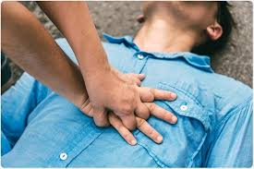  Chest Compressions  Put your hands together like this and push down hard and fast in the middle of the person’s chest. The “Staying Alive” tune is a rough guide to the rhythm required.  THE UK RESUSCITATION COUNCIL RECOMMENDS THAT YOU DO NOT PERFORM RESCUE BREATHS OR MOUTH-TO-MOUTH VENTILATION AT THIS TIME; PERFORM CHEST COMPRESSIONS ONLY  Now watch this video clip from the UK Resuscitation Council: Out of Hospital Cardiac Arrest Guidance during COVID-19
Using a Defibrillator  (i.e. an Automated External Defibrillator or AED)  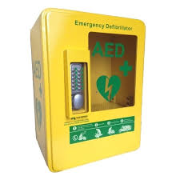 | After a cardiac arrest, every minute without CPR and defibrillation reduces someone's chance of survival by 10 per cent.  If you are on your own, do not interrupt the CPR to go and get a defibrillator. If it's possible, send someone else to find one. When you call 999, the operator can tell you if there is a public access defibrillator nearby.  To use a defibrillator, follow these simple steps:  Step 1: Turn the defibrillator on by pressing the green button and follow its instructions.  Step 2: Peel off the sticky pads and attach them to the patient’s skin, one on each side of the chest, as shown in the picture on the defibrillator.  Step 3: Once you have attached the pads, stop CPR and do not touch the patient. The defibrillator will then analyse the patient’s heart rhythm.  Step 4: The defibrillator will assess whether a shock is needed and if so, it will tell you to press the shock button. An automatic defibrillator will shock the patient without prompt. Do not touch the patient while they are being shocked.  Step 5: The defibrillator will tell you when the shock has been delivered and whether you need to continue CPR.  Step 6: Continue with chest compressions and rescue breaths until the patient shows signs of life or the defibrillator tells you to stop so it can analyse the heartbeat again.  Now watch this video clip from the British Heart Foundation: Call Push Rescue - Defibrillator Awareness
The Recovery Position | If a person is unconscious but breathing normally and has no other life-threatening conditions, place them in the recovery position.  Putting someone in the recovery position will keep their airway clear and open. It also stops them from choking on vomit.  - With the person lying on their back, kneel on the floor at their side.  - Extend the arm nearest you at a right angle to their body with their palm facing up.  - Take their other arm and fold it so the back of their hand rests on the cheek closest to you, and hold it in place.  - Use your free hand to bend the person's knee farthest from you to a right angle.  - Carefully roll the person onto their side by pulling on the bent knee.  - Their bent arm should be supporting the head, and their extended arm will stop you rolling them too far.  - Make sure their bent leg is at a right angle.  - Open their airway by gently tilting their head back and lifting their chin, and check that nothing is blocking their airway.  - Call 999 and stay with the person and monitor their condition until help arrives.  Suspected spinal injury  - If you think a person may have a spinal injury, do not attempt to move them until the emergency services reach you.  - If it is necessary to open their airway, place your hands on either side of their head and gently lift their jaw with your fingertips to open the airway. Take care not to move their neck.  You should suspect a spinal injury if the person:  - has been involved in an incident that's directly affected their spine, such as a fall from height or being struck directly in the back  - complains of severe pain in their neck or back  - won't move their neck  - feels weak, numb or paralysed  - has lost control of their limbs, bladder or bowels  Now watch this clip video clip from the Epilepsy Society: Recovery Position - Step by Step Guide
Choking | Mild choking:  If the airway is only partly blocked, the person will usually be able to speak, cry, cough or breathe. They'll usually be able to clear the blockage themselves:  - encourage them to keep coughing to try to clear the blockage  - ask them to try to spit out the object if it's in their mouth  - don't put your fingers in their mouth to help them as they may bite you accidentally  - If coughing doesn't work, start back blow | Severe choking:  - Weakening cough  - Unable to speak  - Struggling or unable to breathe.  - Distressed look on the face.  - Will become unconscious if untreated
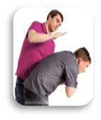 | Severe choking: back blows and abdominal thrusts  Back Blows  - Stand behind them and slightly to one side  - Support their chest with 1 hand  - Lean them forward so the object blocking their airway will come out of their mouth, rather than moving further down  - Give up to 5 sharp blows between their shoulder blades with the heel of your hand. The heel is between the palm of your hand and your wrist  - Check if the blockage has cleared.  - If not, give up to 5 abdominal thrusts.  Abdominal Trusts  Do not give abdominal thrusts to babies under 1 year old or pregnant women.  - Stand behind the person who is choking.  - Place your arms around their waist and bend them forward.  - Clench one fist and place it right above their belly button.  - Put the other hand on top of your fist and pull sharply inwards and upwards.  - Repeat this movement up to 5 times.  - If the person's airway is still blocked after trying back blows and abdominal thrusts, get help immediately:  - Call 999 and ask for an ambulance. Tell the 999 operator the person is choking.  - Continue with the cycles of 5 back blows and 5 abdominal thrusts until help arrives.  - If they become unconscious and stop breathing, you should begin cardiopulmonary resuscitation (CPR) with chest compressions.  NB: Abdominal thrusts can cause serious injuries. A health professional such as your GP or a doctor in A&E should always examine someone after they have received abdominal thrusts  Get urgent medical help at an A&E, NHS walk-in centre or a GP if:  - they have a persistent cough after choking  - they feel something is still stuck in their throat  Now watch this video clip from the British Red Cross: First Aid - Choking
Wounds and Bleeding  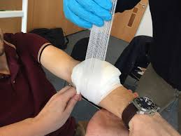 | - Sit or lay the casualty down in case they go into shock  - Examine the wound i.e. note its size, shape, location, if there is anything embedded in it  - Pressure – apply pressure to the wound for at least 10 minutes to control blood loss. Use a clean cloth, clothing or whatever you have to hand. Wear gloves if available or ask the casualty to apply the pressure themselves if they are able  - Dress: Cover any open wound with a dressing, to protect it from infection and promote natural healing  NB: If there is anything embedded in the wound DO NOT REMOVE IT. Apply pressure around the embedded object so that it remains visible.  Now watch this video clip from St. John Ambulance: First Aid for Severe Bleeding
Burns and Scalds  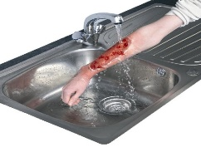 | DO  - Cool the burn immediately with cool or lukewarm running water for at least 10 minutes.  - Remove any clothing or jewellery that's near the burnt area of skin  - Cover the burn with a loosely with a layer of cling film  - A clean plastic bag could also be used for burns on the hand or foot |  | DO NOT  - DO NOT use ice, iced water, or any creams or greasy substances such as butter  - DO NOT remove anything that's stuck to the skin  - DO NOT wrap anything tightly around the burn
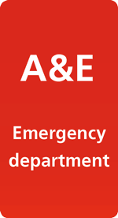 | Call 999 or take the casualty to the Accident and Emergency Department for:  - large or deep burns - bigger than the affected person's palm  - burns of any size that cause white or charred skin  - burns on the face, hands, arms, feet, legs or genitals that cause blisters  - all chemical and electrical burns  Also if the casualty;  - is going into shock (signs include cold, clammy skin, sweating, rapid, shallow breathing, and weakness or dizziness  - is pregnant  - is over 60 years or under 5 years of age  - has breathed in smoke or fumes.  Now watch this video clip from the British Red Cross: First Aid for Burns
Fractures/Broken Bones  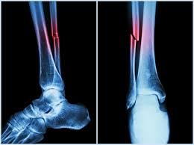 | Signs and symptoms  - Pain/tenderness  - Swelling and bruising  - Deformity/irregularity  - Loss of Power/unnatural movement  First Aid for Broken Bones  - Keep the injury still  - Keep the casualty warm  - Cover open wounds with a sterile dressing  - Don’t try to bandage the injury and never try to straighten a broken bone  - Ensure the casualty gets medical assistance as soon as possible at the Accident and Emergency department  Always Call 999 if:  - You suspect a spinal or neck injury  - The casualty has difficulty in breathing  - The affected area is turning white or blue (poor circulation to the area)  - There is deformity, irregularity, unnatural movement or bone sticking through the skin  - The casualty is in a lot of pain or is starting to go into shock  Now watch this video clip from the British Red Cross: First Aid for Broken bones
Heart Attack  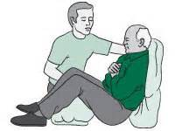 | A heart attack is a serious medical emergency in which the supply of blood to the heart is suddenly blocked, usually by a blood clot.  Symptoms of a heart attack can include:  - chest pain – the chest can feel like it's being pressed or squeezed by a heavy object, and pain can radiate from the chest to the jaw, neck, arms and back  - shortness of breath  - feeling weak or lightheaded, or both  - an overwhelming feeling of anxiety  Not everyone experiences severe chest pain. This is particularly the case with many women. The pain can often be mild and mistaken for indigestion. Look for a combination of the symptoms above.  - If you suspect someone is having a heart attack - Call 999  - Help the person to sit down. Sitting down on the floor and leaning against a chair or a wall, with the knees bent, feet on the floor, will ease the strain on the heart.  - Sitting them on the floor also means they are less likely to hurt themselves if they collapse  Now watch this video clip from the British Red Cross: First Aid for a Heart Attack
Stroke  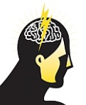 | Strokes are caused either by a clot in the brain or a bleed in the brain. This results in the blood supply to that part of the brain being cut off, causing damage to the brain cells in that area.  If you suspect someone has had a stroke, carry out the F.A.S.T. TEST:  Face: is there weakness on one side of their face?  Arms: can they raise both arms?  Speech: is their speech slurred? Can you understand what they’re saying?  Time: to call 999, if you see any of these signs  *A stroke needs immediate attention. The faster a person having a stroke gets medical help, the less damage there will be*  Now watch this video clip from the British Red Cross: First Aid - Stroke

