

Mon Workforce Development Newsletter #04
21st April 2020
This newsletter contains up to date information about ‘anything and everything training’.
We are continuing to work on Toolkits to support Mandatory Training for Social Care staff during the Covid 19 period. To view the Toolkits and any other current training related information please visit our website: Monmouthshire Workforce Development: Covid 19 Resources



Today’s Toolkits
Toolkit 4: Care of Medicines. Part 1 - Introduction
Toolkit 4: Care of Medicines. Part 2 - Medication Requiring Additional Procedures and Guidelines
Please Note: These toolkits are based on Monmouthshire County Council’s Medication Policy.
Although you will find some of the information useful, if you are working for another Social Care provider please refer to your own medication policy and procedures in the first instance

Toolkit 5: Safeguarding
Safeguarding is everyone’s responsibility and as part of your employment in Social Care in Monmouthshire you will need to demonstrate your understanding of basic safeguarding by completing the Safeguarding Level 1 workbook.
If you have any queries regarding this please contact KatieJacobs@monmouthshire.gov.uk.


App of the Day
Wales Safeguarding Procedures

These are the national Wales Safeguarding Procedures. They detail the essential roles and responsibilities for practitioners to ensure that they safeguard children and adults who are at risk of abuse and neglect. To download the app go to: Safeguarding Wales

E-Learning
Violence Against Women, Domestic Abuse and Sexual Violence (VAWADSV)
All staff must complete the Violence Against Women, Domestic Abuse and Sexual Violence (VAWADSV) eLearning which can be found here: VAWDASV E-Learning.
If you have not already completed the training, please do so now and then share the certificate of completion with your manager.

Social Care Wales: Covid 19 Resources

What you need to know
Coronavirus and our work
Temporary registration of social workers
The social care worker card
News updates

Supporting staff and carers
Recruiting staff
Your health and well-being
Guidance for volunteering in social care settings

Supporting adults and older people
The Mental Capacity Act and Covid-19: what’s changed?
Ethical framework for adult social care during Covid-19
Domestic violence and abuse – guidance for professionals
Activities for people with dementia
Communicating with the D/deaf community

Supporting children and young people
Online safety and well-being
Providing safe services for children and young people through the internet
The Social Care Worker Card

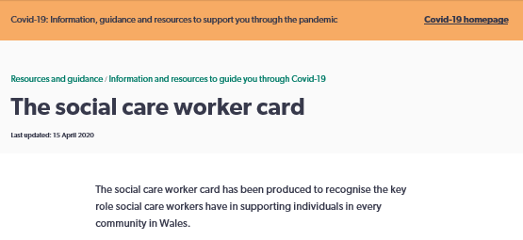
Social Care Wales Announcement

Social care workers have made us aware that it can be difficult for them to prove their identity with the police, when travelling from home to their work, and supermarkets, when trying to benefit from special shopping arrangements made for NHS staff and other key workers. This, in turn, can have an impact on their ability to provide effective care and support for vulnerable people. As the social care sector is made up of thousands of organisations, there is currently no single card that identifies social care workers as key workers. The card we have developed is a response to this need at a time when it’s needed the most.

For full details please use this link: Social Care Worker Card

YouTube Video – the correct way to put on and take off PPE


We will continue to add more online training, e-learning and useful documents.
If you have any specific, urgent training needs please contact socialservices.trainingadmin@monmouthshire.gov.uk
If you have any questions about the online training please contact juliacollacott@monmouthshire.gov.uk

Monmouthshire Workforce Development Covid 19 Resources

