

PLANTS FOR WOODLAND Those marked E are evergreen

Compiled by Cheryl Cummings at https://gardendesignerwales.co.uk/blog

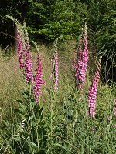
Taller shrubs for structure and ground cover
Aucuba japonica E
Buxus sempervirens E
Choisya ternata E
Daphne laureola E
Eleagnus ebbingei E
Hypericum inodorum 'Elstead'
Osmanthus delaveyi E Digitalis purpurea
Sambucus nigra and cultivars eg 'Laciniata'Symphoricarpos laevigatus
Viburnum tinus and rhytidophyllum E

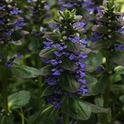
Low ground covering shrubs
Hypericum calycinum E
Rubus tricolor E
Sarcococca humilis E
Vinca minor E
Ajuga reptans ‘Catlin’s Giant’

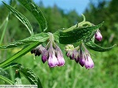
Ferns
Asplenium scolopendrium E
Dryopteris affinis
Polystichum setiferum E

Symphytum

Herbaceous perennials for ground covering
Ajuga reptans 'Catlin's Giant' E
Alchemilla mollis
Corydalis lutea E
Digitalis lutea E
Digitalis purpurea and albiflora
Epimedium cultivars eg 'Sulphureum' E
Euphorbia amygdaloides 'Purpurea' and robbiae E
Geranium macrorrhizum and cultivarsGeranium phaeumHelleborus foetidus and x hybridus E
Iris foetidissima E
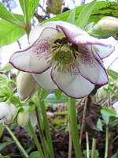
Lamium maculatum E
Lunaria rediviva
Luzula sylvatica 'Marginata' E
Symphytum offionale and uplandicum
Tellima grandiflora E
Viola riviniana 'Purpurea'
Helleborus x hybridus

Bulbs
Allium ursinum
Cyclamen coum and hederifolium
Hyacinthoides non-scripta
Gallanthus nivalis



