

ORNAMENTAL TREES
Compiled by Cheryl Cummings at https://gardendesignerwales.co.uk/blog

Medium size plant 5 plus metres apart

Acer campestre Prunus ‘Tai Haku’ avenue
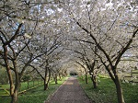
Acer grosseri herzii
Alnus incana ‘Laciniata’
Betula pendula ‘Tristis’
Betula utilis ‘Jaqumontii’
Parrotia persica
Prunus serrula
Prunus ‘Tai Haku’Pyrus calleryana ‘Chanticleer’
Sorbus aucuparia ‘Asplenifolia’

Small – plant 3+ metres apart Crataegus ‘Paul’s Scarlet’
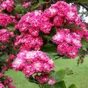
Acer davidii
Acer griseum
Amelanchier lamarckii
Cornus controversa
Crataegus prunifoliaIlex aquifolium cultivars eg ‘J.C. Van Toll’
Malus cultivars eg ‘John Downie’
Prunus ‘Mount Fuji’, Schimidsu Sakura’ etc.
Pyrus salicifolia ‘Pendula
Sorbus ‘Vilmorinii’
Cydonia oblonga, quince
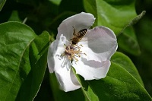
Fruit trees
Cydonia oblonga eg ‘Vranja’
Malus sylvestris domestica cultivars
Pyrus communis sativa cultivars
Prunus domestica cultivars
Morus nigra
Mespilus germanica



