

Online Booking Site – How to cancel a place
The following link will take you to the booking site.
Course Booking for Private & Independent Sector
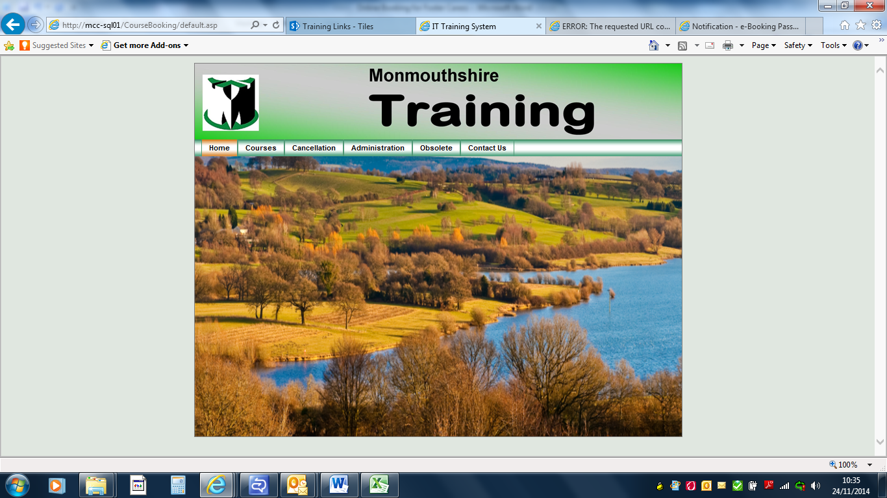
Just under training you will see a tab that says cancellation. If you click the cancellation tab the following screen will appear.
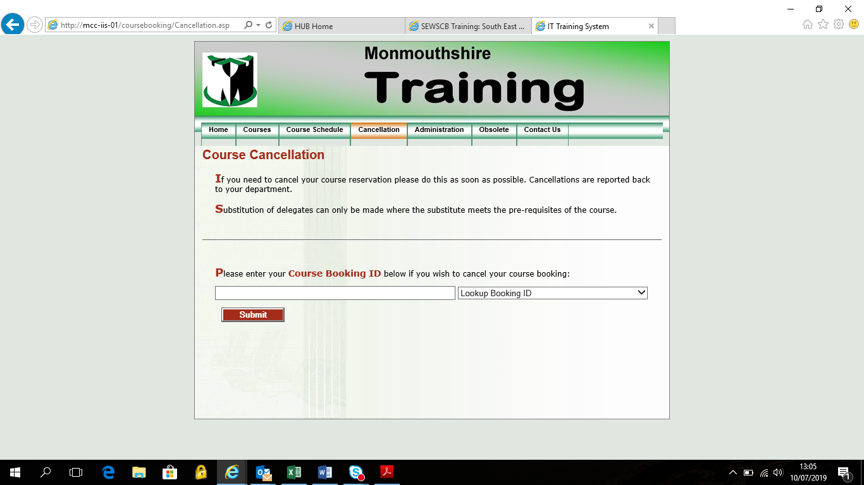
As you can see it is asking you to enter the Course Booking ID. This can be found on the confirmation email that you received when you booked the course. See example below I have highlighted the code in red.
Course Booking Application
PLEASE DO NOT REPLY TO THIS EMAIL
This email is to confirm that Rachel Cox has been booked onto the following course:
Course title: Health & Safety Induction Training Combined
Course venue: Magor Room 6, Wales 1, Magor
Date(s): 15/07/2019
Time: 8:45 to 16:30
Course Booking ID: H&S IND43446
PLEASE NOTE REGISTRATION WILL BE 15 MINUTES PRIOR TO THE COURSE START TIME. PLEASE ENSURE YOU ARE THERE IN TIME SO THE COURSE CAN START PROMPTLY.
IF YOU ARRIVE AFTER 10AM OR 2PM YOU WILL NOT BE ABLE TO ATTEND THE COURSE. MAIN DOORS OPEN AT 08.45AM.
FOR VENUE ADDRESSES PLEASE FOLLOW THIS LINK https://www.scwdpmonmouthshire.co.uk/venues/ MANY THANKS.
PLEASE ENSURE YOU INFORM US IF CANCELLING YOUR PLACE BY EMAILING socialservices.trainingadmin@monmouthshire.gov.uk OR YOU COULD INCUR A CANCELLATION FEE.
FOR MORE DETAILS ON OUR CHARGING POLICY PLEASE FOLLOW THIS LINK https://www.scwdpmonmouthshire.co.uk/charging-and-non-attendance-policy/
The Training Team will endeavour to ensure that all courses run as scheduled, however, we reserve the right to cancel where unforeseen circumstances arise.
Please be aware when attending a training course in Innovation House, Magor that you may need to use our overflow car park on the site.
When driving on to the site it is the first turning on the left. It is signposted and parking is free. Many thanks.
Thank you for your application.
Kind Regards
Social Care and Health Training Team

You can either type in the code H&S IND43446 or copy and paste it. Copying and pasting is better if you can.
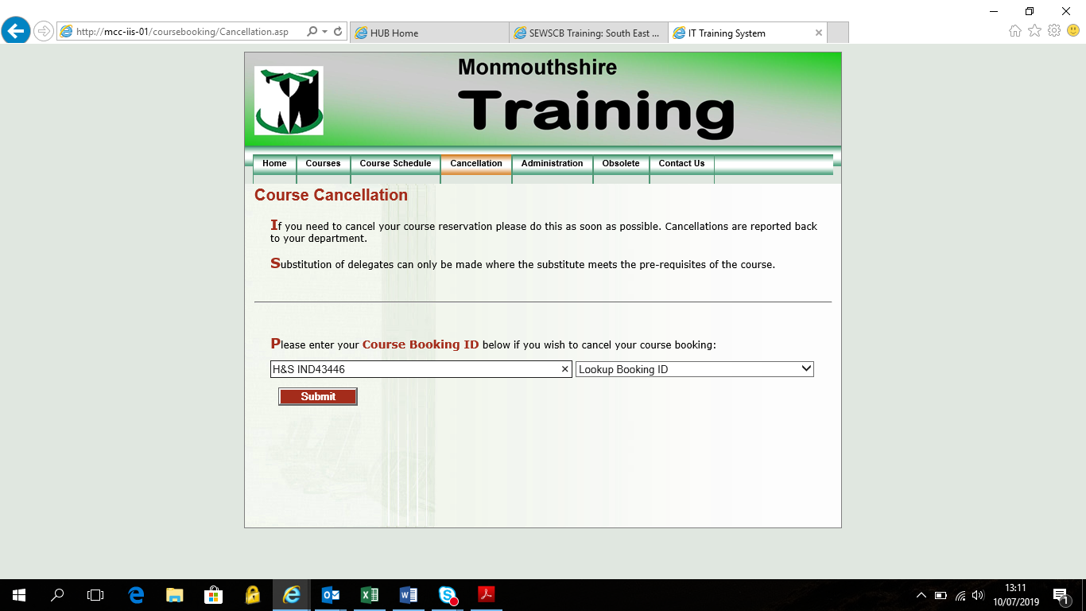

Once you have entered the code press submit and the following screen will appear.
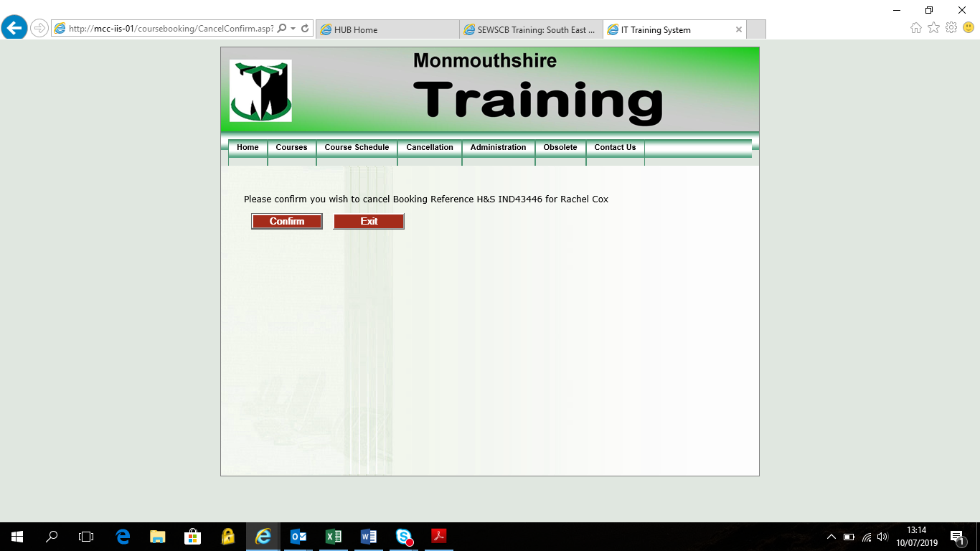
It will show the name of the person you wish to cancel and if this is correct press confirm. If it isn’t you may have entered the wrong Booking ID.

Once you have pressed confirm the message below will appear.
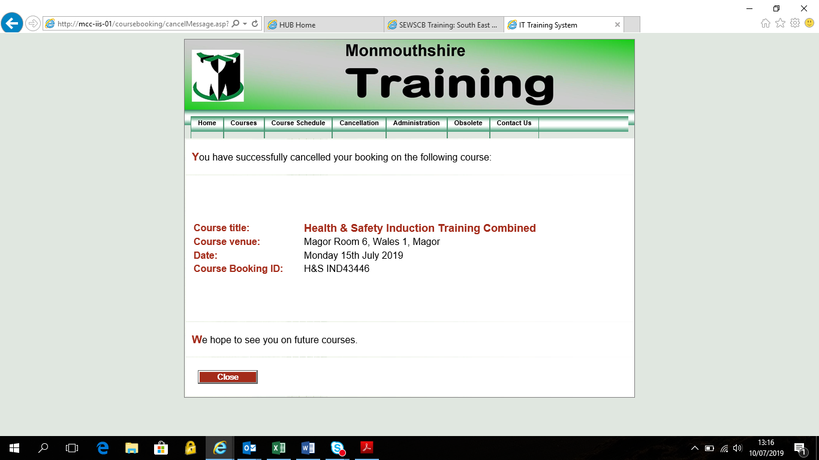

Once you have confirmed an email will be automatically sent to the address you put on the booking form. See example below
Course Booking Cancellation
PLEASE BE AWARE THERE COULD BE A CHARGE FOR CANCELLING THIS PLACE.
FOR MORE DETAILS ON OUR CHARGING POLICY PLEASE FOLLOW THIS LINK https://www.scwdpmonmouthshire.co.uk/charging-and-non-attendance-policy/
PLEASE DO NOT REPLY TO THIS EMAIL
This email is to confirm the following course booking has been cancelled:
Name: Rachel Cox
Course title: Health & Safety Induction Training Combined
Course venue: Magor Room 6, Wales 1, Magor
Date(s): 15/07/2019
Time: 8:45 to 16:30
Course Booking ID: H&S IND43446
We hope to see you on future courses,
Kind Regards
Social Care and Health Training Team

We advise you to please keep a copy of the email cancellation as evidence as it may be required as proof of cancellation when invoices are issued.
If you need any additional support or have any problems/queries please do not hesitate to contact Mon Workforce Development Team.
Rachel Cox
Tel: 01873 735443
Mobile: 07775 220932
Email: rachelcox@monmouthshire.gov.uk
Or Dominique Davies
Tel: 01873 735410
Mobile: 07971 813003
Email: Dominiquedavies@monmouthshire.gov.uk
Postal address:
Monmouthshire County Council
Mon Workforce Development Team
Innovation House
PO Box 106
Caldicot
NP26 9AN

