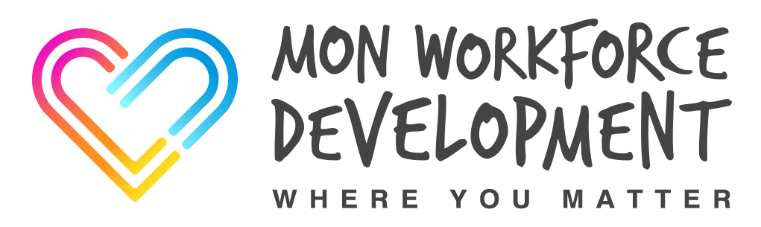

Online Booking Site – How to book a place
The following link will take you to the booking site.
Course Booking for Private & Independent Sector
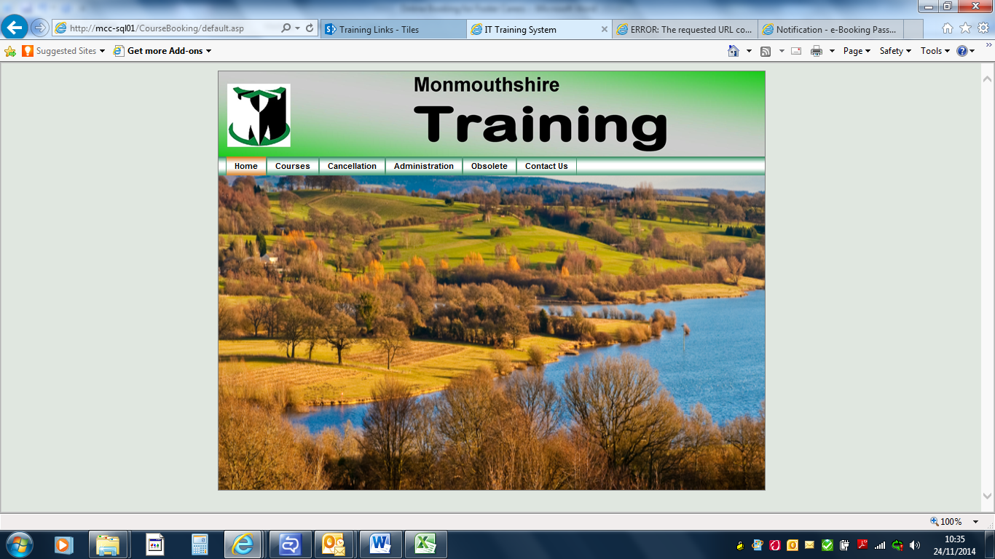
If the link takes you to the top page just click courses which is just under the Monmouthshire logo.
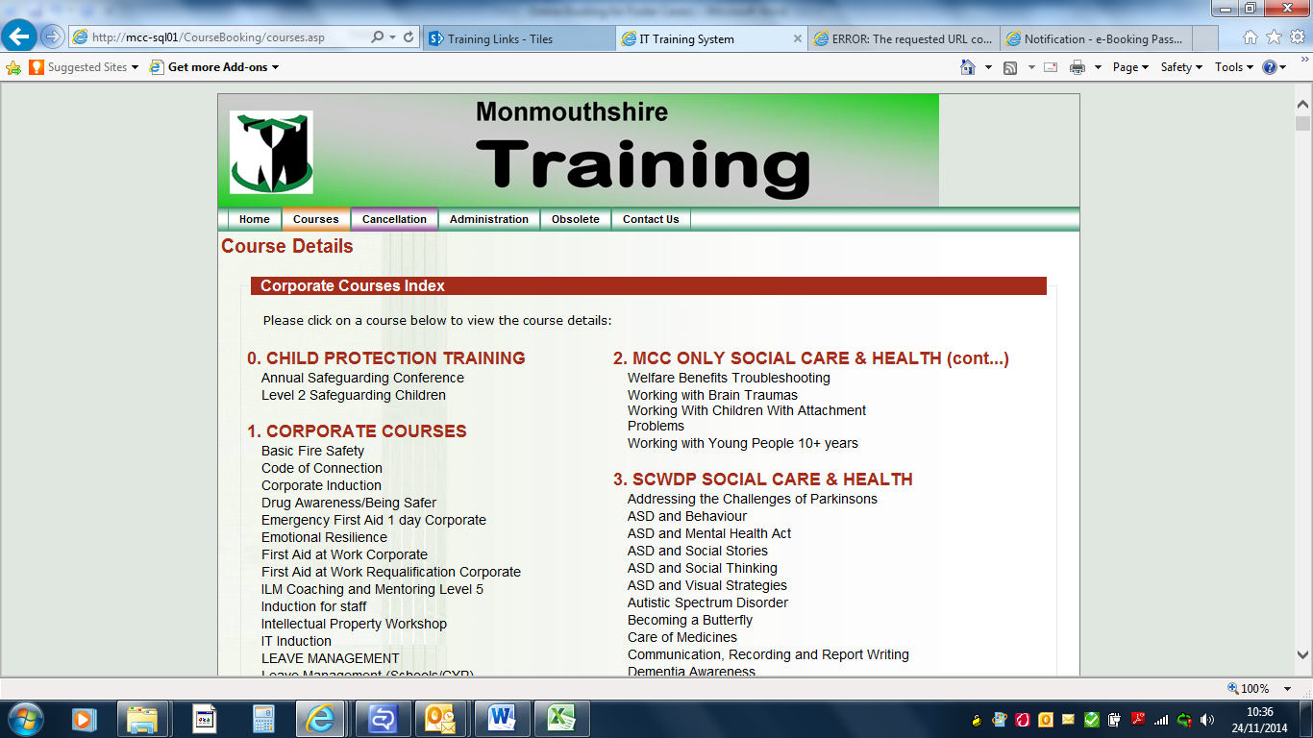
Most of the courses available to you are under section 3 SCWDP Social Care & Health.
Once you see a course you want if you click the title it will take you to a screen showing dates and times of the course and some aims and objectives.
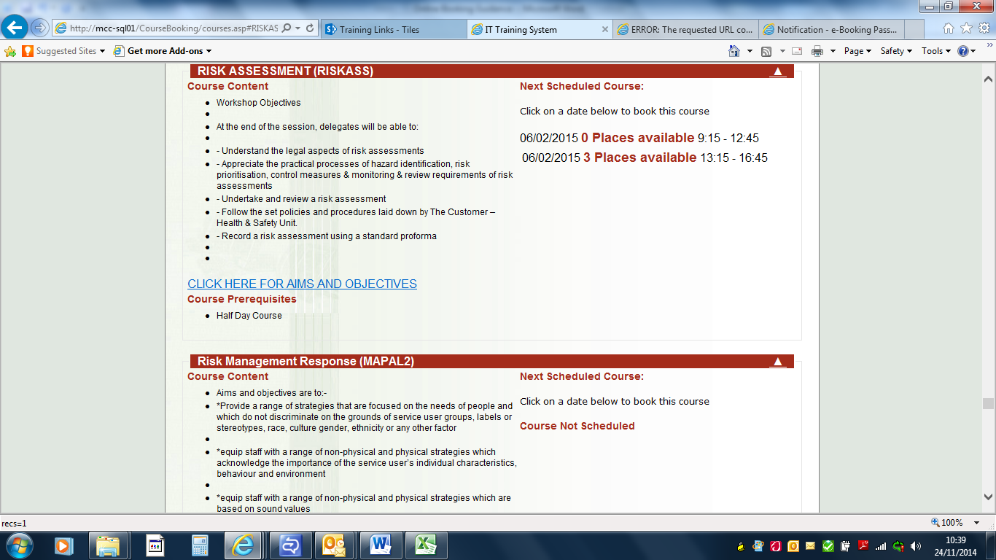
When you find a suitable date click the date and it will bring up a booking form. Yours may look slightly different to mine as it’s external. All lines have to be completed before you are allowed to submit the form.
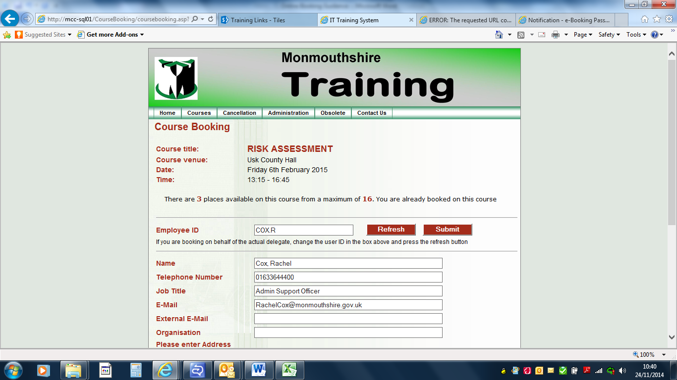
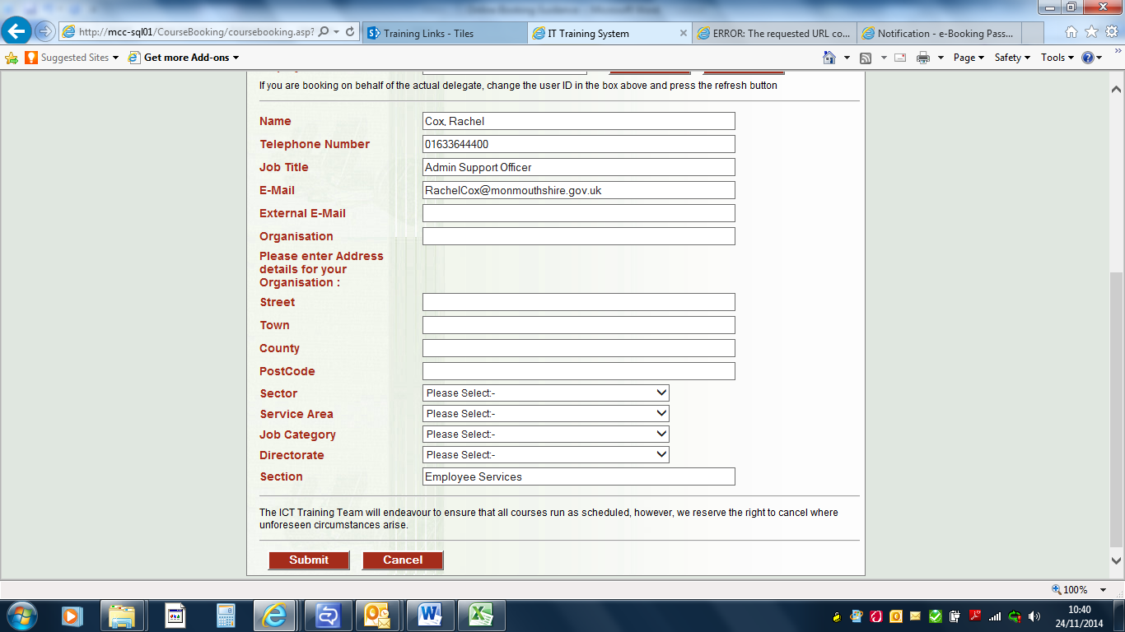
Once you have submitted the form an email will be automatically sent to the address you put on the booking form.
If you are booking more than one place on the same date use the arrow ( )in the top left hand corner to take you back and then you can just change the name and job title if necessary and submit the form without having to complete all the details again.
We advise you keep a copy of the email confirmation or make a note of the Course Booking ID as you will need this if you wish to cancel a place at a later date.
If you need any additional support or have any problems/queries please do not hesitate to contact Mon Workforce Development Team.
Rachel Cox
Tel: 01873 735443
Mobile: 07775 220932
Email: rachelcox@monmouthshire.gov.uk
Or Dominique Davies
Tel: 01873 735410
Mobile: 07971 813003
Email: Dominiquedavies@monmouthshire.gov.uk
Postal address:
Monmouthshire County Council
Mon Workforce Development
Innovation House
PO Box 106
Caldicot, NP26 9AN

