

LARGE SHRUBS FOR STRUCTURAL PLANTING Plant 1.5 to 2 metres apart.
Those marked S are shade tolerant
Those marked E are evergreen
Particularly good for rural locations *
Particularly good for screening Sc
Perfect for pollinators are marked P

Compiled by Cheryl Cummings at https://gardendesignerwales.co.uk/blog

Arbutus unedo E
Aucuba japonica S E Sc Berberis x ottawensis ‘Superba S * P
Berberis x ottawensis ‘Superba’ S * P
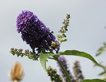
Berberis stenophylla and darwinii S E * P
Buddleja alternifolia and davidii cultivars P
Calicarpa bodiniera
Chaenomoles speciosa eg ‘Nivalis’ * P
Cornus mas * P
Cornus alba ‘Spaethii’, ‘Elegantissima’ etc * P
Corylus avellana ‘Purpurea’ * P Buddleia & common carder bee
Cotinus coggygria *
Cotoneaster bullatus, watereri, lactaeus S E Sc * P

Eleagnus ebbingei S E Sc
Euonymus alatus *
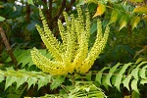
Forsythia suspensa
Hydrangea quercifolia and paniculata cultivars
Kolkwitsia amabilis ‘Pink Cloud’
Ligustrum lucidum S E Sc * P
Lonicera fragrantissima
Mahonia x media ‘Charity’ S E P Philadelphus ‘Virginal’ S * Mahonia media
Prunus laurocerasus S E Sc P

Prunus lusitanica S E Sc P
Pyracantha coccinea S E Sc * P
Rhus typhina ‘Laciniata’
Rubus phoenicolasius P
Rosa species eg ‘alba, californica, moyesii ‘Geranium’,’Nevada’, rugosa * P
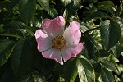

Species Rose

Salix eleagnos ‘Angustiflia’ * PSambucus nigra ‘Laciniata’
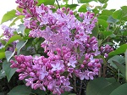
‘Black Lace’ etc. S Sc * P
Sambucus nigra ‘Laciniata’. ‘Black Lace’ etc. S Sc * P
Syringa vulgaris cultivars Sc * P
Viburnum plicatum ‘Mariesii’, sargentii ‘ Onondaga’
Viburnum rhtidophyllum E S Sc
Virburnum tinus S E Sc *

Syringa vulgaris

Compiled by Cheryl Cummings at https://gardendesignerwales.co.uk/blog



