

HERBACEOUS PERENNIALS
Those marked S are tolerant of shade
Those requiring a moist soil are marked M
Those requiring an open sunny position are marked O
Perfect for pollinators are marked P

Compiled by Cheryl Cummings at https://gardendesignerwales.co.uk/blog

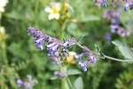
Achillea cultivars O P
Agastache foeniculum O P
Alchemilla mollis S
Anemone x hybrida S P
Aquilegia vulgaris cultivars S P
Aster amellus, frickartii ‘Little Carlow’ O P

Nepeta and long horned bee

Astilbe cultivars S MAstrantia major cultivars S M P
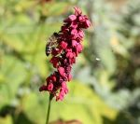
Bergenia cultivars S P
Campanula latifolia, lactiflora O P
Cynara cardunculus O P
Dicentra spectabilis
Echinops ritro P
Echinacea purpurea O P
Eryngium species and cultivars O P
Erysimum ‘Bowles Mauve’ O P Geranium ‘Rozanne’
Eupatorium purpureum O P
Euphorbia griffithii ‘Fireglow’, polychroma etc.

Geranium pratense, macrorrhizum S, ‘Rozanne’ etc PGeum cultivars P
Helenium cultivars P
Helianthus ‘Lemon Queen’ P
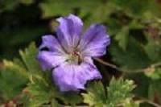
Helleborus x hybridus S, sternii, argutifolius P
Hemerocallis cultivars
Iris sibirica
Kniphofia cultivars
Lamium ‘White Nancy’ etc. P
Monarda didyma O P
Nepeta ‘Six Hills’ Giant’, ‘Walkers Low’ P Persicaria amplexicaulis and honey bee
Paeonia cultivars
Papaver orientale cultivars P
Penstemon cultivars
Persicaria amplexicaulis cultivars P

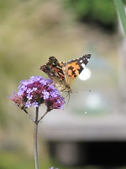
Phlox paniculata
Pulmonaria ‘Mawsons’ Blue’ etc. P
Rudbeckia ‘Goldsturm’ O P
Sedum spectablile etc P
Solidaga P
Symphytum cultivars P
Tellima grandiflora rubra
Thalictrum aquilegifolium
Verbena bonariensis P
Veronica spicata P Verbena bonariensis and painted lady butterfly



Nepeta and long horned bee

