
SAFEGUARDING ADULTS REFRESHER
LEVEL 2

The half day Safeguarding Adults course is an awareness raising course designed to update participants understanding of:-
- Who may be an adult at risk
- What abuse/neglect is
- Your role in reporting adult abuse/neglect
- Where to get advice, information and support
- The safeguarding process and what happens next

The certificate is valid for 3 years, then participants will need to attend the Safeguarding Adults Refresher course again. If they do not attend the Refresher course again then they will need to attend the full day course.

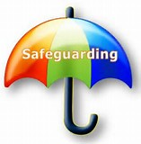

The Workforce Development Team can be contacted on 01873 735410 or 01873 735443

