
SAFEGUARDING ADULTS LEVEL 2

The one day Safeguarding Adults is an awareness raising course designed to give participant’s an understanding of:-

- Who may be an adult at risk
- What abuse/neglect is
- Your role in reporting adult abuse/neglect
- Where to get advice, information and support
- The safeguarding process and what happens next

The certificate is valid for 3 years, then participants will need to attend the Safeguarding Adults Refresher course (half day).

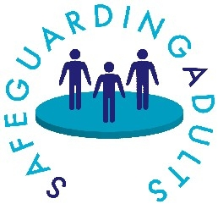

The Workforce Development Team can be contacted on 01873 735410 or 01873 735443

