MOVING & HANDLING REFRESHER
This one day course will refresh knowledge in relation to:
- The need for safe moving and handling in all aspects of your life
- Reducing the risk of musculoskeletal injuries caused by poor manual handling in the workplace
- Your responsibilities when manual handling tasks are carried out
- Carrying out risk assessments associated with manual handling tasks
- The legislation associated with manual handling in the workplace
The Refresher course needs to be completed 12 – 18 months after the Foundation Course. If participants have not attended a Refresher within 2 years they would need to complete the 2 day Foundation course again.
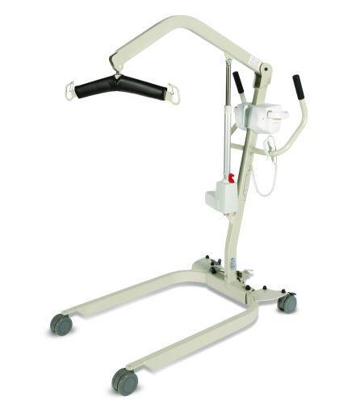
Due to the practical aspects of the training participants must wear suitable clothing and flat enclosed shoes.
Participants have to fully participate in all practical activities in order to be awarded a certificate of competence in Moving & Handling.
If you have a member of staff who is temporarily unable to carry out these types of activities we advise you defer their training until they are recovered and can fully participate.
The Workforce Development Team can be contacted on 01873 735410 or 01873 735443

