
MOVING & HANDLING
FOUNDATION COURSE
COURSE CONTENT
Module A - Manual Handling Theory
Module B - Inanimate Load Handling & Practical Application of Ergonomics
Module C - Sitting, Standing & Walking
Module D - Bed mobility
Module E - Lateral Transfers
Module F - Hoisting

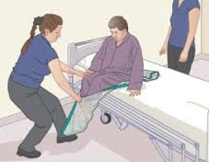

Due to the practical aspects of the training participants must wear suitable clothing and flat enclosed shoes.
Participants have to fully participate in all practical activities in order to be awarded a certificate of competence in Moving & Handling.
If you have a member of staff who is temporarily unable to carry out these types of activities we advise you defer their training until they are recovered and can fully participate.
For further information the Training Team can be contacted on 01873 735410 or 01873 735443

