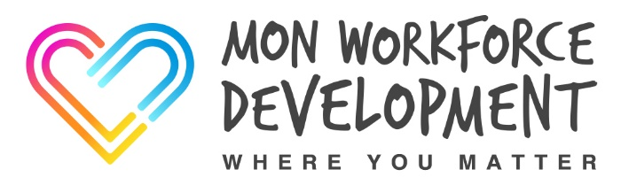
MOVING & HANDLING
MODULES A, B and/or C
COURSE CONTENT
Module A - Manual Handling Theory
Module B - Inanimate Load Handling & Practical Application of Ergonomics
Module C - Sitting, Standing & Walking

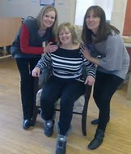

In order to gain the Manual Handling All Wales Passport you do not need to complete all the modules you can still get the passport by completing the relevant modules. For instance if you are an Office Worker you would only need to complete Modules A & B. If you worked in the Community taking Service Users out you would only need to complete Modules A, B & C. If you are not using beds and hoists there is no need to complete the 2 day course.
Due to the practical aspects of the training participants must wear suitable clothing and flat enclosed shoes.
Participants have to fully participate in all practical activities in order to be awarded a certificate of competence in Moving & Handling.
If you have a member of staff who is temporarily unable to carry out these types of activities we advise you defer their training until they are recovered and can fully participate.
The Workforce Development Team can be contacted on 01873 735410 or 01873 735443

