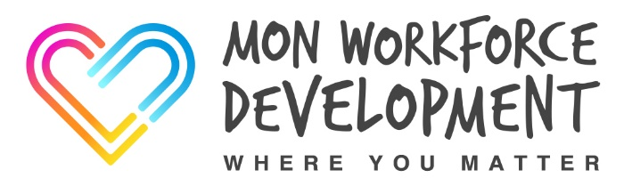
BASIC LIFE SKILLS ANNUAL UPDATE
This 3 hour session is designed to refresh participant’s knowledge and skills required to save lives in a medical emergency.
Participants will be able to practice their skills in the following areas
- CPR
- Recovery Position
- Choking
Participants must have a current Emergency Aid, First Aid or First Aid Refresher certificate in order to attend this course.

Participants have to fully participate in all activities. Typical activities that cause problems are:
- Kneeling to do CPR
- Chest compressions (for anyone with wrist, hand or shoulder problems)
- Not being able to get down low enough to do rescue breaths
- Not having enough lung capacity to give rescue breaths
- Turning the ‘casualty’ into the recovery position
If you have a member of staff who is temporarily unable to carry out these types of activities we advise you defer their training until they are recovered and can fully participate. Should a member of staff have a chronic health problem, and they are genuinely unable to carry out the activities or are likely to put themselves at potential risk by carrying them out please speak to the Workforce Development Team to determine if the situation can be managed.
The Workforce Development Team can be contacted on
01873 735410 or 01873 735443

