VENUES & INFORMATION
Please note that lunches are no longer provided and some of the locations do not have shops near so we recommend you bring a packed lunch.
Tea, coffee and water are available during the courses.
Due to the practical nature of some courses we advise participants to wear flat enclosed shoes and trousers.

COUNTY HALL, USK
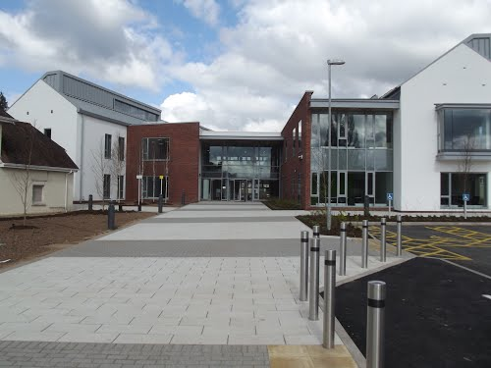

County Hall
Usk County Hall
The Rhadyr
Usk
Monmouthshire
NP15 1GA

CEFNDY MEDEQUIP, NEWPORT (PREVIOUSLY VISION PRODUCTS)
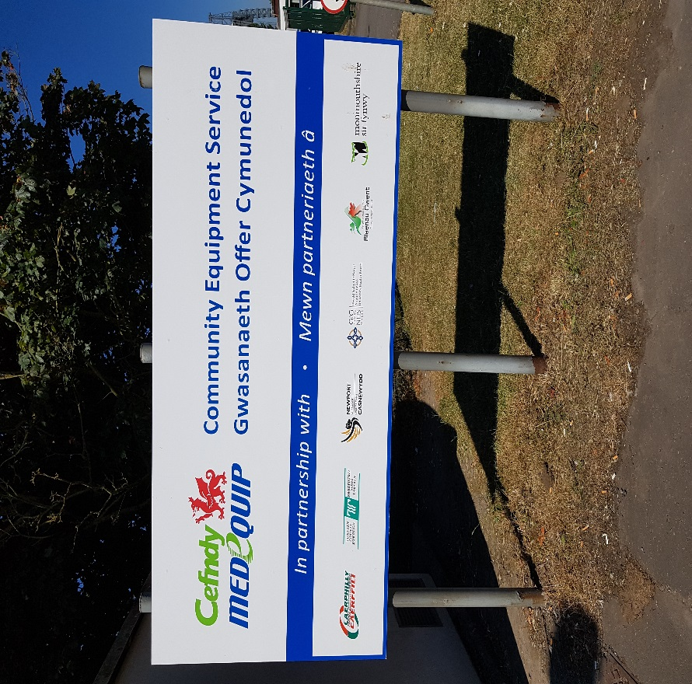
Mariner Way
Stephenson Street Industrial Estate
Newport
NP19 4PQ

Tel: 01633 290919

The post code will not take you to the venue so please use the directions below or you will be taken to the wrong side of the river.

- From the Coldra Roundabout, Junction 24 of M4 (NP18 2NX) (A)
- Exit the roundabout onto Ringland Way/​Southern Distributor Rd/​A48
- Go through 2 roundabouts
- At the roundabout, take the 1st exit onto Southern Distributor Rd/​A48
- Go through 2 roundabouts
- Just after Newport Stadium, turn left onto Langland Way (B)
- Continue forward onto Oxwich Road
- Turn left onto Corporation Road
- Turn right onto Stephenson St
- Just after the red railway bridge, turn left onto Mariner Way (C)
- Follow the road around to the right until you reach a building and car park signposted “Cefndy Medequip” (Previously known as “Vision Products)”
INNOVATION HOUSE, MAGOR
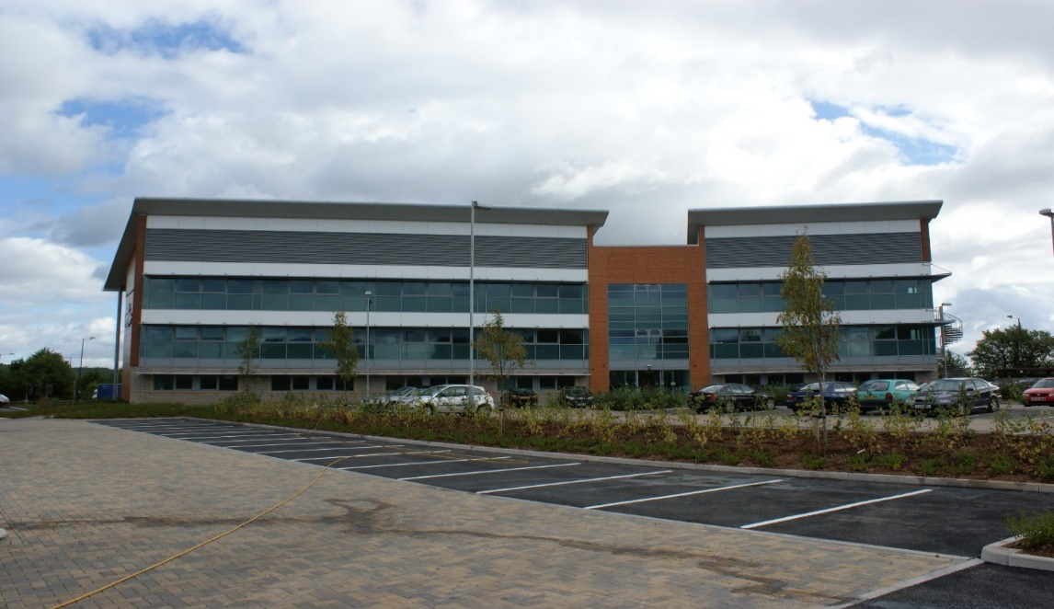

Innovation House
Wales 1 Business Park
Magor
NP26 3DG

Please be aware when attending training at Innovation House participants must use the overflow car park. When entering the site this is the first turning on the left. The car park is signposted and free of charge. Under no circumstances are participants to park in BAM spaces or in the Hotel.
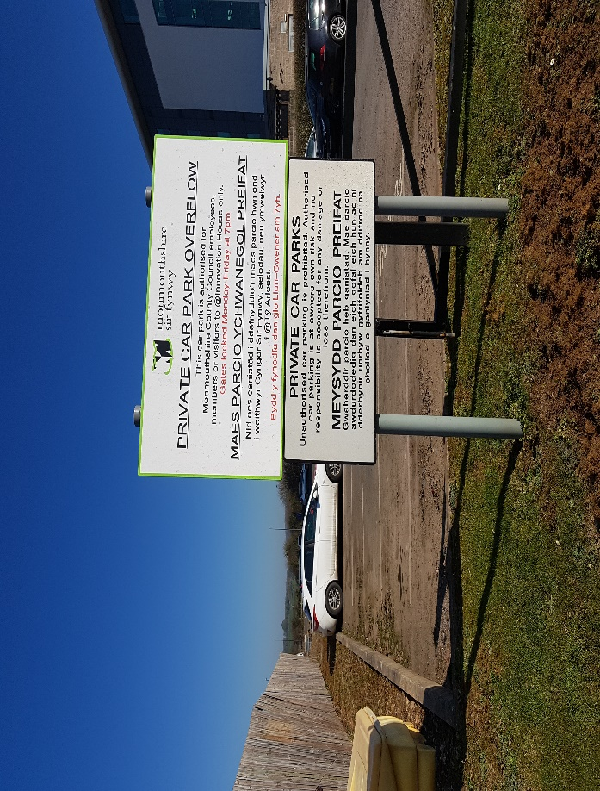

CENTENARY HALL, USK
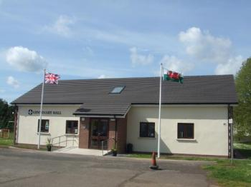
Maryport Street South
Usk
Monmouthshire
NP15 1AD

