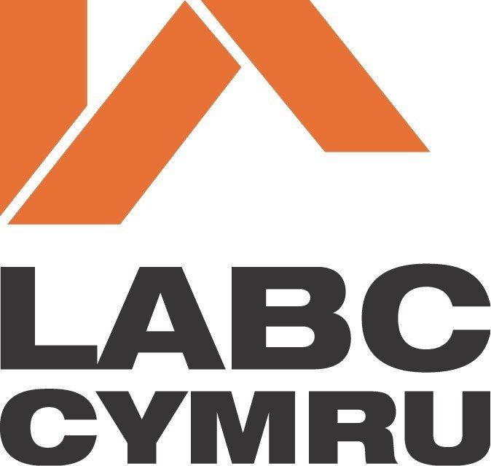

Email. buildingcontrol@monmouthshire.gov.uk


Telephone. (01633) 644833

‘Helping people design and construct safe and sustainable buildings’

REGULARISATION APPLICATION FOR UNAUTHORISED BUILDING WORKS

PLEASE NOTE:

When completing the Application Form ‘On Screen’ please double click the grey boxes then ‘checked’ and ‘ok’to insert an ‘x’ in appropriate box

(Carried out on or after 11th November 1985)
The Building Act 1984 & The Building Regulations 2010 (as amended)

Application Notes

Applicant / Owner may apply in writing for a Regularisation Certificate, this form will be classed as a statement which is made in accordance with Regulation 18 – Building Regulations 2010

Regularisation Charge (retrospective applications)

The charge required when depositing an application for Regularisation is 100% of the appropriate Charge listed in the tables A, B or C (see Monmouthshire Building Control Charges) excluding VAT, however an additional 50% premium added to it. This type of work is exempt VAT. E.g. an unauthorised loft conversion less than 60m2 will attract a charge of £600 (vat not applicable) plus 50% = £900

We as a local Authority may require the applicant / owner to take reasonable steps to ascertain the extent of the works, this may include laying open of unauthorised work, making tests and/or taking samples to ensure the relevant requirements are met.

Your personal information will be processed in accordance with our Privacy Notice of which a summary is attached.

1. | Application Type
 | REGULARISATION
2. | Location of building work
Address:
Postcode:
3. Applicant details
Name/s:
Address:

Postcode:
Tel No:
Mobile:

E-mail:
Applicants preferred method of contact:
Tel Mobile E-mail Text Applicants preferred method of receiving documents/notices: Letter E-mail
4. Agents details (if applicable)
Name/s:
Address:

Postcode:
Tel. No:
Mobile:

E-mail:
Agents preferred method of contact:
Tel Mobile E-mail Text Agents preferred method of receiving documents/notices: Letter E-mail
If agent appointed, do you want us to send correspondence to applicant also? Yes No
5. Description of work (Include all elements of Building Work)

6. No. of storeys (including basements): Existing
Present

7. Use of the building (i.e. domestic, commercial, industrial, assembly (please specify))

Existing
Present

If non-domestic, please clarify whether the building (or part of) will be put to a use which is designated under Fire Safety Regulatory Reform Order 2005: Yes No
If yes please submit an additional set of drawings
8. Drainage provision

Existing: Foul water: Surface water:
Proposed: Foul water: Surface water:

Are you aware of any public sewers within your boundaries?
Yes No

Means of water supply:
Means of water supply:

9. Charges (See Monmouthshire Building Control charges notes)
Please note: If your application is for multiple work then you may be required to pay more than one charge.

Type of work |  | Fee Enclosed
Extension(s)  (see table B) | 0 – 10 m2 10 – 60 m2 60 – 80 m2  If over 80m2, please provide an estimated cost of the work, this will then fall into the “Alteration work” category below. | £
New Domestic Garage(s) (see table B) | If over 60m2, please provide an estimated cost of work, this will then fall into the “alteration work” category below. | £
Loft conversion  (see table B) | If over 60m2, provide an estimated cost of the work, this will then fall into the “alteration work” category. | £
Other work  (see table B) | Replacement windows  Electrical installation  Alteration to single thermal element  Alteration of multiple thermal element  Solar Panels/PV panels  Solid Fuel Appliance (e.g. log burner) | £  £  £  £  £  £
All Alteration Work  (see table C)  All work that doesn’t fall in tables  A & B | Estimated cost of work £  Description of work: | £
All Non-Domestic work (see table C) | Estimated cost of work £  E.G. Industrial/commercial | £
 | Total Enclosed: | £

10. Do you require a receipt? Yes No
If your fee has been agreed prior to making this application, please clarify the following:

- Officer’s name:
- Date Agreed:
jk kj kjj klnlnnknlkkmnlk
ii. Date agreed

11. Planning Permission
Have you checked if Planning Permission was required for this development? Yes No
Planning Officers Name
Please clarify the reference no. and approval date (if applicable).
Ref: DC/ Approval Date:

12. Sustainable Drainage Systems Approving Body (SAB) Approval (applies to surface water only)
Was SuDS approval required? Yes No
If yes, please clarify the reference no. and approval date (if known)
Ref: Approval Date:

13. Regularisation certificate
Do you require a Regularisation Certificate ? Yes No If yes, where shall we send it?
Applicant Agent Other (please specify name/address)
Please note there will be no extra charge for the initial certificate.
14. Statement
This notice is given in relation to the building work as described and is submitted in accordance with Regulation 18 – Building Regulation 2010
Name: Signed: Date:

A site location plan (min scale 1:1250) is required to be submitted with this application

Part P (Electrical Safety) – Domestic applications

Please indicate which of the following methods you intend to use in order to demonstrate that all fixed electrical installations work associated with this application will be designed, installed, inspected and tested in accordance with BS 7671: 2001 (as amended).

a. Competent person scheme

b. BS 7671 certificate

c. Building Control body

d. Don’t know

e. No electrical work applies

Type of Heating system(s) Existing Present:
For Official use only

15. Please Check the Boxes

- Have you used the most recent fee guide (Monmouthshire Building Control charges applicable from 1st April 2018) ?
- Have you included ALL elements of building works? (see Monmouthshire Building Control Charges: Examples, combination of work types (Domestic Properties) )
- Have you included your Cheque (payable to Monmouthshire County Council or MCC)?
- If your work falls within Table C (Estimated cost of works), have you applied a realistic commercial value to the work? (If not, a builders estimate may be required)
- Have you provided drawings and a site plan with your Regularisation Application?
- Is the correct fee enclosed (i.e amount less VAT + 50%)?

If necessary please add any relevant comments here :

If you require any assistance with your application, please contact the relevant Building Control Surveyor for your area (refer to http://www.monmouthshire.gov.uk/buildingcontrol/ ) – building control area list.
Now please send your completed form, along with all the necessary information and cheque to:
Building Control Department, County Hall, The Rhadyr, Usk, Monmouthshire, NP15 1GA

Data Privacy Summary Notice

How we will use your information

Processing of your personal data by Monmouthshire County Council (MCC) is necessary to fulfil our legal obligation. Without this information, the Building Control Department within MCC may not be able to fulfil your request for a regularisation application.
Your personal details will not be shared further, unless in relation to safeguarding or other legal obligations.
Your records will be safely stored and retained in line with our retention policy, unless we need to retain under another lawful basis.
You have a number of rights in relation to the information including the right of access to information we hold about you and the right to complain if you are unhappy with the way your information is being processed. For further information on how we process your information and your rights please click the following link: http://www.monmouthshire.gov.uk/app/uploads/2018/04/ENTPH001-Privacy-Notice.docx

Should you need to make a complaint about the way your data has been processed, please contact dataprotection@monmouthshire.gov.uk or if you are not fully satisfied you may contact the Information Commissioner’s Office online at www.ico.org.uk/concerns or via their helpline: 0303 123 1113

